

Checkbook NYC 2.0

Business Requirements document

version 0.6

May 17, 2013

**Document Information and Approvals**

**UTORS**

|  |  |  |  |  |  |
| --- | --- | --- | --- | --- | --- |
| **Version History** | |  |  |  | |
| ***Version #*** | ***Date*** | ***Organization*** | ***Author*** | ***Reason for Change*** | ***Description*** |
| **Pre - 0.1** | **02/23/2012** | **REI Systems** | **Meghana Pothana / Peter Yoon** | **Draft** | **Initial Draft** |
| **0.1** | **03/01/2012** | **REI Systems** | **Peter Yoon / Meghana Pothana** | **Made changes after PM review** | **Final Version for Sprint 1** |
| **0.2** | **03/12/2012** | **REI Systems** | **Meghana Pothana / Peter Yoon** | **Updated API and Search Requirements** | **API-Budget Domain and Smart search requirements have been added.** |
| **0.3** | **04/03/2012** | **REI Systems** | **Meghana Pothana / Peter Yoon** | **Updated the requirements** | **n/a** |
| **0.4** | **12/17/2012** | **REI Systems** | **Peter Yoon / Meghana Pothana** | **Updated the requirements according to new change requests.** | **n/a** |
| **0.5** | **01/25/2013** | **REI Systems** | **Peter Yoon / Meghana Pothana** | **Updated Nonfunctional Requirements** | **n/a** |
| **0.6** | **05/17/2013** | **REI Systems** | **Meghana Pothana / Peter Yoon** | **Updated the requirements** | **Pending contracts rules updated along with updating rules for API, data feeds, Advanced search, contracts, spending and payroll rules.** |

***Note:*** This document has been approved as the official Business Requirements Document for Checkbook NYC 2.0 and accurately reflects the current understanding of business requirements.

|  |  |  |  |
| --- | --- | --- | --- |
| ***Organization*** | ***Approver Name*** | ***Project Role*** | ***Date*** |
| **REI Systems** | **Amanandan Dhami** | **Project Manager** | **03/12/2012** |
| **REI Systems** | **Amanandan Dhami** | **Project Manager** | **01/31/2013** |
| **REI Systems** | **Amanandan Dhami** | **Project Manager** | **05/17/2013** |

**Table of Contents**

1 Introduction 1

1.1 Project Overview 1

1.2 Document Purpose 1

1.3 Scope 1

*a)* *In Scope* 1

*b)* *Out of Scope* 1

1.4 Intended Audience 1

1.5 Stakeholders 1

1.6 Glossary 2

1.7 Document Overview 3

1.8 References 3

1.9 Assumptions and Constraints 3

*a)* *Assumptions* 3

*b)* *Constraints* 3

2 System Architecture 4

3 Application Layout 5

4 Business Rules & Functional Requirements 6

4.1 Contracts 7

4.2 Payroll 69

4.3 Spending 112

4.4 Trends 144

4.5 Resources 157

4.6 Help 162

5 Non-Functional Requirements 168

5.1 Hardware Requirements 168

5.2 Software Requirements 168

5.3 Web Accessibility Requirements 168

5.4 Security and Privacy Requirements 168

5.5 Reliability/Disaster Recovery Requirements 168

6 Performance Requirements 169

6.1 System Capacity (Req ID 9.1) 169

7 Smart Search Requirements 170

8 Narrow-down Facet Requirements 171

9 API/Data Feeds Requirements 172

10 Data Requirements 172

10.1 Data Model 172

10.2 Data Dictionary 172

10.3 Data Mapping 173

11 Design Requirements 173

12 Appendices 173

1. Introduction
   1. Project Overview

The main objective of the Checkbook NYC 2.0 (CB 2.0) application is to establish a transparency dashboard that exhibits various New York City financial information such as Revenue, Budget, Spending, Contracts and Payroll. The application uses extract, transform, load (ETL) processes to perform this function. The application will significantly increase the availability of detailed financial information to the public. The infrastructure of the application will also support the security and confidentiality of exclusive data.

* 1. Document Purpose

The purpose of the Business Requirements Document is to describe the business, functional, and non-functional requirements for the Checkbook NYC 2.0 application. The document will provide the readers with a solid understanding of the system features and their business objectives. The document will also be utilized as the basis for the following tasks:

* + - Creating solution designs
    - Developing test plans, test scripts, and test cases
    - Determining project completion
  1. Scope

1. In Scope

The Business Requirements Document addresses the business, functional, and non-functional requirements of the Checkbook NYC 2.0 application.

1. Out of Scope

The Business Requirements Document does not include step-by-step operational procedures for utilizing the application.

* 1. Intended Audience

The Business Requirements Document is produced for anyone with a stake in the development of the application. This document is written to be easily understood by readers who may not possess extensive technical knowledge. However, technical architects or developers should also find the information in the document beneficial when designing future applications that may address similar requirements.

* 1. Stakeholders

Stakeholders are the individuals or groups who have a vested interest in this project and whose interests need to be considered throughout the project.

*List of Stakeholders:*

|  |  |  |
| --- | --- | --- |
| **Stakeholders** | **Organization** | **Role** |
| Employees of REI Systems | REI Systems | Contractor, implements the application according to requirements |
| Ari Hoffnung | Office of New York City Comptroller | Sponsor, provides requirements for Checkbook NYC 2.0 |
| Jonathan Rosenberg | Office of New York City Comptroller | Business Stakeholder, provides functional direction for Checkbook NYC2.0 |
| Edward Sokolowski | Office of New York City Comptroller | Point of Contact, ensures all the deliverables are accurate and presented in timely fashion |
| Rod Lustan | Northrop Grumman | Subject Matter Expert, developed legacy system Checkbook 1.0 |
| Peter Reddy | Financial Information System Agency | Subject Matter Expert – Interface, provides all data from FMS |
| Michael Bott | Office of New York City Comptroller | Chief Information Officer |
| Charles Odiase | Office of Management & Budget | Subject Matter Expert |
| Preston Niblack | Office of the Mayor | Subject Matter Expert |
| Polonsky, Ezra | Office of the Mayor | Subject Matter Expert |

* 1. Glossary

| **Term/Acronym** | **Definition** |
| --- | --- |
| API (Application Programming Interface) | Specification of interface for accessing services or applications from a given program. |
| Data Feed | Mechanism to filter and download data. |
| Drupal | Content Management System |
| ETL | Extraction, Transformation, and Loading of source file data. |
| Open-source | Open to the public. |
| Wireframe | Mockup of the actual production. |

* 1. Document Overview

The Business Requirements Document presents detailed wireframes of most web pages of the application. The wireframes represent REI’s interpretation of the requirements provided by the clients. The wireframes have been reviewed and approved by the clients. The features associated with the wireframe are linked to a corresponding business and functional requirements table that identifies and describes each requirement. The wireframes allow the readers to picture the expected end result more easily.

In addition, the document provides a high level description of the non-functional requirements in a listed format. The depiction of the system architecture (*in section 2*) should assist the readers in better grasping the non-functional requirements.

* 1. References

|  |  |  |
| --- | --- | --- |
| **Source** | **Version ID** | **Date** |
| Checkbook NYC 2.0 Wireframes/Mockups | 0.7 | 11/01/2012 |
| Checkbook NYC 2.0 Data model | 0.7 | 12/17/2012 |
| Checkbook NYC 2.0 Data Mapping | 0.4 | 12/17/2012 |

* 1. Assumptions and Constraints

1. Assumptions

Assumptions associated with the NYC Checkbook 2.0 are listed below:

* The application will be open source.
* The client will provide up-to-date financial data.

1. Constraints

Constraints imposed on the NYC Checkbook 2.0 are listed below:

* The operational requirements depend on the infrastructure on which the application is deployed on.
* Secure Sockets Layers must be installed on the applicable web servers.

1. System Architecture

The first process in ETL is to consume incoming data files from various sources. The data is then processed into the ‘master’ database.  Once the ‘master’ database is refreshed, the three ‘shard’ databases are refreshed one at a time.  The approach has been specifically chosen to divide up the workload of refreshing data and displaying data. As a single shard is refreshing, the CB2.0 application configurations will dynamically alter to instruct a ‘shard’, which isn’t refreshing, to display the content in the application.



1. Application Layout

The layout explains the possible pathways users can take throughout the application. The layout also describes the relationship the application pages have among themselves.

Help

Resources

Data Feeds

Trends

Home

Site Navigation & Glossary

Resources List

Data Feeds

All Trends

Top Navigation

Revenue *

FAQ

API

Trend Details

Budget*

Ask a Question

Spending

Report a Problem

Contracts

Share an Idea

Payroll

* Future enhancement to be part of Checkbook NYC 3.0 (CB 3.0) within the diagram.

1. Business Rules & Functional Requirements

* The business rules identify the features that allow the application to fulfill the business objectives of the project. The functional requirements explain the UI interface elements that assist the application to meet the business rules. In this section, orange dots mark the features that cover the business rules and yellow dots mark the features that cover the functional requirements.
* The dots link the description of the feature to the mockup.
* An overall mockup of an application page is presented first, and then each feature within the page is cropped out and displayed above the corresponding requirement in the following table as an enlarged view.
  1. Contracts

Contracts Landing – Business Rules

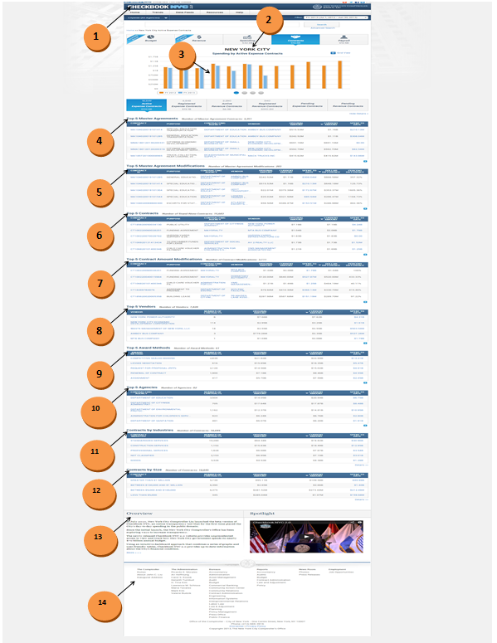

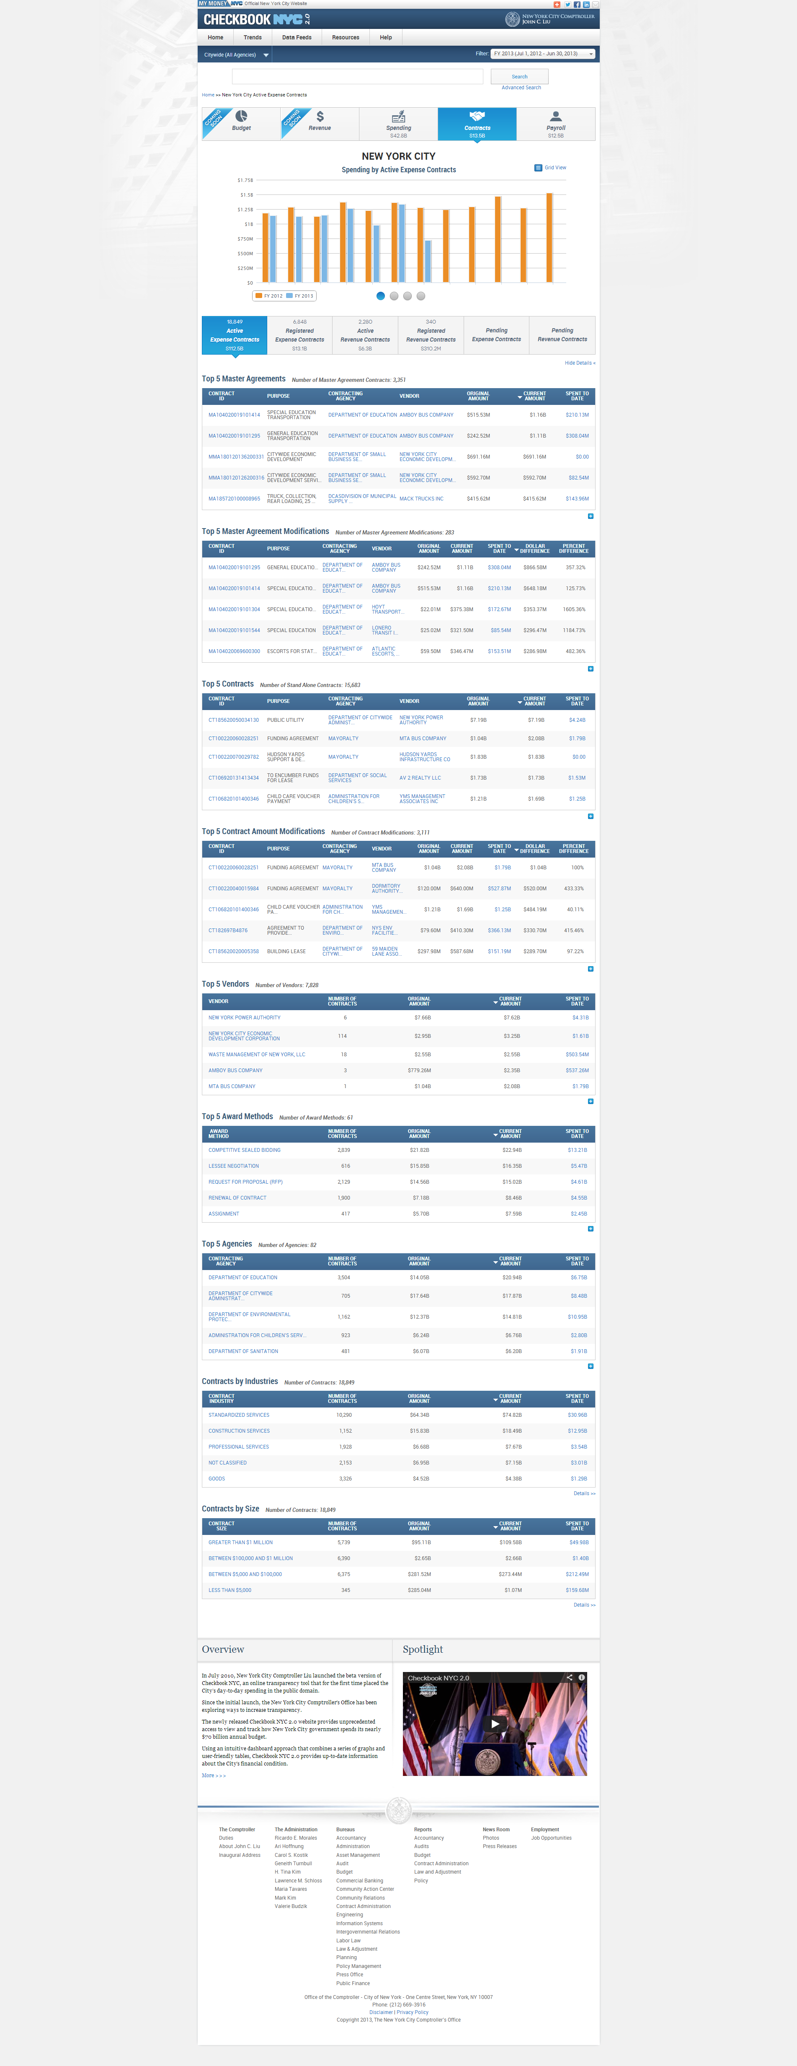

|  |  |  |  |
| --- | --- | --- | --- |
| **ID** | **KEY** | **FEATURE** | **DESCRIPTION** |
| **1.0** |  | **Header** | * The header includes all components above the top menu bar. It should include NYC 2.0 logo, Comptroller logo, my money site logo, social media links like add this, twitter, Facebook, LinkedIn and also includes email option. All these should be hyperlinked including logos. |

|  |  |  |  |
| --- | --- | --- | --- |
| **ID** | **KEY** | **FEATURE** | **DESCRIPTION** |
| **1.1** |  | **Definition of Active Status** | * The system shall consider a contract active on a particular year by considering its Period of Performance (POP) start date and Period of Performance end date. The following provides a clear explanation:   *Current Fiscal Year (FY2013)*   * The start date for all active contracts shall meet one of the following: * equal to 7/1/2012 * earlier than 7/1/2012 * equal to OR earlier than 11/2/2012 (Current Date) * The end date for all active contracts shall meet one of the following: * later than 6/30/2011 * The following table are examples of active and inactive contracts for the current fiscal year:     *Previous Fiscal Year (ex. FY2010)*   * The start date for all active contracts shall meet one of the following: * equal to 7/1/2010 * earlier than 7/1/2010 * equal to OR earlier than 6/30/2011 * The end date for all active contracts shall meet one of the following: * later than 6/30/2010 * The following table are examples of active and inactive contracts for fiscal year 2010: |

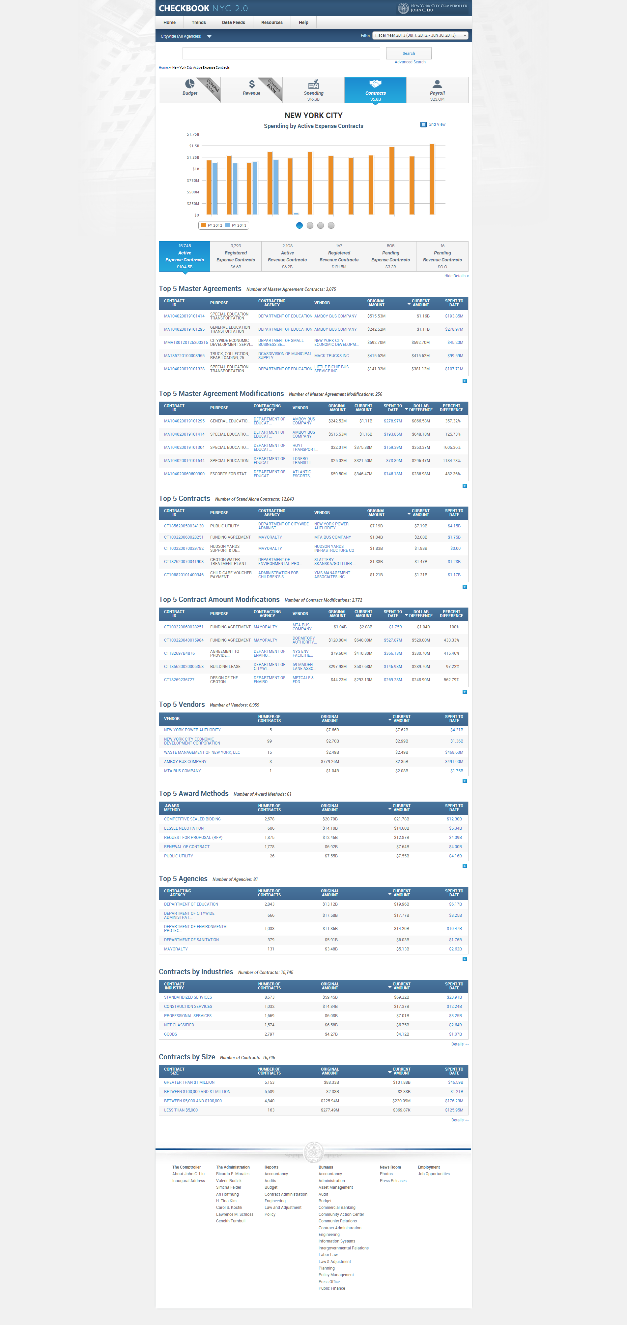

|  |  |  |  |
| --- | --- | --- | --- |
| **ID** | **KEY** | **FEATURE** | **DESCRIPTION** |
| **1.2** |  | **Titles Rule** | * The system shall display the page titles of all contracts pages in CAPS. For example, ‘NEW YORK CITY’. |

|  |  |  |  |  |
| --- | --- | --- | --- | --- |
| **ID** | **KEY** | **FEATURE** | **DESCRIPTION** | |
| **1.3** |  | **Contract Version Rule** | * The system shall only display the latest version of all contracts of the selected FY/CY in all contracts pages (except the Contracts details page). * The system shall display all versions of contracts for Pending contracts in widgets, visualizations and transaction pages. * The system shall display all versions of contracts for only two visualizations in pending contracts, Top Ten Agencies and Top Ten Vendors. |



|  |  |  |  |  |  |  |
| --- | --- | --- | --- | --- | --- | --- |
| **ID** | | **KEY** | **FEATURE** | | **DESCRIPTION** | |
| **1.4** |  | **Monthly graph (Selected current FY/CY vs. Previous FY/CY; includes CTA1, CT1, and MA1)** | * The system shall display a monthly bar graph of contracts spending comparing previous year to selected year. * Title: Spending by [Contract Status] [Contract Type] Contracts *eg.* Spending by Active Expense Contracts * Legend: * Previous Year * Current Year * Bar Colors:   - Previous Year (Cadmium Orange [#ED872D])  - Selected Year (Celestial Blue [#4997D0])   * The x-axis scaling: N/A * The y-axis scaling: dollar amounts (Highcharts/Highstocks library shall determine scale unit). * This graph is not applicable for pending contracts. | |

|  |  |  |  |  |  |  |
| --- | --- | --- | --- | --- | --- | --- |
| **ID** | | **KEY** | **FEATURE** | | **DESCRIPTION** | |
| **1.5** |  | **Top 10 Agencies (By Current Amount; includes CT1, CTA1, and MA1)** | The system shall display a ranking bar graph of the top 10 agencies rated by their total contracts current amount.   * Title: Top Ten Agencies by [Contract Status] [Contract Type] Contracts *eg.* Top Ten Agencies by Active Expense Contracts * No legend shall be applicable for this graph. * Bar Color:   (Celestial Blue [#4997D0])   * The x-axis scaling: N/A * The y-axis scaling: dollar amounts (Highcharts/Highstocks library shall determine scale unit). * Pending Contract Rules: * The system shall display contract types MMA1, MA1, CTA1, and CT1 along with the updated contract types CTR’s and MAR’s. * The system shall use the same formula for calculating dollar amount in the bottom navigation to display amount in this visualization. The dollar amount and the number of contracts displayed in the visualization should match with the bottom navigation numbers. ALL versions shall be considered. | |

|  |  |  |  |  |  |  |
| --- | --- | --- | --- | --- | --- | --- |
| **ID** | | **KEY** | **FEATURE** | | **DESCRIPTION** | |
| **1.6** |  | **Top 10 Contracts (By Current Amount; includes CT1, CTA1, and MA1)** | * The system shall display a ranking bar visualization of the top 10 contracts rated by their current amount. * Title: Top Ten [Contract Status] [Contract Type] Contracts by Current Amount *eg.* Top Ten Active Expense Contracts by Current Amount * No legend shall be applicable for this graph. * Bar Color:   (Celestial Blue [#4997D0])   * The x-axis scaling: N/A * The y-axis scaling: dollar amounts (Highcharts/Highstocks library shall determine scale unit). * Pending Contract Rules: * The system shall display contract types MMA1, MA1, CTA1 and CT1 along with the updated contract types CTR’s and MAR’s. Only the latest version shall be considered. | |

|  |  |  |  |  |  |  |
| --- | --- | --- | --- | --- | --- | --- |
| **ID** | | **KEY** | **FEATURE** | | **DESCRIPTION** | |
| **1.7** |  | **Top 10 Vendors (By Current Amount; includes CT1, CTA1, and MA1)** | The system shall display a ranking bar graph of the top 10 vendors rated by their total contracts current amount.   * Title: Top Ten Vendors by [Contract Status] [Contract Type] Contracts *eg.* Top Ten Vendors by Active Expense Contracts * No legend shall be applicable for this graph. * Bar Color:   (Celestial Blue [#4997D0])   * The x-axis scaling: N/A * The y-axis scaling: dollar amounts (Highcharts/Highstocks library shall determine scale unit). * Pending Contract Rules: * The system shall display contract types MMA1, MA1, CTA1, and CT1 along with the updated contract types CTR’s and MAR’s. * The system shall use the same formula for calculating dollar amount in the bottom navigation to display amount in this visualization. The dollar amount and the number of contracts displayed in the visualization should match with the bottom navigation numbers. All versions shall be considered. | |



|  |  |  |  |  |  |
| --- | --- | --- | --- | --- | --- |
| **ID** | **KEY** | **FEATURE** | | **DESCRIPTION** | |
| **1.8** |  | **Top 5 Master Agreements widget (Not applicable for Revenue Contracts)** | * The system shall only consider MMA1 and MA1 contract types the widget. * The system shall align the last column on the right of each widget roughly right to the left side of the ‘+’ indicator at the bottom of the widget. * The system shall display the static content ‘Number of Master Agreement Contracts: x’ located on the right of the widget title. * The system shall display the table headings and the static content in sentence case. The number in the static content shall contain commas when necessary. * Widget Alignment: * The system, by default, shall sort the numbers in descending order, i.e, highest on the top and lowest on the bottom. The text, by default shall be sorted in alphabetical order, i.e,A-Z. * The system shall break the text in the column headings into 2 lines, if it is more than 1 word. If it is 3 or more words, then the characters shall be balanced in 2 lines, prioritizing the first line. The second line shall be in the center of the first line. * The system shall align the first line of the text-column heading to the left, with second line centered. * The system shall center-align the number-column headings. * The system shall align the numbers in the widgets to the right, but centered in the column. * The system shall align the text in the widgets to the left within the data rows. * The system shall display the table row text in up to 2 lines. If there is more text than that it shall be truncated by ellipses. * The system shall align the columns to be roughly equidistant from one other. * The system shall display the title ‘Top Master Agreements’ if the widget displays less than 5 contracts. * Pending Contract Rules: * The system shall display contract types MMA1, MA1, CTA1, and CT1 along with the updated contract types CTR’s and MAR’s. * The system shall display all versions of contracts. All contracts must be hyperlinked and lead to contract ID details page. * The system shall display only general information and vendor information contents for new pending contract ID page. * The system shall display the new contract as pending contract under the associated contracts section, part of contract history widget , if the contract is new and the parent contract is available in oasis file. * The system shall hyperlink the modified contracts to the existing parent contract ID details page. The contract modification will be seen as a pending contract in the contract history section of the detailed page. | |



|  |  |  |  |  |  |
| --- | --- | --- | --- | --- | --- |
| **ID** | **KEY** | **FEATURE** | **DESCRIPTION** | | |
| **1.9** |  | **Top 5 Master Agreement Modifications widget (Not applicable for Revenue Contracts)** | | * The system shall only consider MMA1 and MA1 contract types the widget. * Dollar Difference = Current Amount – Original Amount * Percent Difference = 100 * [(Current Amount - Original Amount)/Original Amount] * The system shall align the last column on the right of each widget roughly right to the left side of the ‘+’ indicator at the bottom of the widget. * The system shall display the static content ‘Number of Master Agreement Modifications: x’ located on the right of the widget title. * The system shall display the table headings and the static content in sentence case. The number in the static content shall contain commas when necessary. * Widget Alignment: * The system, by default, shall sort the numbers in descending order, i.e,highest on the top and lowest on the bottom. The text, by default shall be sorted in alphabetical order, i.e,A-Z. * The system shall break the text in the column headings into 2 lines, if it is more than 1 word. If it is 3 or more words, then the characters shall be balanced in 2 lines, prioritizing the first line. The second line shall be in the center of the first line. * The system shall align the first line of the text-column heading to the left, with second line centered. * The system shall center-align the number-column headings. * The system shall align the numbers in the widgets to the right, but centered in the column. * The system shall align the text in the widgets to the left within the data rows. * The system shall display the table row text in up to 2 lines. If there is more text than that it shall be truncated by ellipses. * The system shall align the columns to be roughly equidistant from one other. * The system shall display the title ‘Top Master Agreement Modifications’ if the widget displays less than 5 contracts. * Pending Contract Rules: * The system shall display contract types MMA1, MA1, CTA1 and CT1 along with the updated contract types CTR’s and MAR’s. * The system shall display all versions of contracts. All contracts must be hyperlinked and lead to contract ID details page. * The system shall display only general information and vendor information contents for new pending contract ID page. * The system shall display the new contract as pending contract under the associated contracts section, part of contract history widget , if the contract is new and the parent contract is available in oasis file. * The system shall hyperlink the modified contracts to the existing parent contract ID details page. The contract modification will be seen as a pending contract in the contract history section of the detailed page. |



|  |  |  |  |  |
| --- | --- | --- | --- | --- |
| **ID** | **KEY** | **FEATURE** | **DESCRIPTION** | |
| **1.10** |  | **Top 5 Contracts widget** | * The system shall only consider CTA1 and CT1 contract types the widget for expense contracts landing pages. Only the RCT contract type shall be considered in the widget for revenue contracts landing pages. * The system shall align the last column on the right of each widget roughly right to the left side of the ‘+’ indicator at the bottom of the widget. * The system shall display the static content ‘Number of Stand Alone Contracts: x’ located on the right of the widget title. * The system shall display the table headings and the static content in sentence case. The number in the static content shall contain commas when necessary. * Widget Alignment: * The system, by default, shall sort the numbers in descending order, i.e, highest on the top and lowest on the bottom. The text, by default shall be sorted in alphabetical order, i.e,A-Z. * The system shall break the text in the column headings into 2 lines, if it is more than 1 word. If it is 3 or more words, then the characters shall be balanced in 2 lines, prioritizing the first line. The second line shall be in the center of the first line. * The system shall align the first line of the text-column heading to the left, with second line centered. * The system shall center-align the number-column headings. * The system shall align the numbers in the widgets to the right, but centered in the column. * The system shall align the text in the widgets to the left within the data rows. * The system shall display the table row text in up to 2 lines. If there is more text than that it shall be truncated by ellipses. * The system shall align the columns to be roughly equidistant from one other. * The system shall display the title ‘Top Contracts’ if the widget displays less than 5 contracts. * Pending Contract Rules: * The system shall display contract types MMA1, MA1, CTA1, and CT1 along with the updated contract types CTR’s and MAR’s. * The system shall display all versions of contracts. All contracts must be hyperlinked and lead to contract ID details page. * The system shall display only general information and vendor information contents for new pending contract ID page. * The system shall display the new contract as pending contract under the associated contracts section, part of contract history widget , if the contract is new and the parent contract is available in oasis file. * The system shall hyperlink the modified contracts to the existing parent contract ID details page. The contract modification will be seen as a pending contract in the contract history section of the detailed page. |



|  |  |  |  |  |
| --- | --- | --- | --- | --- |
| **ID** | **KEY** | **FEATURE** | **DESCRIPTION** | |
| **1.11** |  | **Top 5 Contract Amount Modifications widget** | * The system shall only consider CTA1 and CT1 contract types the widget for expense contracts landing pages. Only the RCT contract type shall be considered in the widget for revenue contracts landing pages. * Dollar Difference = Current Amount – Original Amount * Percent Difference = 100 * [(Current Amount - Original Amount)/Original Amount] * The system shall align the last column on the right of each widget roughly right to the left side of the ‘+’ indicator at the bottom of the widget. * The system shall display the static content ‘Number of Contract Modifications: x’ located on the right of the widget title. * The system shall display the table headings and the static content in sentence case. The number in the static content shall contain commas when necessary. * Widget Alignment: * The system, by default, shall sort the numbers in descending order, i.e, highest on the top and lowest on the bottom. The text, by default shall be sorted in alphabetical order, i.e,A-Z. * The system shall break the text in the column headings into 2 lines, if it is more than 1 word. If it is 3 or more words, then the characters shall be balanced in 2 lines, prioritizing the first line. The second line shall be in the center of the first line. * The system shall align the first line of the text-column heading to the left, with second line centered. * The system shall center-align the number-column headings. * The system shall align the numbers in the widgets to the right, but centered in the column. * The system shall align the text in the widgets to the left within the data rows. * The system shall display the table row text in up to 2 lines. If there is more text than that it shall be truncated by ellipses. * The system shall align the columns to be roughly equidistant from one other. * The system shall display the title ‘Top Contract Amount Modifications’ if the widget displays less than 5 contracts. * Pending Contract Rules: * The system shall display contract types MMA1, MA1, CTA1, and CT1 along with the updated contract types CTR’s and MAR’s. * The system shall display all versions of contracts. All contracts must be hyperlinked and lead to contract ID details page. * The system shall display only general information and vendor information contents for new pending contract ID page. * The system shall display the new contract as pending contract under the associated contracts section, part of contract history widget , if the contract is new and the parent contract is available in oasis file. * The system shall hyperlink the modified contracts to the existing parent contract ID details page. The contract modification will be seen as a pending contract in the contract history section of the detailed page. |



|  |  |  |  |  |
| --- | --- | --- | --- | --- |
| **ID** | **KEY** | **FEATURE** | **DESCRIPTION** | |
| **1.12** |  | **Top 5 Vendors widget** | * The system shall only consider MA1, CTA1, and CT1 contract types the widget for expense contracts landing pages. Only the RCT contract type shall be considered in the widget for revenue contracts landing pages. * The Original Amount is the aggregate of the original amount for all the contracts that have been assigned to the selected vendor and that are active/registered/pending during the selected FY/CY. * The system shall align the last column on the right of each widget roughly right to the left side of the ‘+’ indicator at the bottom of the widget. * The system shall display the static content ‘Number of Vendors: x’ located on the right of the widget title. * The system shall display the table headings and the static content in sentence case. The number in the static content shall contain commas when necessary. * Widget Alignment: * The system, by default, shall sort the numbers in descending order, i.e,highest on the top and lowest on the bottom. The text, by default shall be sorted in alphabetical order, i.e,A-Z. * The system shall break the text in the column headings into 2 lines, if it is more than 1 word. If it is 3 or more words, then the characters shall be balanced in 2 lines, prioritizing the first line. The second line shall be in the center of the first line. * The system shall align the first line of the text-column heading to the left, with second line centered. * The system shall center-align the number-column headings. * The system shall align the numbers in the widgets to the right, but centered in the column. * The system shall align the text in the widgets to the left within the data rows. * The system shall display the table row text in up to 2 lines. If there is more text than that it shall be truncated by ellipses. * The system shall align the columns to be roughly equidistant from one other. * The system shall display the title ‘Top Vendors’ if the widget displays less than 5 contracts. * Pending Contract Rules: * The system shall display contract types MMA1, MA1, CTA1, and CT1 along with the updated contract types CTR’s and MAR’s. * The system shall display all versions of contracts. All contracts must be hyperlinked and lead to contract ID details page. * The system shall display only general information and vendor information contents for new pending contract ID page. * The system shall display the new contract as pending contract under the associated contracts section, part of contract history widget , if the contract is new and the parent contract is available in oasis file. * The system shall hyperlink the modified contracts to the existing parent contract ID details page. The contract modification will be seen as a pending contract in the contract history section of the detailed page. |



|  |  |  |  |  |  |
| --- | --- | --- | --- | --- | --- |
| **ID** | **KEY** | **FEATURE** | | **DESCRIPTION** | |
| **1.13** |  | **Top 5 Award Methods widget** | * The system shall only consider MA1, CTA1, and CT1 contract types the widget for expense contracts landing pages. Only the RCT contract type shall be considered in the widget for revenue contracts landing pages. * The Original Amount is the aggregate of the original amount for all the contracts that have been assigned to the selected award method and that are active/registered/pending during the selected FY/CY. * The system shall align the last column on the right of each widget roughly right to the left side of the ‘+’ indicator at the bottom of the widget. * The system shall display the static content ‘Number of Award Methods: x’ located on the right of the widget title. * The system shall display the table headings and the static content in sentence case. The number in the static content shall contain commas when necessary. * Widget Alignment: * The system, by default, shall sort the numbers in descending order, i.e,highest on the top and lowest on the bottom. The text, by default shall be sorted in alphabetical order, i.e,A-Z. * The system shall break the text in the column headings into 2 lines, if it is more than 1 word. If it is 3 or more words, then the characters shall be balanced in 2 lines, prioritizing the first line. The second line shall be in the center of the first line. * The system shall align the first line of the text-column heading to the left, with second line centered. * The system shall center-align the number-column headings. * The system shall align the numbers in the widgets to the right, but centered in the column. * The system shall align the text in the widgets to the left within the data rows. * The system shall display the table row text in up to 2 lines. If there is more text than that it shall be truncated by ellipses. * The system shall align the columns to be roughly equidistant from one other. * The system shall display the title ‘Top Award Methods’ if the widget displays less than 5 contracts. * Pending Contract Rules: * The system shall display contract types MMA1, MA1, CTA1, and CT1 along with the updated contract types CTR’s and MAR’s. * The system shall display all versions of contracts. All contracts must be hyperlinked and lead to contract ID details page. * The system shall display only general information and vendor information contents for new pending contract ID page. * The system shall display the new contract as pending contract under the associated contracts section, part of contract history widget , if the contract is new and the parent contract is available in oasis file. * The system shall hyperlink the modified contracts to the existing parent contract ID details page. The contract modification will be seen as a pending contract in the contract history section of the detailed page. | |



|  |  |  |  |  |
| --- | --- | --- | --- | --- |
| **ID** | **KEY** | **FEATURE** | **DESCRIPTION** | |
| **1.14** |  | **Top 5 Agencies widget** | * The system shall only consider MA1, CTA1, and CT1 contract types the widget for expense contracts landing pages. Only the RCT contract type shall be considered in the widget for revenue contracts landing pages. * The Original Amount is the aggregate of the original amount for all the contracts that have been assigned to the selected agency and that are active/registered/pending during the selected FY/CY. * The system shall align the last column on the right of each widget roughly right to the left side of the ‘+’ indicator at the bottom of the widget. * The system shall display the static content ‘Number of Agencies: x’ located on the right of the widget title. * The system shall display the table headings and the static content in sentence case. The number in the static content shall contain commas when necessary. * Widget Alignment: * The system, by default, shall sort the numbers in descending order, i.e,highest on the top and lowest on the bottom. The text, by default shall be sorted in alphabetical order, i.e,A-Z. * The system shall break the text in the column headings into 2 lines, if it is more than 1 word. If it is 3 or more words, then the characters shall be balanced in 2 lines, prioritizing the first line. The second line shall be in the center of the first line. * The system shall align the first line of the text-column heading to the left, with second line centered. * The system shall center-align the number-column headings. * The system shall align the numbers in the widgets to the right, but centered in the column. * The system shall align the text in the widgets to the left within the data rows. * The system shall display the table row text in up to 2 lines. If there is more text than that it shall be truncated by ellipses. * The system shall align the columns to be roughly equidistant from one other. * The system shall display the title ‘Top Agencies’ if the widget displays less than 5 contracts. * Pending Contract Rules: * The system shall display contract types MMA1, MA1, CTA1 and CT1 along with the updated contract types CTR’s and MAR’s. * The system shall display all versions of contracts. All contracts must be hyperlinked and lead to contract ID details page. * The system shall display only general information and vendor information contents for new pending contract ID page. * The system shall display the new contract as pending contract under the associated contracts section, part of contract history widget , if the contract is new and the parent contract is available in oasis file. * The system shall hyperlink the modified contracts to the existing parent contract ID details page. The contract modification will be seen as a pending contract in the contract history section of the detailed page. |



|  |  |  |  |  |
| --- | --- | --- | --- | --- |
| **ID** | **KEY** | **FEATURE** | **DESCRIPTION** | |
| **1.15** |  | **Contracts by Industries widget** | * The system shall only consider MA1, CTA1, and CT1 contract types the widget for expense contracts landing pages. Only the RCT contract type shall be considered in the widget for revenue contracts landing pages. * The Original Amount is the aggregate of the original amount for all the contracts that have been assigned to the selected industry and that are active/registered/pending during the selected FY/CY. * The system shall align the last column on the right of each widget roughly right to the left side of the ‘+’ indicator at the bottom of the widget. * The system shall display the static content ‘Number of Industries: x’ located on the right of the widget title. * The system shall display the table headings and the static content in sentence case. The number in the static content shall contain commas when necessary. * Widget Alignment: * The system, by default, shall sort the numbers in descending order, i.e,highest on the top and lowest on the bottom. The text, by default shall be sorted in alphabetical order, i.e,A-Z. * The system shall break the text in the column headings into 2 lines, if it is more than 1 word. If it is 3 or more words, then the characters shall be balanced in 2 lines, prioritizing the first line. The second line shall be in the center of the first line. * The system shall align the first line of the text-column heading to the left, with second line centered. * The system shall center-align the number-column headings. * The system shall align the numbers in the widgets to the right, but centered in the column. * The system shall align the text in the widgets to the left within the data rows. * The system shall display the table row text in up to 2 lines. If there is more text than that it shall be truncated by ellipses. * The system shall align the columns to be roughly equidistant from one other. * The system shall align the columns to be roughly equidistant from one other. * Pending Contract Rules: * The system shall display contract types MMA1, MA1, CTA1 and CT1 along with the updated contract types CTR’s and MAR’s. * The system shall display all versions of contracts. All contracts must be hyperlinked and lead to contract ID details page. * The system shall display only general information and vendor information contents for new pending contract ID page. * The system shall display the new contract as pending contract under the associated contracts section, part of contract history widget , if the contract is new and the parent contract is available in oasis file. * The system shall hyperlink the modified contracts to the existing parent contract ID details page. The contract modification will be seen as a pending contract in the contract history section of the detailed page. |



|  |  |  |  |  |  |
| --- | --- | --- | --- | --- | --- |
| **ID** | **KEY** | **FEATURE** | | **DESCRIPTION** | |
| **1.16** |  | **Contracts by Size widget** | * The system shall only consider MA1, CTA1, and CT1 contract types the widget for expense contracts landing pages. Only the RCT contract type shall be considered in the widget for revenue contracts landing pages. * The Original Amount is the aggregate of the original amount for all the contracts that have been assigned to the selected contract size and that are active/registered/pending during the selected FY/CY. * The system shall align the last column on the right of each widget roughly right to the left side of the ‘+’ indicator at the bottom of the widget. * The system shall display the static content ‘Number of Contracts: x’ located on the right of the widget title. * The system shall display the table headings and the static content in sentence case. The number in the static content shall contain commas when necessary. * Widget Alignment: * The system, by default, shall sort the numbers in descending order, i.e,highest on the top and lowest on the bottom. The text, by default shall be sorted in alphabetical order, i.e,A-Z. * The system shall break the text in the column headings into 2 lines, if it is more than 1 word. If it is 3 or more words, then the characters shall be balanced in 2 lines, prioritizing the first line. The second line shall be in the center of the first line. * The system shall align the first line of the text-column heading to the left, with second line centered. * The system shall center-align the number-column headings. * The system shall align the numbers in the widgets to the right, but centered in the column. * The system shall align the text in the widgets to the left within the data rows. * The system shall display the table row text in up to 2 lines. If there is more text than that it shall be truncated by ellipses. * The system shall align the columns to be roughly equidistant from one other. * Pending Contract Rules: * The system shall display contract types MMA1, MA1, CTA1 and CT1 along with the updated contract types CTR’s and MAR’s. * The system shall display all versions of contracts. All contracts must be hyperlinked and lead to contract ID details page. * The system shall display only general information and vendor information contents for new pending contract ID page. * The system shall display the new contract as pending contract under the associated contracts section, part of contract history widget , if the contract is new and the parent contract is available in oasis file. * The system shall hyperlink the modified contracts to the existing parent contract ID details page. The contract modification will be seen as a pending contract in the contract history section of the detailed page. | |

|  |  |  |  |  |  |
| --- | --- | --- | --- | --- | --- |
| **ID** | **KEY** | **FEATURE** | | **DESCRIPTION** | |
| **1.17** |  | **Top 5 Departments widget (Only applicable for agency specific contracts)** | * The system shall only consider MA1, CTA1, and CT1 contract types the widget for expense contracts landing pages. Only the RCT contract type shall be considered in the widget for revenue contracts landing pages. * The system shall not display the contracting agency in the widget. Therefore, the header name must be ‘AGENCY NAME’. * The Original Amount is the aggregate of the original amount for all the contracts that have been assigned to the selected department and that are active/registered/pending during the selected FY/CY. * The system shall not present the Spent to Date (RFED) values as links. * The system shall align the last column on the right of each widget roughly right to the left side of the ‘+’ indicator at the bottom of the widget. * The system shall display the static content ‘Number of Departments: x’ located on the right of the widget title. * The system shall display the table headings and the static content in sentence case. The number in the static content shall contain commas when necessary. * Widget Alignment: * The system, by default, shall sort the numbers in descending order, i.e,highest on the top and lowest on the bottom. The text, by default shall be sorted in alphabetical order, i.e,A-Z. * The system shall break the text in the column headings into 2 lines, if it is more than 1 word. If it is 3 or more words, then the characters shall be balanced in 2 lines, prioritizing the first line. The second line shall be in the center of the first line. * The system shall align the first line of the text-column heading to the left, with second line centered. * The system shall center-align the number-column headings. * The system shall align the numbers in the widgets to the right, but centered in the column. * The system shall align the text in the widgets to the left within the data rows. * The system shall display the table row text in up to 2 lines. If there is more text than that it shall be truncated by ellipses. * The system shall align the columns to be roughly equidistant from one other. * The system shall display the title ‘Top Departments’ if the widget displays less than 5 contracts. * Pending Contract Rules: * The system shall display contract types MMA1, MA1, CTA1 and CT1 along with the updated contract types CTR’s and MAR’s. * The system shall display all versions of contracts. All contracts must be hyperlinked and lead to contract ID details page. * The system shall display only general information and vendor information contents for new pending contract ID page. * The system shall display the new contract as pending contract under the associated contracts section, part of contract history widget , if the contract is new and the parent contract is available in oasis file. * The system shall hyperlink the modified contracts to the existing parent contract ID details page. The contract modification will be seen as a pending contract in the contract history section of the detailed page. | |



|  |  |  |  |  |  |  |
| --- | --- | --- | --- | --- | --- | --- |
| **ID** | | **KEY** | **FEATURE** | | **DESCRIPTION** | |
| **1.18** |  | **Media Box** | * The system shall display an Overview section which provides the purpose of the application and a brief description of the information presented. * The system shall display a YouTube video under the Spotlight section; the video shall introduce the application to the viewers. | |

Contracts Landing – Functional Requirements

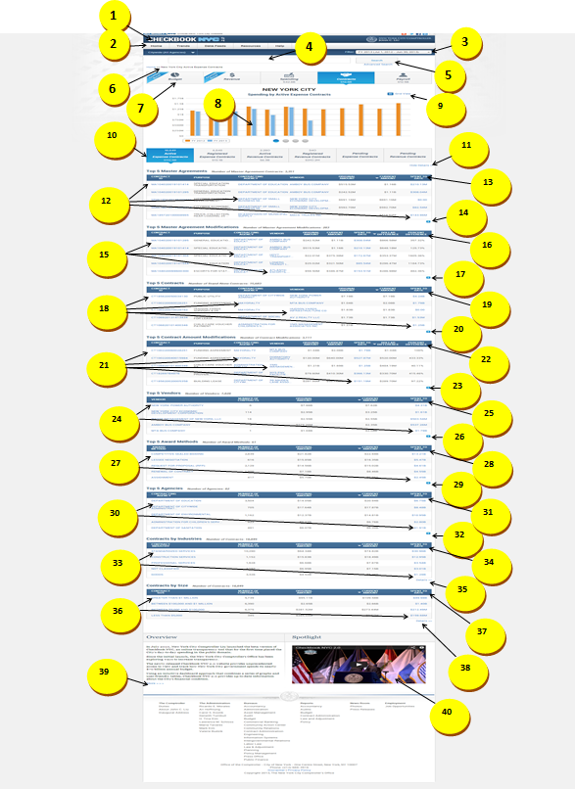



|  |  |  |  |
| --- | --- | --- | --- |
| **ID** | **KEY** | **FEATURE** | **DESCRIPTION** |
| **1.19** |  | **Top Menu Bar** | * + - The system shall present tabs at the top menus bar in the following order: Home, Trends, Data Feeds, Resources, and Help.     - The system shall not contain dropdowns for the Home and Data Feeds tabs.     - The system shall present the dropdown for Trends in the following order: Featured Trends, All Trends, Financial, Revenue Capacity, Debt Capacity, Demographic, and Operational. * Each of the additional trends: Financial, Revenue Capacity, Debt Capacity, Demographic, Operational -have additional groupings of trends, which are opened in the menu call out. * The system shall contain following dropdowns for help tab-Site Navigation & Glossary, FAQ, Ask a Question, Report a Problem and Share an idea. * Site Navigation & Glossary shall display information for three domains: Contracts, Payroll and Spending. Within contracts domain, agencies list with codes is embedded to be downloaded. |



|  |  |  |  |  |  |
| --- | --- | --- | --- | --- | --- |
| **ID** | | **KEY** | **FEATURE** | **DESCRIPTION** | |
| **1.20** |  | | **Citywide Filter** | * The system shall direct the user to an agency specific landing page if user clicks on any particular agency from the dropdown list. By default, citywide agencies filter shall be preselected. * Once user selects an agency, the top navigation numbers will also update that agency level for the selected year. |



|  |  |  |  |  |
| --- | --- | --- | --- | --- |
| **ID** | **KEY** | **FEATURE** | **DESCRIPTION** | |
| **1.21** |  | **Date Filter** | * The system shall allow the user to select a particular fiscal year or calendar year. Contracts data, by default, shall display current fiscal year. * When the user navigates through other domains, the date filter shall not carry forward to the other domains. It always defaults to current fiscal year. * The system shall have Budget, Revenue domains not clickable and amount will update to zero dollars when user selects calendar year. Only Spending, Contracts and Payroll domains shall update based on calendar year. * The system shall always default to current fiscal year for pending contracts. |



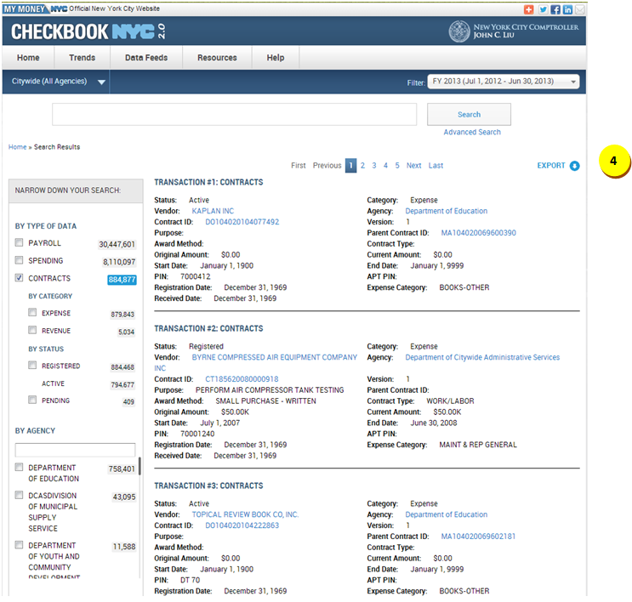

|  |  |  |  |  |
| --- | --- | --- | --- | --- |
| **ID** | **KEY** | **FEATURE** | **DESCRIPTION** | |
| **1.22** |  | **Smart Search** | * + - The system shall place the Smart Search box below Citywide and Date Filter navigation and above top navigation.     - The smart search box will have “Type Ahead Search”.     - The system shall support ALL string searches.     - The system shall not present the top navigation upon smart search results.     - The system shall present the citywide filter and Date filter in the smart search results. * The system shall direct the user to NYC Spending page for current FY or the selected FY upon clicking date filter. * The system shall display all resulting fields in two lines with hover over functionality * The system shall present export functionality in smart search. * The resulting field names for contracts domain are Status, Category, vendor, Agency, Contract ID, Version, Purpose, Parent Contract ID, Award Method, Contract type, Original Amount, Current Amount, Start Date, end Date, Pin , Apt pin, Registration date, Expense Category and Received Date. Only Agency, Vendor, Contract Id and Parent Contract ID shall be hyperlinked. * The narrow-down facet selections are By Type of Data, By Agency, By Vendor, By Expense Category, and By Fiscal Year. * Upon selecting contracts domain under type of data, the category and status sub-categories shall be displayed. Under category, expense and revenue shall be displayed and under status active, registered and pending shall be displayed. The items under the sub-category will not be selected by default. |



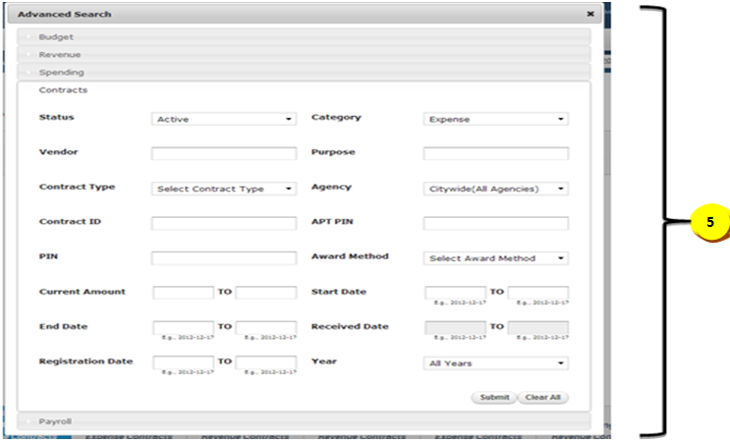

|  |  |  |  |  |
| --- | --- | --- | --- | --- |
| **ID** | **KEY** | **FEATURE** | **DESCRIPTION** | |
| **1.23** |  | **Advanced Search** | * The system shall allow the advanced search to search for specific contracts transactions based on criteria(s), including ‘Contract Type' and 'Contract ID'. Different tabs within the advanced search pop-up shall allow the user to search in different domains. * The system shall present the following search criteria with the dropdown functionality:   + Status   + Contract Type   + Category   + Agency   + Award Method   + Year * The system shall present the following search criteria with the text-box functionality:   + Current Amount   + Purpose * The system shall present the following search criteria with the text-box autocomplete functionality:   + Vendor   + Contract ID   + PIN   + APT PIN * The system shall present the following search criteria with the calendar functionality:   + End Date   + Registration Date   + Start Date   + Received Date * The system shall present an ‘All Fiscal Years’ option to the Years category. * The system shall display the pre-selected filters by default. The pre-selected filters are active status, expense category, citywide agencies and all years. * The system shall display data for all autocomplete fields based on dropdown fields: Status, Category, Contract type, Agency, Award Method and Year. * The system shall have the registration date and year disabled for pending contracts and received date disabled for active and registered contracts. * The system shall display top navigation bar, with Contracts domain highlighted in advanced search results page. * For pending contracts, year and registration date fields are not applicable. By default, the advanced search will open up spending domain. The results page shall also have the top navigation bar updated based on agency/vendor/year selected from the advanced search form. * The system shall support narrow-down functionality for the advanced search. For instance, if a specific agency is selected from the ‘AGENCY’ criteria then the autocomplete options will only be applicable for the selected agency. * The system shall perform **“exact”** functionality when user selects any result from the dropdown autocomplete list and that search term shall be pre-selected within the narrow down facet if applicable. * The system shall perform **“like”** functionality when user enters search term within text box and clicks submit button. The search term shall not be pre-selected within the narrow down facet. |



|  |  |  |  |  |  |
| --- | --- | --- | --- | --- | --- |
| **ID** | **KEY** | **FEATURE** | | **DESCRIPTION** | |
| **1.24** |  | **Breadcrumbs** | * The system shall present breadcrumbs which consist of a maximum of eight elements. * Upon initial visit to the application, the first element shall be ‘Home’.  The titles of the breadcrumb elements shall be specific.  The breadcrumbs shall essentially present a historical path of navigation.  Below is an example:   Home > New York City Active Expense Contracts > Department of Defense Active Expense Contracts > Department of Defense Active Expense Contracts Transactions > Active Expense Contracts Greater than $1M > Standardized Services Active Expense Contracts > Active Expense Master Agreements Transactions > CTA1290583294   * Once the user visits the ninth page, the eighth element shall disappear, and shall be replaced by a new element. Only the eighth element will update. * No short names to be used in breadcrumbs. Placement of the breadcrumbs will be above the visualization to the left. | |



|  |  |  |  |  |  |
| --- | --- | --- | --- | --- | --- |
| **ID** | **KEY** | **FEATURE** | | **DESCRIPTION** | |
| **1.25** |  | **Top Navigation** | * The system shall display the sum of the current amounts of all MA1, CT1, RCT1, and CTA1 Registered Expense Contracts for the selected FY/CY on the 'Contracts' button. The amount must have 1 decimal digit. * The user shall be able to navigate from one domain to another by clicking on the desired domain button. * Upon changing domains, the data will be displayed based on current fiscal year. * The system shall present a top navigation with the following categories in order: Revenue, Budget, Spending, Contracts, and Payroll. * The system shall display on each box the Icon, Title of the Domain, and the Number in a 3-line format. * The system shall update at NYC, Agency, and Vendor level. As vendor is not applicable to Budget, Revenue, and Payroll domains, the numbers shall update to zero dollars and not clickable. The user shall be able to view these domains by clicking on home/agency. | |



|  |  |  |  |  |  |  |
| --- | --- | --- | --- | --- | --- | --- |
| **ID** | | **KEY** | **FEATURE** | | **DESCRIPTION** | |
| **1.26** |  | **Monthly graph (Selected current FY/CY vs Previous FY/CY; includes CTA1, CT1, and MA1)** | * The system shall direct the user to the spending transaction upon clicking any bar. Top slider, bottom slider, and visualization shall remain constant. The contents below the bottom slider shall be refreshed to appropriate transactions table. All records in the resulting transaction table shall have issue date in the selected month (from bar graph). The records shall also have ‘contracts’ for the Expense Type column. The summation of the check amounts shall be equal to the respective amounts in the graph tooltip. Only the bottom half of the page shall refresh. * The system shall tooltip with the following information upon hovering over a bar: * ‘Month: [selected month]’ * ‘Amount: [$amount]’ | |

|  |  |  |  |  |  |  |
| --- | --- | --- | --- | --- | --- | --- |
| **ID** | | **KEY** | **FEATURE** | | **DESCRIPTION** | |
| **1.27** |  | **Top 10 Agencies (By Current Amount; includes CT1, CTA1, and MA1)** | * The system shall direct the user to agency specific contracts landing page upon clicking any bar. * The system shall tooltip with the following information upon hovering over a bar: * Agency: [selected agency] * Number of Contracts: [count] * Amount: [$amount] | |

|  |  |  |  |  |  |  |
| --- | --- | --- | --- | --- | --- | --- |
| **ID** | | **KEY** | **FEATURE** | | **DESCRIPTION** | |
| **1.28** |  | **Top 10 Contracts (By Current Amount; includes CT1, CTA1, and MA1)** | * The system shall direct the user to contracts details page upon clicking any bar. Only the bottom half of the page shall refresh. * The system shall tooltip with the following information upon hovering over a bar: * Contract ID: [selected contract ID] * Vendor: [vendor name] * Agency: [agency name] * Amount: [$amount] | |

|  |  |  |  |  |  |  |
| --- | --- | --- | --- | --- | --- | --- |
| **ID** | | **KEY** | **FEATURE** | | **DESCRIPTION** | |
| **1.29** |  | **Top 10 Vendors (By Current Amount; includes CT1, CTA1, and MA1)** | * The system shall direct the user to vendor specific contracts landing page upon clicking any bar. * The system shall tooltip with the following information upon hovering over a bar: * Vendor: [selected vendor name] * Number of Contracts: [count] * Amount: [$amount] | |



|  |  |  |  |  |  |  |
| --- | --- | --- | --- | --- | --- | --- |
| **ID** | | **KEY** | **FEATURE** | | **DESCRIPTION** | |
| **1.30** |  | | **Grid View** | * The system shall allow the Grid View to display the information on the graphical visualization as numeric data in a table format within a new browser window. (A new browser window shall display the information)   + - The system shall present the title of the Grid View in upper case, for example NEW YORK CITY, DEPARTMENT OF SANITATION. * The second and third lines underneath shall be in sentence case.   + - The system shall present sorting arrows with rules consistent to those of the widgets (see sorting arrows details listed under, ‘Widgets’).     - The system shall maintain the 2-line standardization and alignment rules described under “Widgets” section of this documentation.     - The system shall support up to 2 decimal places for numbers in the table rows.     - The system shall present Print and Export functionalities for the Grid View. | |



|  |  |  |  |  |  |
| --- | --- | --- | --- | --- | --- |
| **ID** | **KEY** | **FEATURE** | | **DESCRIPTION** | |
| **1.31** |  | **Bottom Navigation** | * + The system shall support the following rules for Active Expense Contracts: * Dollar value displayed under the title shall be the Current Amount sum of all MA1, CTA1, and CT1 contracts active in the selected FY/CY. The amount shall have 1 decimal digit. * Number displayed above the title shall be the count of all MA1, CTA1, and CT1 contracts active in the selected FY/CY.   + The system shall support the following rules for Registered Expense Contracts: * Dollar value displayed under the title shall be the Current Amount sum of all MA1, CTA1, and CT1 contracts registered in the selected FY/CY. The amount shall have 1 decimal digit. * Number displayed above the title shall be the count of all MA1, CTA1, and CT1 contracts registered in the selected FY/CY.   + The system shall support the following rules for Active Revenue Contracts: * Dollar value displayed under the title shall be the Current Amount sum of all RCT1 contracts active in the selected FY/CY. The amount shall have 1 decimal digit. * Number displayed above the title shall be the count of all RCT1 contracts active in the selected FY/CY.   + The system shall support the following rules for Registered Revenue Contracts: * Dollar value displayed under the title shall be the Current Amount sum of all RCT1 contracts registered in the selected FY/CY. The amount shall have 1 decimal digit. * Number displayed above the title shall be the count of all RCT1 contracts registered in the selected FY/CY.   + The system shall support the following rules for Pending Expense Contracts:     - Dollar value displayed under the title is the current amount   for all contracts that are flagged as NEW + (PLUS) (Current amount for latest version of the pending contracts – (MINUS) Current amount for latest version of registered contracts). The amount must have 1 decimal digit.   * Number displayed above the title shall be sum of Number of MAG (from Top 5 MAG contracts) + (PLUS) Number of Contracts (from Top 5 contracts widget).   + The system shall support the following rules for Pending Revenue Contracts:     - Dollar value displayed under the title is the current amount   for all contracts that are flagged as NEW + (PLUS) (Current amount for latest version of the pending contracts – (MINUS) Current amount for latest version of registered contracts). The amount must have 1 decimal digit.   * Number displayed above the title shall be sum of Number of MAG (from Top 5 MAG contracts) + (PLUS) Number of Contracts (from Top 5 contracts widget).   + The system shall present a blue triangle pointer pointed to the selected Bottom Navigation icon.   + The system shall update the values within each button according to the drilldown.   + The system shall update the values based on agency, vendor, award method, industry and size. | |



|  |  |  |  |  |
| --- | --- | --- | --- | --- |
| **ID** | **KEY** | **FEATURE** | **DESCRIPTION** | |
| **1.32** |  | **Show Details link** | * The system shall collapse all contents below the bottom navigation slider upon initial visit to the spending page. Clicking on the 'Show Details' link shall expand the page and display all contents and widgets below the bottom navigation slider. The contents shall not be collapsed again, unless user clicks on 'Hide Details'. |



|  |  |  |  |  |  |
| --- | --- | --- | --- | --- | --- |
| **ID** | **KEY** | **FEATURE** | | **DESCRIPTION** | |
| **1.33** |  | **Top 5 Master Agreements widget hyperlinks** | * The system shall refresh the contents below the ‘Hide Details’ link into the contract details page upon clicking on a contract ID link. The contract details page shall display all historical information of the selected contract. * The system shall direct the user to agency specific contracts landing page upon clicking on an agency name link. The agencies displayed in the widget shall only be contracting agencies. * The system shall direct the user to vendor specific contracts landing page upon clicking on a vendor name link. * The system shall present a new browser window with the spending transactions relevant to the selected master agreement upon clicking on the Spent to Date (RFED) value link. However, the aggregate of all the line item disbursement records in the transactions table shall not match the associated RFED value (NYC Comptroller’s Office has verified this mismatch as a non-discrepancy). The title of the transactions table shall be ‘Master Agreement Spending Transactions’. The contents of the selected row of the widget shall carry over to the new browser window as summary static contents located above the transactions table. | |



|  |  |  |  |  |  |
| --- | --- | --- | --- | --- | --- |
| **ID** | **KEY** | **FEATURE** | | **DESCRIPTION** | |
| **1.34** |  | **Top 5 Master Agreements widget sorting** | * The system shall, on default, sort the widget by the ‘CURRENT AMOUNT’ column. Upon initial visit to the page, the arrow shall appear next to the default-sorted header. If a user hovers over a sortable header, the header shall be underlined. If the user clicks on a header (NOT the default-sorted header), then the arrow which was on the default-sorted header shall disappear and an arrow shall appear on the clicked on header. The direction of the pointing arrow shall change for ascending and descending sorting. | |



|  |  |  |  |  |  |
| --- | --- | --- | --- | --- | --- |
| **ID** | **KEY** | **FEATURE** | | **DESCRIPTION** | |
| **1.35** |  | **Top 5 Master Agreements widget ‘+’ / ‘-‘ and ‘Details’** | * The system shall expand the widget to display a maximum of 150 rows of record upon clicking on ‘+’. When expanded, the ‘+’ symbol shall transform to the ‘-‘ symbol and a ‘Details’ link shall appear next to the ‘-‘ symbol; clicking on ‘-‘ shall collapse the widget to its original size. This functionality shall be applicable for all widgets in the contracts landing pages. Clicking on ‘Details’ link shall refresh the contents below the ‘Hide Details’ link into the contracts transactions page. The transactions table shall display only master agreement records with a ‘+’ button located immediately left of the agreement ID. Clicking on the ‘+’ button shall expand the selected row to present all associated children contracts below the agreement. If a master agreement possesses more than 4 associated children contracts, then a scroll bar shall appear on the expanded row for the user to maneuver and view all the children contracts. The title of the transactions table shall be ‘Top Master Agreements [Contract Status] [Contract Type] Contracts Transactions’. | |



|  |  |  |  |  |
| --- | --- | --- | --- | --- |
| **ID** | **KEY** | **FEATURE** | **DESCRIPTION** | |
| **1.36** |  | **Top 5 Master Agreement Modifications widget hyperlinks** | * The system shall refresh the contents below the ‘Hide Details’ link into the contract details page upon clicking on a contract ID link. The contract details page shall display all historical information of the selected contract. * The system shall direct the user to agency specific contracts landing page upon clicking on an agency name link. The agencies displayed in the widget shall only be contracting agencies. * The system shall direct the user to vendor specific contracts landing page upon clicking on a vendor name link. * Clicking on the Spent to Date (RFED) value link shall present a new browser window with the spending transactions relevant to the selected contract. However, the aggregate of all the line item disbursement records in the transactions table shall not match the associated RFED value (NYC Comptroller’s Office has verified this mismatch as a non-discrepancy). The title of the transactions table shall be ‘Master Agreement Modifications Spending Transactions’. The contents of the selected row of the widget shall carry over to the new browser window as summary static contents located above the transactions table. |



|  |  |  |  |  |
| --- | --- | --- | --- | --- |
| **ID** | **KEY** | **FEATURE** | **DESCRIPTION** | |
| **1.37** |  | **Top 5 Master Agreement Modifications widget sorting** | * The system shall, on default, sort the widget by the ‘DOLLAR DIFFERENCE’ column. Upon initial visit to the page, the arrow shall appear next to the default-sorted header. If a user hovers over a sortable header, the header shall be underlined. If the user clicks on a header (NOT the default-sorted header), then the arrow which was on the default-sorted header shall disappear and an arrow shall appear on the clicked on header. The direction of the pointing arrow shall change for ascending and descending sorting. |



|  |  |  |  |  |
| --- | --- | --- | --- | --- |
| **ID** | **KEY** | **FEATURE** | **DESCRIPTION** | |
| **1.38** |  | **Top 5 Master Agreement Modifications widget ‘+’ / ‘-‘ and ‘Details’** | * The system shall expand the widget to display a maximum of 150 rows of record upon clicking on ‘+’. When expanded, the ‘+’ symbol shall transform to the ‘-‘ symbol and a ‘Details’ link shall appear next to the ‘-‘ symbol; clicking on ‘-‘ shall collapse the widget to its original size. This functionality shall be applicable for all widgets in the contracts landing pages. Clicking on ‘Details’ link shall refresh the contents below the ‘Hide Details’ link into the contracts transactions page. The transactions table shall display only master agreement records with a ‘+’ button located immediately left of the agreement ID. Clicking on the ‘+’ button shall expand the selected row to present all associated children contracts below the agreement. If a master agreement possesses more than 4 associated children contracts, then a scroll bar shall appear on the expanded row for the user to maneuver and view all the children contracts. The title of the transactions table shall be ‘Top Master Agreement Contract Amount Modifications [Contract Status] [Contract Type] Contracts Transactions’. |



|  |  |  |  |  |
| --- | --- | --- | --- | --- |
| **ID** | **KEY** | **FEATURE** | **DESCRIPTION** | |
| **1.39** |  | **Top 5 Contracts widget hyperlinks** | * The system shall refresh the contents below the ‘Hide Details’ link into the contract details page upon clicking on a contract ID link. The contract details page shall display all historical information of the selected contract. * The system shall direct the user to agency specific contracts landing page upon clicking on an agency name link. The agencies displayed in the widget shall only be contracting agencies. * The system shall direct the user to vendor specific contracts landing page upon clicking on a vendor name link. * The system shall present a new browser window with the spending transactions relevant to the selected contract upon clicking on the Spent to Date (RFED) value link. However, the aggregate of all the line item disbursement records in the transactions table shall not match the associated RFED value (NYC Comptroller’s Office has verified this mismatch as a non-discrepancy). The title of the transactions table shall be ‘Contract Spending Transactions’. The contents of the selected row of the widget shall carry over to the new browser window as summary static contents located above the transactions table. |



|  |  |  |  |  |
| --- | --- | --- | --- | --- |
| **ID** | **KEY** | **FEATURE** | **DESCRIPTION** | |
| **1.40** |  | **Top 5 Contracts widget sorting** | * The system shall, on default, sort the widget by the ‘CURRENT AMOUNT’ column. Upon initial visit to the page, the arrow shall appear next to the default-sorted header. If a user hovers over a sortable header, the header shall be underlined. If the user clicks on a header (NOT the default-sorted header), then the arrow which was on the default-sorted header shall disappear and an arrow shall appear on the clicked on header. The direction of the pointing arrow shall change for ascending and descending sorting. |



|  |  |  |  |  |
| --- | --- | --- | --- | --- |
| **ID** | **KEY** | **FEATURE** | **DESCRIPTION** | |
| **1.41** |  | **Top 5 Contracts widget ‘+’ / ‘-‘ and ‘Details’** | * The system shall expand the widget to display a maximum of 150 rows of record upon clicking on ‘+’. When expanded, the ‘+’ symbol shall transform to the ‘-‘ symbol and a ‘Details’ link shall appear next to the ‘-‘ symbol; clicking on ‘-‘ shall collapse the widget to its original size. This functionality shall be applicable for all widgets in the contracts landing pages. Clicking on ‘Details’ link shall refresh the contents below the ‘Hide Details’ link into the contracts transactions page. The transactions table shall display only CTA1 and CT1 when the filter is applied on expense contracts and RCT when the filter is applied on revenue contracts. The title of the transactions table shall be ‘Top Contracts [Contract Status] [Contract Type] Contracts Transactions’. |



|  |  |  |  |  |
| --- | --- | --- | --- | --- |
| **ID** | **KEY** | **FEATURE** | **DESCRIPTION** | |
| **1.42** |  | **Top 5 Contract Amount Modifications widget hyperlinks** | * The system shall refresh the contents below the ‘Hide Details’ link into the contract details page upon clicking on a contract ID link. The contract details page shall display all historical information of the selected contract. * The system shall direct the user to agency specific contracts landing page upon clicking on an agency name link. The agencies displayed in the widget shall only be contracting agencies. * The system shall direct the user to vendor specific contracts landing page upon clicking on a vendor name link. * The system shall present a new browser window with the spending transactions relevant to the selected contract upon clicking on the Spent to Date (RFED) value link. However, the aggregate of all the line item disbursement records in the transactions table shall not match the associated RFED value (NYC Comptroller’s Office has verified this mismatch as a non-discrepancy). The title of the transactions table shall be ‘Contract Modification Spending Transactions’. The contents of the selected row of the widget shall carry over to the new browser window as summary static contents located above the transactions table. |



|  |  |  |  |  |
| --- | --- | --- | --- | --- |
| **ID** | **KEY** | **FEATURE** | **DESCRIPTION** | |
| **1.43** |  | **Top 5 Contract Amount Modifications widget sorting** | * The system shall, on default, sort the widget by the ‘DOLLAR DIFFERENCE’ column. Upon initial visit to the page, the arrow shall appear next to the default-sorted header. If a user hovers over a sortable header, the header shall be underlined. If the user clicks on a header (NOT the default-sorted header), then the arrow which was on the default-sorted header shall disappear and an arrow shall appear on the clicked on header. The direction of the pointing arrow shall change for ascending and descending sorting. |



|  |  |  |  |  |
| --- | --- | --- | --- | --- |
| **ID** | **KEY** | **FEATURE** | **DESCRIPTION** | |
| **1.44** |  | **Top 5 Contract Amount Modifications widget ‘+’ / ‘-‘ and ‘Details’** | * The system shall expand the widget to display a maximum of 150 rows of record upon clicking on ‘+’. When expanded, the ‘+’ symbol shall transform to the ‘-‘ symbol and a ‘Details’ link shall appear next to the ‘-‘ symbol; clicking on ‘-‘ shall collapse the widget to its original size. This functionality shall be applicable for all widgets in the contracts landing pages. Clicking on ‘Details’ link shall refresh the contents below the ‘Hide Details’ link into the contracts transactions page. The transactions table shall display only CTA1 and CT1 when the filter is applied on expense contracts and RCT when the filter is applied on revenue contracts. The title of the transactions table shall be ‘Top Contract Amount Modifications [Contract Status] [Contract Type] Contracts Transactions’. |



|  |  |  |  |  |
| --- | --- | --- | --- | --- |
| **ID** | **KEY** | **FEATURE** | **DESCRIPTION** | |
| **1.45** |  | **Top 5 Vendors widget hyperlinks** | * The system shall direct the user to vendor specific contracts landing page upon clicking on a vendor name link. * The system shall present a new browser window with the spending transactions relevant to the selected vendor upon clicking on the Spent to Date (RFED) value link. However, the aggregate of all the line item disbursement records in the transactions table shall not match the associated RFED value (NYC Comptroller’s Office has verified this mismatch as a non-discrepancy). The title of the transactions table shall be ‘Vendor Contracts Spending Transactions’. The contents of the selected row of the widget shall carry over to the new browser window as summary static contents located above the transactions table. |



|  |  |  |  |  |
| --- | --- | --- | --- | --- |
| **ID** | **KEY** | **FEATURE** | **DESCRIPTION** | |
| **1.46** |  | **Top 5 Vendors widget sorting** | * The system shall, on default, sort the widget by the ‘CURRENT AMOUNT’ column. Upon initial visit to the page, the arrow shall appear next to the default-sorted header. If a user hovers over a sortable header, the header shall be underlined. If the user clicks on a header (NOT the default-sorted header), then the arrow which was on the default-sorted header shall disappear and an arrow shall appear on the clicked on header. The direction of the pointing arrow shall change for ascending and descending sorting. |



|  |  |  |  |  |  |
| --- | --- | --- | --- | --- | --- |
| **ID** | | **KEY** | **FEATURE** | **DESCRIPTION** | |
| **1.47** |  | | **Top 5 Vendors widget ‘+’ / ‘-‘ and ‘Details’** | * The system shall expand the widget to display a maximum of 150 rows of record upon clicking on ‘+’. When expanded, the ‘+’ symbol shall transform to the ‘-‘ symbol and a ‘Details’ link shall appear next to the ‘-‘ symbol; clicking on ‘-‘ shall collapse the widget to its original size. This functionality shall be applicable for all widgets in the contracts landing pages. Clicking on ‘Details’ link shall refresh the contents below the ‘Hide Details’ link into the contracts transactions page. The transactions table shall display only MA1, CTA1, and CT1 when the filter is applied on expense contracts and RCT when the filter is applied on revenue contracts. The title of the transactions table shall be ‘Vendors [Contract Status] [Contract Type] Contracts Transactions’. |



|  |  |  |  |  |
| --- | --- | --- | --- | --- |
| **ID** | **KEY** | **FEATURE** | **DESCRIPTION** | |
| **1.48** |  | **Top 5 Award Methods widget hyperlinks** | * The system shall direct the user to award method specific contracts landing page upon clicking on an award method name link. * The system shall present a new browser window with the spending transactions relevant to the selected award method upon clicking on the Spent to Date (RFED) value link. However, the aggregate of all the line item disbursement records in the transactions table shall not match the associated RFED value (NYC Comptroller’s Office has verified this mismatch as a non-discrepancy). The title of the transactions table shall be ‘Award Method Contracts Spending Transactions’. The contents of the selected row of the widget shall carry over to the new browser window as summary static contents located above the transactions table. |



|  |  |  |  |  |
| --- | --- | --- | --- | --- |
| **ID** | **KEY** | **FEATURE** | **DESCRIPTION** | |
| **1.49** |  | **Top 5 Award Methods widget sorting** | * The system shall, on default, sort the widget by the ‘CURRENT AMOUNT’ column. Upon initial visit to the page, the arrow shall appear next to the default-sorted header. If a user hovers over a sortable header, the header shall be underlined. If the user clicks on a header (NOT the default-sorted header), then the arrow which was on the default-sorted header shall disappear and an arrow shall appear on the clicked on header. The direction of the pointing arrow shall change for ascending and descending sorting. |



|  |  |  |  |  |
| --- | --- | --- | --- | --- |
| **ID** | **KEY** | **FEATURE** | **DESCRIPTION** | |
| **1.50** |  | **Top 5 Award Methods widget ‘+’ / ‘-‘ and ‘Details’** | * The system shall expand the widget to display a maximum of 150 rows of record upon clicking on ‘+’. When expanded, the ‘+’ symbol shall transform to the ‘-‘ symbol and a ‘Details’ link shall appear next to the ‘-‘ symbol; clicking on ‘-‘ shall collapse the widget to its original size. This functionality shall be applicable for all widgets in the contracts landing pages. Clicking on ‘Details’ link shall refresh the contents below the ‘Hide Details’ link into the contracts transactions page. The transactions table shall display only MA1, CTA1, and CT1 when the filter is applied on expense contracts and RCT when the filter is applied on revenue contracts. The title of the transactions table shall be ‘Award Methods [Contract Status] [Contract Type] Contracts Transactions’. |



|  |  |  |  |  |
| --- | --- | --- | --- | --- |
| **ID** | **KEY** | **FEATURE** | **DESCRIPTION** | |
| **1.51** |  | **Top 5 Agencies widget hyperlinks** | * The system shall direct the user to agency specific contracts landing page upon clicking on an agency name link. * The system shall present a new browser window with the spending transactions relevant to the selected agency upon clicking on the Spent to Date (RFED) value link. However, the aggregate of all the line item disbursement records in the transactions table shall not match the associated RFED value (NYC Comptroller’s Office has verified this mismatch as a non-discrepancy). The title of the transactions table shall be ‘Agency Contracts Spending Transactions’. The contents of the selected row of the widget shall carry over to the new browser window as summary static contents located above the transactions table. |



|  |  |  |  |  |
| --- | --- | --- | --- | --- |
| **ID** | **KEY** | **FEATURE** | **DESCRIPTION** | |
| **1.52** |  | **Top 5 Agencies widget sorting** | * The system shall, on default, sort the widget by the ‘CURRENT AMOUNT’ column. Upon initial visit to the page, the arrow shall appear next to the default-sorted header. If a user hovers over a sortable header, the header shall be underlined. If the user clicks on a header (NOT the default-sorted header), then the arrow which was on the default-sorted header shall disappear and an arrow shall appear on the clicked on header. The direction of the pointing arrow shall change for ascending and descending sorting. |



|  |  |  |  |  |
| --- | --- | --- | --- | --- |
| **ID** | **KEY** | **FEATURE** | **DESCRIPTION** | |
| **1.53** |  | **Top 5 Agencies widget ‘+’ / ‘-‘ and ‘Details’** | * The system shall expand the widget to display a maximum of 150 rows of record upon clicking on ‘+’. When expanded, the ‘+’ symbol shall transform to the ‘-‘ symbol and a ‘Details’ link shall appear next to the ‘-‘ symbol; clicking on ‘-‘ shall collapse the widget to its original size. This functionality shall be applicable for all widgets in the contracts landing pages. Clicking on ‘Details’ link shall refresh the contents below the ‘Hide Details’ link into the contracts transactions page. The transactions table shall display only MA1, CTA1, and CT1 when the filter is applied on expense contracts and RCT when the filter is applied on revenue contracts. The title of the transactions table shall be ‘Agencies [Contract Status] [Contract Type] Contracts Transactions’. |



|  |  |  |  |  |
| --- | --- | --- | --- | --- |
| **ID** | **KEY** | **FEATURE** | **DESCRIPTION** | |
| **1.54** |  | **Contracts by Industries widget hyperlinks** | * The system shall direct the user to industry specific contracts landing page upon clicking on an industry name link. * The system shall present a new browser window with the spending transactions relevant to the selected industry upon clicking on the Spent to Date (RFED) value link. However, the aggregate of all the line item disbursement records in the transactions table shall not match the associated RFED value (NYC Comptroller’s Office has verified this mismatch as a non-discrepancy). The title of the transactions table shall be ‘Industry Spending Transactions’. The contents of the selected row of the widget shall carry over to the new browser window as summary static contents located above the transactions table. |



|  |  |  |  |  |
| --- | --- | --- | --- | --- |
| **ID** | **KEY** | **FEATURE** | **DESCRIPTION** | |
| **1.55** |  | **Contracts by Industries widget sorting** | * The system shall, on default, sort the widget by the ‘CURRENT AMOUNT’ column. Upon initial visit to the page, the arrow shall appear next to the default-sorted header. If a user hovers over a sortable header, the header shall be underlined. If the user clicks on a header (NOT the default-sorted header), then the arrow which was on the default-sorted header shall disappear and an arrow shall appear on the clicked on header. The direction of the pointing arrow shall change for ascending and descending sorting. |



|  |  |  |  |  |
| --- | --- | --- | --- | --- |
| **ID** | **KEY** | **FEATURE** | **DESCRIPTION** | |
| **1.56** |  | **Contracts by Industries widget ‘Details’** | * The system shall refresh the contents below the ‘Hide Details’ link into the contracts transactions page upon clicking on ‘Details’ link. The transactions table shall display only MA1, CTA1, and CT1 when the filter is applied on expense contracts and RCT when the filter is applied on revenue contracts. The title of the transactions table shall be ‘Contracts by Industries [Contract Status] [Contract Type] Contracts Transactions’. |



|  |  |  |  |  |
| --- | --- | --- | --- | --- |
| **ID** | **KEY** | **FEATURE** | **DESCRIPTION** | |
| **1.57** |  | **Contracts by Size widget hyperlinks** | * The system shall direct the user to contracts size specific contracts landing page upon clicking on a contracts size link. * The system shall present a new browser window with the spending transactions relevant to the selected contract size upon clicking on a Spent to Date (RFED) value link. However, the aggregate of all the line item disbursement records in the transactions table shall not match the associated RFED value (NYC Comptroller’s Office has verified this mismatch as a non-discrepancy). The title of the transactions table shall be ‘Contracts Spending Transactions’. The contents of the selected row of the widget shall carry over to the new browser window as summary static contents located above the transactions table. |



|  |  |  |  |  |
| --- | --- | --- | --- | --- |
| **ID** | **KEY** | **FEATURE** | **DESCRIPTION** | |
| **1.58** |  | **Contracts by Size widget sorting** | * The system shall, on default, sort the widget by the ‘CURRENT AMOUNT’ column. Upon initial visit to the page, the arrow shall appear next to the default-sorted header. If a user hovers over a sortable header, the header shall be underlined. If the user clicks on a header (NOT the default-sorted header), then the arrow which was on the default-sorted header shall disappear and an arrow shall appear on the clicked on header. The direction of the pointing arrow shall change for ascending and descending sorting. |



|  |  |  |  |  |
| --- | --- | --- | --- | --- |
| **ID** | **KEY** | **FEATURE** | **DESCRIPTION** | |
| **1.59** |  | **Contracts by Size widget ‘Details’** | * The system shall refresh the contents below the ‘Hide Details’ link into the contracts transactions page upon clicking on ‘Details’ link. The transactions table shall display only MA1, CTA1, and CT1 when the filter is applied on expense contracts and RCT when the filter is applied on revenue contracts. The title of the transactions table shall be ‘Contracts by Size [Contract Status] [Contract Type] Contracts Transactions’. |

|  |  |  |  |  |
| --- | --- | --- | --- | --- |
| **ID** | **KEY** | **FEATURE** | **DESCRIPTION** | |
| **1.60** |  | **Top 5 Departments widget (Only applicable for agency specific contracts) sorting** | * The system shall, on default, sort the widget by the ‘CURRENT AMOUNT’ column. Upon initial visit to the page, the arrow shall appear next to the default-sorted header. If a user hovers over a sortable header, the header shall be underlined. If the user clicks on a header (NOT the default-sorted header), then the arrow which was on the default-sorted header shall disappear and an arrow shall appear on the clicked on header. The direction of the pointing arrow shall change for ascending and descending sorting. |

|  |  |  |  |  |
| --- | --- | --- | --- | --- |
| **ID** | **KEY** | **FEATURE** | **DESCRIPTION** | |
| **1.61** |  | **Top 5 Departments widget (Only applicable for agency specific contracts) ‘+’ / ‘-‘ and ‘Details’** | * The system shall expand the widget to display a maximum of 150 rows of record upon clicking on ‘+’. When expanded, the ‘+’ symbol shall transform to the ‘-‘ symbol and a ‘Details’ link shall appear next to the ‘-‘ symbol; clicking on ‘-‘ shall collapse the widget to its original size. This functionality shall be applicable for all widgets in the contracts landing pages. |



|  |  |  |  |  |
| --- | --- | --- | --- | --- |
| **ID** | **KEY** | **FEATURE** | **DESCRIPTION** | |
| **1.62** |  | **Media Box – Overview ‘More>>’ link** | * The system shall direct the user to a new page which covers the entire story presented in the Overview section of the Media Box. |



|  |  |  |  |  |
| --- | --- | --- | --- | --- |
| **ID** | **KEY** | **FEATURE** | **DESCRIPTION** | |
| **1.63** |  | **Media Box – Spotlight Video** | * The system shall allow the user to maneuver the video’s play/pause/stop and volume options. |

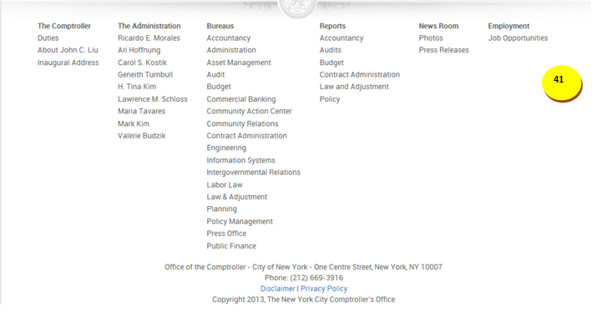

|  |  |  |  |  |  |  |
| --- | --- | --- | --- | --- | --- | --- |
| **ID** | | **KEY** | **FEATURE** | | **DESCRIPTION** | |
| **1.64** |  | **Footer** | * The system shall present a list of links that serve as additional resources about the NYC financial information. | |

Contracts Transactions – Business Rules

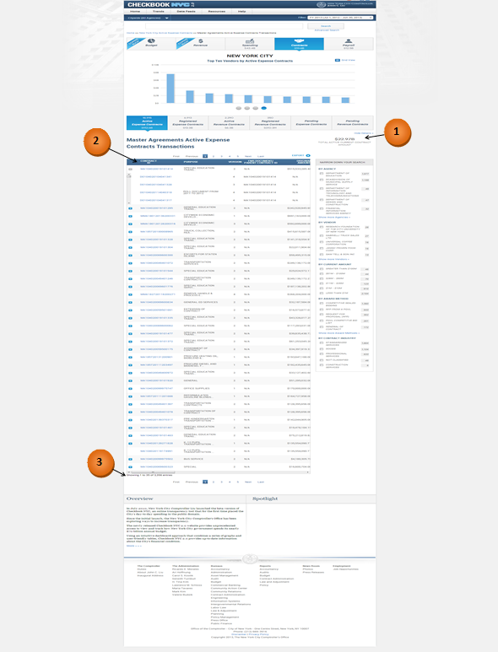

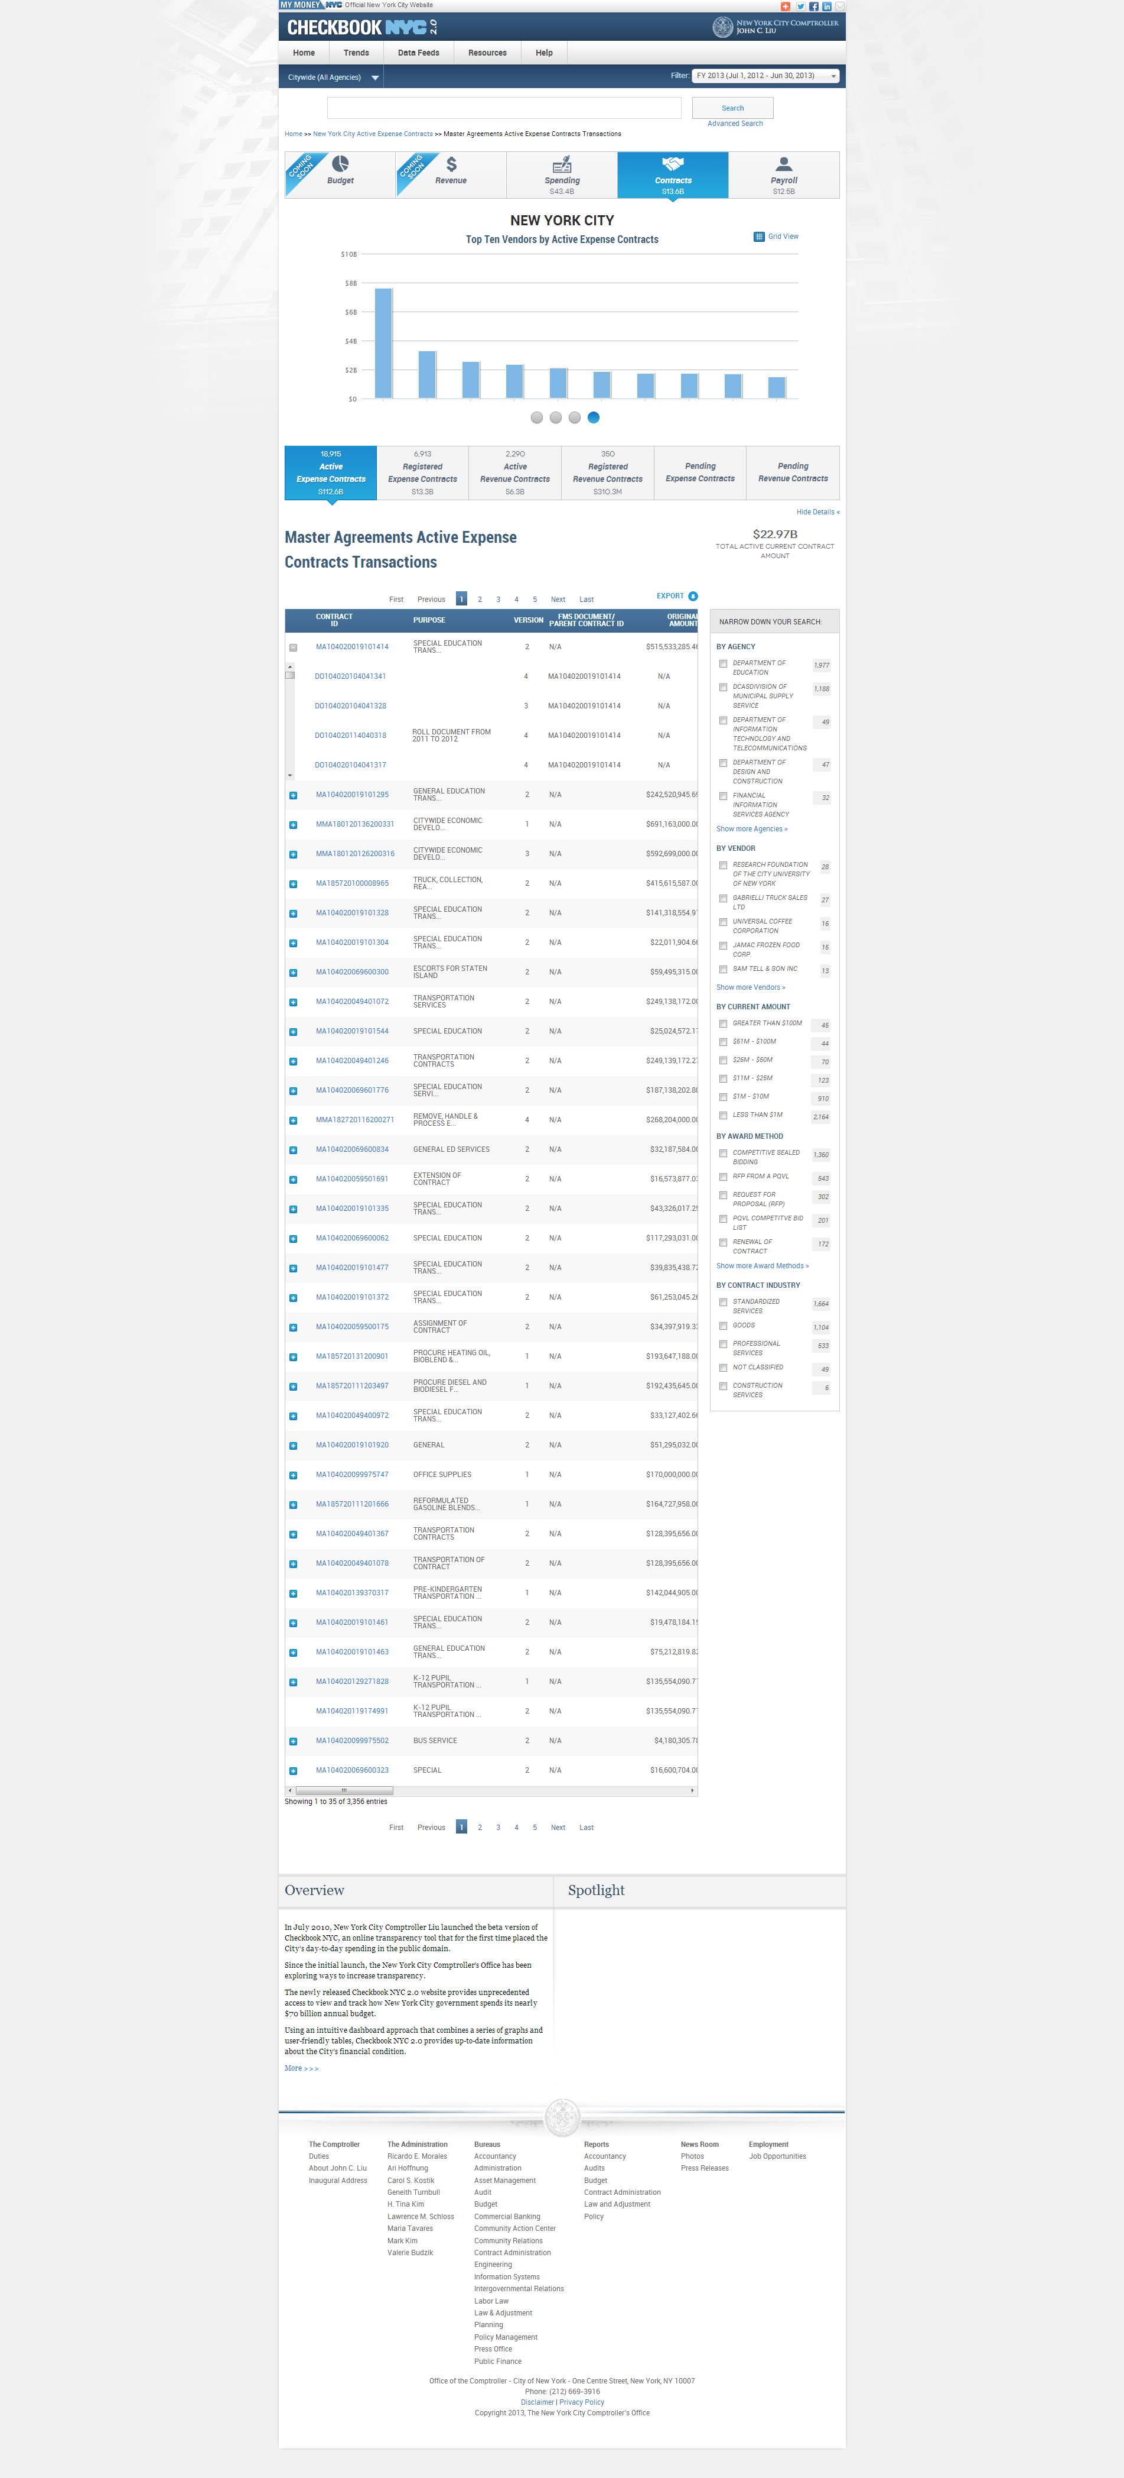

|  |  |  |  |
| --- | --- | --- | --- |
| **ID** | **KEY** | **FEATURE** | **DESCRIPTION** |
| **1.65** |  | **Static Content in Contracts Transactions Page When Visited by Clicking on ‘Details’ Link** | * The system shall display the following static content located to the right of the transactions title: * The total current contract amount value for all contracts the selected widget represents and the text ‘Total [selected Contract Status] Current Contract Amount’ underneath the value. * The system shall display no static content for Pending contract transaction pages. |



|  |  |  |  |  |  |
| --- | --- | --- | --- | --- | --- |
| **ID** | **KEY** | **FEATURE** | | **DESCRIPTION** | |
| **1.66** |  | **Contracts Transactions Table** | * The system shall present a contracts transactions table which consists of the following columns: ‘CONTRACT ID’, ‘PURPOSE’, ‘VERSION’, FMS DOCUMENT/PARENT CONTRACT ID’, ‘ORIGINAL AMOUNT’, ‘CURRENT AMOUNT’, ‘SPENT TO DATE’, ‘DOLLAR DIFFERENCE’, ‘PERCENT DIFFERENCE’, ‘VENDOR NAME’, ‘CONTRACT TYPE’, ‘AWARD METHOD’, ‘EXPENSE CATEGORY’, ‘INDUSTRY’, ‘START DATE’, ‘END DATE’, ‘REGISTRATION DATE’, ‘PIN’, and ‘APT PIN’. * The system shall support a table which can display only 35 records in one page. | |



|  |  |  |  |  |
| --- | --- | --- | --- | --- |
| **ID** | **KEY** | **FEATURE** | **DESCRIPTION** | |
| **1.67** |  | **The records count static content** | * The system shall present 'Displaying transactions [x] – [y] of [z]'. X is the order number of the first record within the table, y is the order number of the last record within the table, and z is the total number of records. |

|  |  |  |  |  |  |
| --- | --- | --- | --- | --- | --- |
| **ID** | **KEY** | **FEATURE** | | **DESCRIPTION** | |
| **1.68** |  | **Table Alignment** | * + - The system shall align the numbers in the widgets to the right, but centered in the column.     - The system shall align the text in the widgets to the left within the data rows.     - The system shall align the columns to be roughly equidistant from one other. | |

Contracts Transactions – Functional Requirements

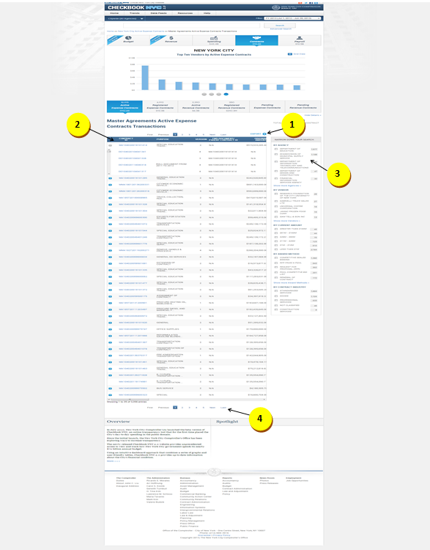

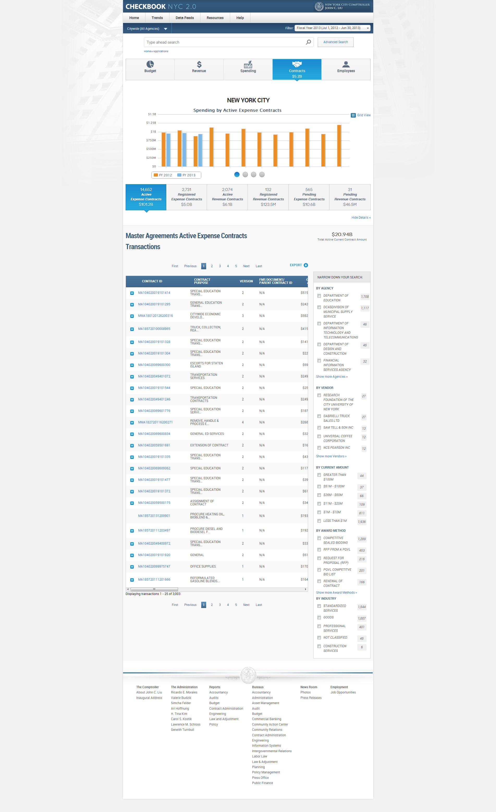

|  |  |  |  |
| --- | --- | --- | --- |
| **ID** | **KEY** | **FEATURE** | **DESCRIPTION** |
| **1.69** |  | **Export Link** | * The system shall support an export function which allows the user to download part or all of the records in comma delimited format. The user shall have the option of selecting 'CURRENT PAGE', 'ALL PAGES, or PAGES FROM x to y. |



|  |  |  |  |  |  |
| --- | --- | --- | --- | --- | --- |
| **ID** | **KEY** | **FEATURE** | | **DESCRIPTION** | |
| **1.70** |  | **Contracts Transactions Table** | * **Active/ Registered Contracts**: The system shall present a contracts transactions table that consists of the following columns: ‘CONTRACT ID’, ‘ PURPOSE’, ‘VERSION’, FMS DOCUMENT/PARENT CONTRACT ID’, ‘ORIGINAL AMOUNT’, ‘CURRENT AMOUNT’, ‘SPENT TO DATE’, ‘VENDOR’, ‘CONTRACTING AGENCY’,‘CONTRACT TYPE’, ‘AWARD METHOD’, ‘EXPENSE CATEGORY’, ‘CONTRACT INDUSTRY’, ‘START DATE’, ‘END DATE’, ‘REGISTRATION DATE’, ‘PIN’, and ‘APT PIN’. * **Active/ Registered Contracts** :The system shall present a contracts transactions table that consists of the following columns coming from dollar and percent difference widgets in this order: ‘CONTRACT ID’, ‘ PURPOSE’, ‘VERSION’, FMS DOCUMENT/PARENT CONTRACT ID’, ‘ORIGINAL AMOUNT’, ‘CURRENT AMOUNT’, ‘SPENT TO DATE’, ‘DOLLAR DIFFERENCE’, ‘PERCENT DIFFERENCE’, ‘VENDOR’, ‘CONTRACTING AGENCY’,‘CONTRACT TYPE’, ‘AWARD METHOD’, ‘EXPENSE CATEGORY’, ‘CONTRACT INDUSTRY’, ‘START DATE’, ‘END DATE’, ‘REGISTRATION DATE’, ‘PIN’, and ‘APT PIN’. * **Pending Contracts:** The system shall present a contracts transactions table that consists of the following columns in this order: ‘CONTRACT ID’, ‘ PURPOSE’, ‘RECEIVED DATE’, ‘VENDOR’, ‘ORIGINAL AMOUNT’, ‘CURRENT AMOUNT’, ‘START DATE’, ‘END DATE’, ‘VERSION’, FMS DOCUMENT/PARENT CONTRACT ID’, ‘CONTRACTING AGENCY’, ‘CONTRACT TYPE’, ‘ORIGINAL/MODIFIED’, ‘AWARD METHOD’ , ‘CONTRACT INDUSTRY’, ‘PIN’, and ‘APT PIN’. * **Pending Contracts:** The system shall present a contracts transactions table that consists of the following columns coming from dollar and percent difference widgets in this order: ‘CONTRACT ID’, ‘ PURPOSE’, ‘RECEIVED DATE’, ‘VENDOR’, ‘ORIGINAL AMOUNT’, ‘CURRENT AMOUNT’, ‘START DATE’, ‘END DATE’, ‘DOLLAR DIFFERENCE’, ‘PERCENT DIFFERENCE’, ‘VERSION’, FMS DOCUMENT/PARENT CONTRACT ID’, ‘CONTRACTING AGENCY’, ‘CONTRACT TYPE’, ‘ORIGINAL/MODIFIED’, ‘AWARD METHOD’ , ‘CONTRACT INDUSTRY’, ‘PIN’, and ‘APT PIN’. * The system shall support a table which can display only 35 records in one page. | |

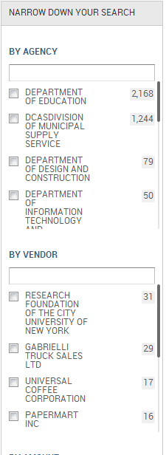

|  |  |  |  |  |  |
| --- | --- | --- | --- | --- | --- |
| **ID** | **KEY** | **FEATURE** | | **DESCRIPTION** | |
| **1.71** |  | **Narrow-down Search** | * + The system shall support a narrow-down facet, located to the left of the transactions table.   + The system shall support smart search with all string search.   + The system shall include full population of data within all facets.   + The user shall be able to see the total number of records that are available in a category, such as number of agencies, vendors, award method, and contract industry. The number of transactions displayed next to each record shall be updated as the user makes selections. * The system shall display following facets for contracts domain: By Agency, By Vendor, By Amount, By Award Method and By Contract Industry. | |



|  |  |  |  |  |  |
| --- | --- | --- | --- | --- | --- |
| **ID** | **KEY** | **FEATURE** | | **DESCRIPTION** | |
| **1.72** |  | **Pagination** | * The system shall support a pagination feature which allows the user to view more than the initial 10 records displayed. The pagination feature: 'First Previous 1 2 3 4 5 Next Last'. | |

Contracts Details – Business Rules

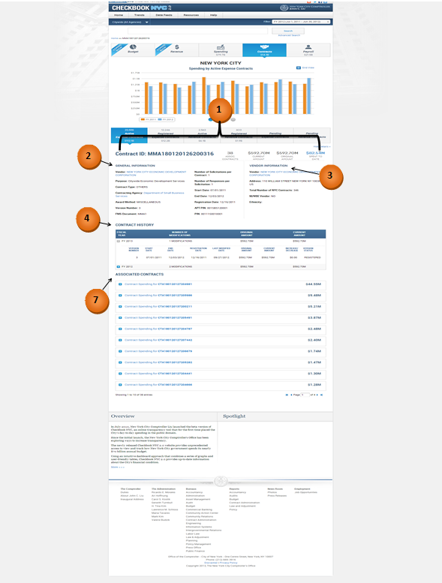

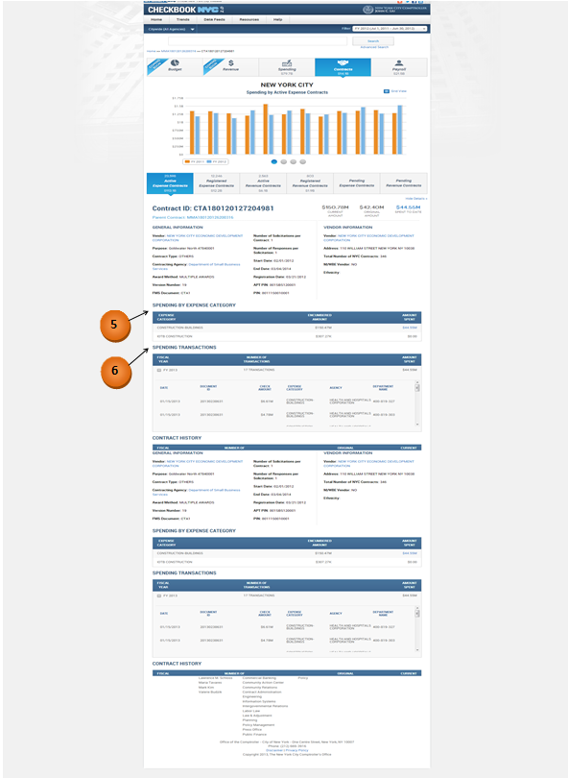

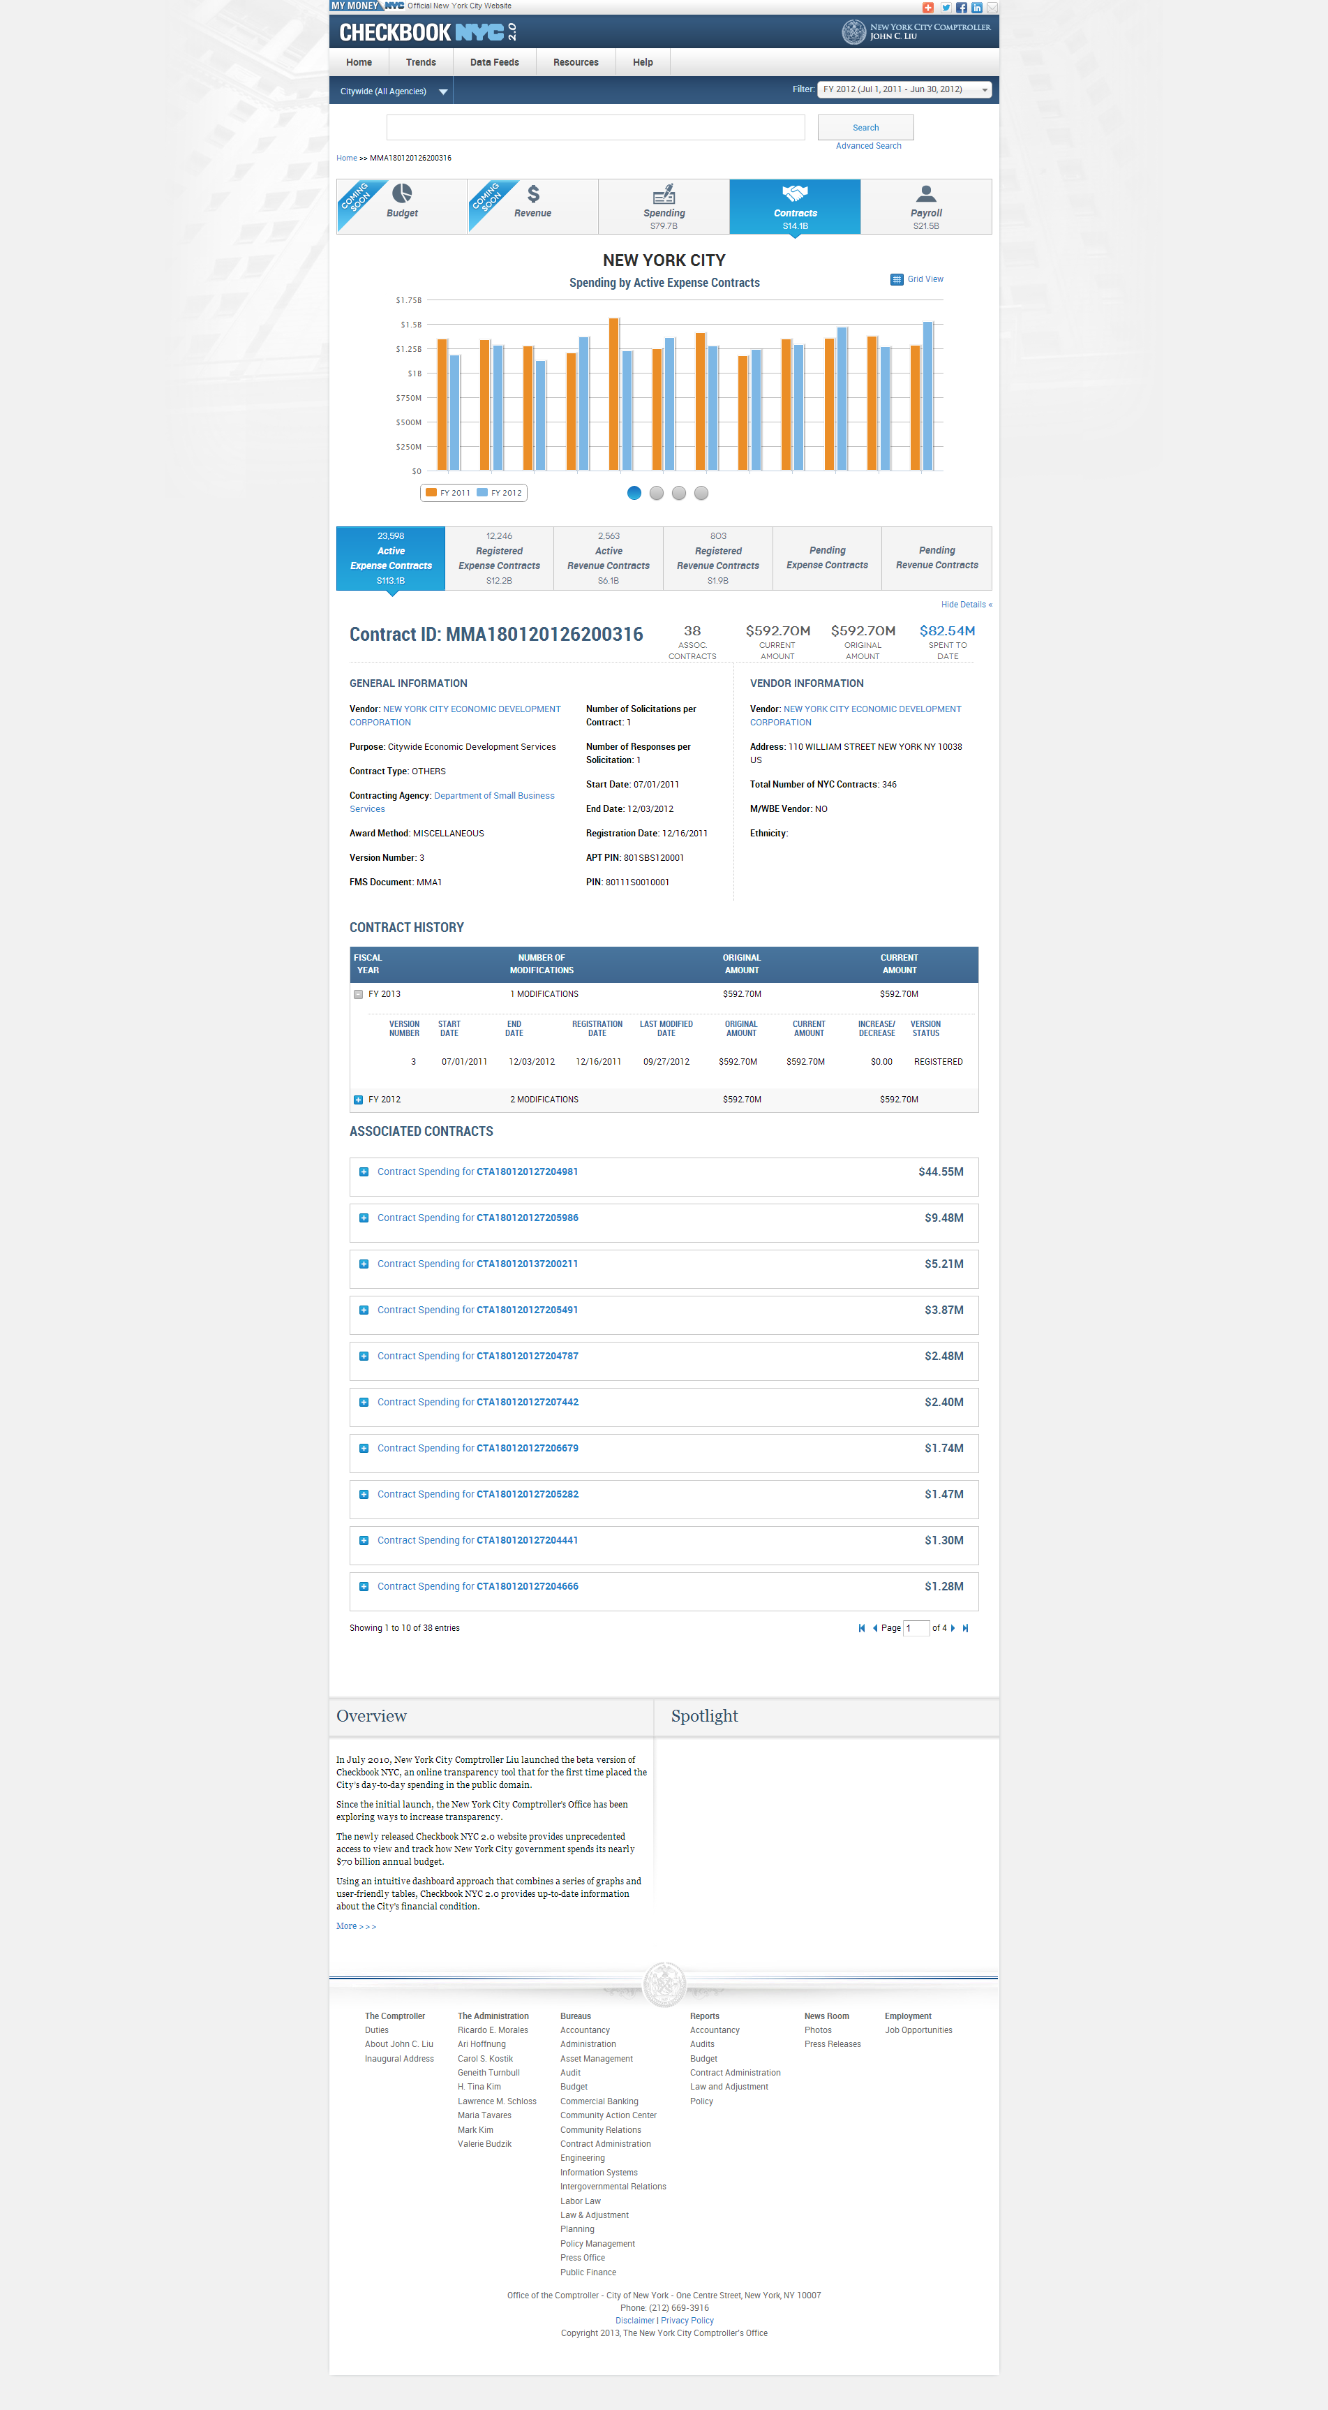

|  |  |  |  |
| --- | --- | --- | --- |
| **ID** | **KEY** | **FEATURE** | **DESCRIPTION** |
| **1.73** |  | **Title & Static Content** | * The system shall present the Contract ID in bold at the top of the details page. * The system shall display ‘Current Amount’, ‘Original Amount’, and ‘Spent to Date’ information to the right of the Contract ID. * The system shall present the RFED amount as the Spent to Date value (will be a link). * Clicking on the value link will present a new browser window of the spending transactions. * The system shall present the parent contract link just below the selected child Contract ID on a details page of a child contract. * The system shall present the count of ‘Assoc. Contracts’ to the left of the static content ‘Current Amount’ on a details page of a master agreement. |



|  |  |  |  |  |  |
| --- | --- | --- | --- | --- | --- |
| **ID** | **KEY** | **FEATURE** | | **DESCRIPTION** | |
| **1.74** |  | **General Information** | * The system shall include the following within the General Information section: Vendor, Purpose, Contract Type, Agency, Award Method, Version Number, FMS Document, Number of Solicitations per Contract, Number of Responses per Solicitation, Start Date, End Date, Registration Date, APT PIN, and PIN. Agency name and vendor name shall be links. Clicking on them shall direct the user to their respective contracts landing pages. | |



|  |  |  |  |  |  |
| --- | --- | --- | --- | --- | --- |
| **ID** | **KEY** | **FEATURE** | | **DESCRIPTION** | |
| **1.75** |  | **Vendor Information** | * The system shall include the following within the Vendor Information section: Vendor Name, Address, Number of Contracts, M/WBE Vendor, and Ethnicity. * Vendors in the pending contracts file that cannot be mapped to the FMSV file by their vendor_customer_codes will be linked to the respective vendor specific pending expense/revenue contracts landing page. * Vendors in the pending contracts file that can be mapped to the FMSV file by their vendor_customer_codes will be linked to the respective vendor specific active expense contracts landing page. * The 'Total Number of NYC Contracts' field displays the count of all active and registered contracts associated to the vendor. Only the latest versions of the active and registered contracts shall be considered. | |



|  |  |  |  |  |  |
| --- | --- | --- | --- | --- | --- |
| **ID** | **KEY** | **FEATURE** | | **DESCRIPTION** | |
| **1.76** |  | **Contract History widget** | * The system shall present, within the Contract History widget, the general information for the different versions the selected contract has gone through from inception to date, year by year. Information for each year shall be presented in single rows. * The system shall present the row of the latest FY in an expanded view while the rows of all previous relevant FY’s shall be presented in a collapsed view. The expanded view shall present the following contract information: no. of modifications, version number, start/end dates, registration date, and last modified date, original amount, current amount, increase/decrease, and version status. The collapsed view shall present only no. of modifications, original amount, and current amount. * The system shall match the widget alignments to those of the widgets from the landing page. | |

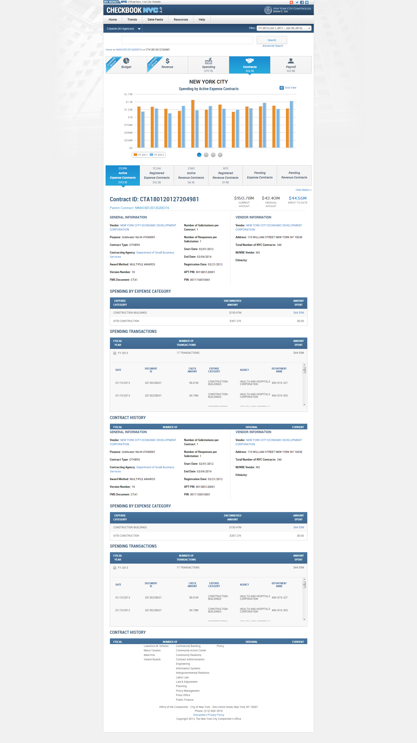

|  |  |  |  |  |  |
| --- | --- | --- | --- | --- | --- |
| **ID** | **KEY** | **FEATURE** | | **DESCRIPTION** | |
| **1.77** |  | **Spending by Expense Category widget (applicable for CTA1 and CT1 contracts)** | * The Spending by Expense Category section presents the total encumbered amount and total amount spent of a contract on each relevant expense category. The Amount Spent dollar value (RFED or Aggregate of disbursements? Please confirm) must be a link. Clicking on the value link shall present a new browser window of the spending transactions. The widget alignments must match the alignments of the widgets from the landing page. | |



|  |  |  |  |  |  |
| --- | --- | --- | --- | --- | --- |
| **ID** | **KEY** | **FEATURE** | | **DESCRIPTION** | |
| **1.78** |  | **Spending Transactions widget** **(applicable for CTA1 and CT1 contracts)** | * The system shall present disbursement information for the selected contract from inception to date, year by year within the Spending Transactions widget. Information for each year shall be presented in single rows. * The system shall present the row of the latest FY in an expanded view while the rows of all previous relevant FY’s shall be presented in a collapsed view. The expanded view shall present the following disbursement information: date, document ID, check amount, expense category, agency, and department. The collapsed view shall present only number of transactions and amount spent. * The system shall match the widget alignments to those of the widgets from the landing page. | |



|  |  |  |  |  |
| --- | --- | --- | --- | --- |
| **ID** | **KEY** | **FEATURE** | **DESCRIPTION** | |
| **1.79** |  | **Associated Contracts List** | * The system shall present all the associated child contracts within the Associated Contracts section of the details page for MMA1 or MA1 master agreements. The order of the associated contracts list shall be based on their spent to date (RFED) amount values (descending order). * The system shall present the first 2 associated contracts in expanded view, which shall display all information about a contract. The rest of the contracts shall be in collapsed view, which only displays the contract ID and the spent to date value (RFED). * The system shall present 'Displaying transactions [x] – [y] of [z]'. X is the order number of the first record within the table, y is the order number of the last record within the table, and z is the total number of records. |

Contracts Details – Functional Requirements

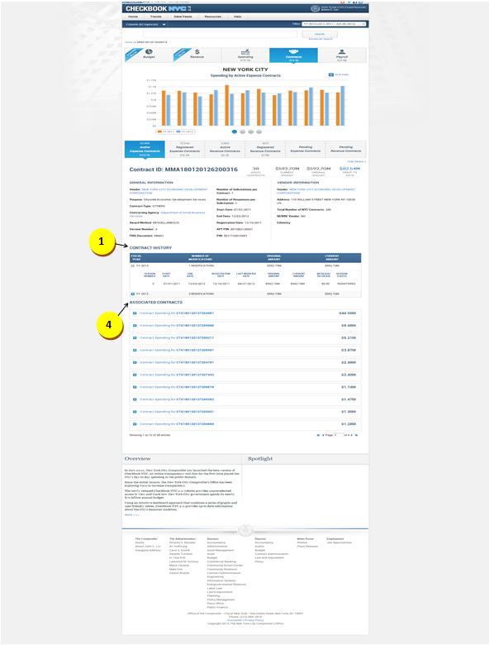

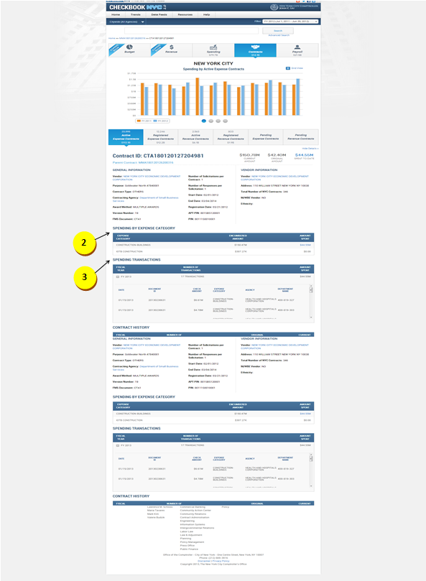



|  |  |  |  |
| --- | --- | --- | --- |
| **ID** | **KEY** | **FEATURE** | **DESCRIPTION** |
| **1.80** |  | **Contract History widget** | * The system shall expand a collapsed row to display additional information upon clicking on the ‘+’ button located on the top left of a collapsed row. Clicking on the ‘-‘button located on the top left of an expanded row shall collapse the row to display limited information. |



|  |  |  |  |  |
| --- | --- | --- | --- | --- |
| **ID** | **KEY** | **FEATURE** | **DESCRIPTION** | |
| **1.81** |  | **Spending by Expense Category widget (applicable for CTA1 and CT1 contracts)** | * The Amount Spent dollar value (RFED) must be a link. Clicking on the value link shall present a new browser window of the spending transactions. The widget alignments must match the alignments of the widgets from the landing page. |



|  |  |  |  |  |
| --- | --- | --- | --- | --- |
| **ID** | **KEY** | **FEATURE** | **DESCRIPTION** | |
| **1.82** |  | **Spending Transactions widget** **(applicable for CTA1 and CT1 contracts)** | * The system shall present a scroll bar to the right end of the expanded row if a FY contains more than 4 disbursement transactions. * The system shall expand a collapsed row to display additional information upon clicking on the ‘+’ button located on the top left of a collapsed row. Clicking on the ‘-‘button located on the top left of an expanded row shall collapse the row to display limited information. |



|  |  |  |  |  |
| --- | --- | --- | --- | --- |
| **ID** | **KEY** | **FEATURE** | **DESCRIPTION** | |
| **1.83** |  | **Associated Contracts List** | * The system will collapse the expanded view upon clicking on the ’-‘button, located to the left of the associated contract. Clicking on the ’+‘button, located to the left of the associated contract in collapsed view, shall expand the information. * The system shall allow the user to maneuver the pagination feature to view all the associated contracts if a master agreement possesses more than 10 associated child contracts. * The system will present the associated contracts IDs as links. Clicking on the ID shall direct the user to the selected child contract details page. |

* 1. Payroll

Payroll Landing – Business Rules

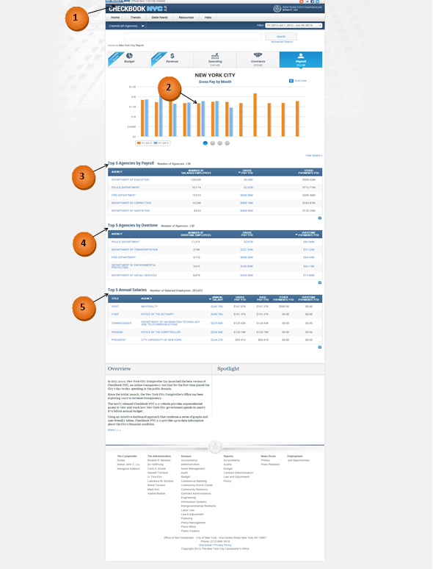

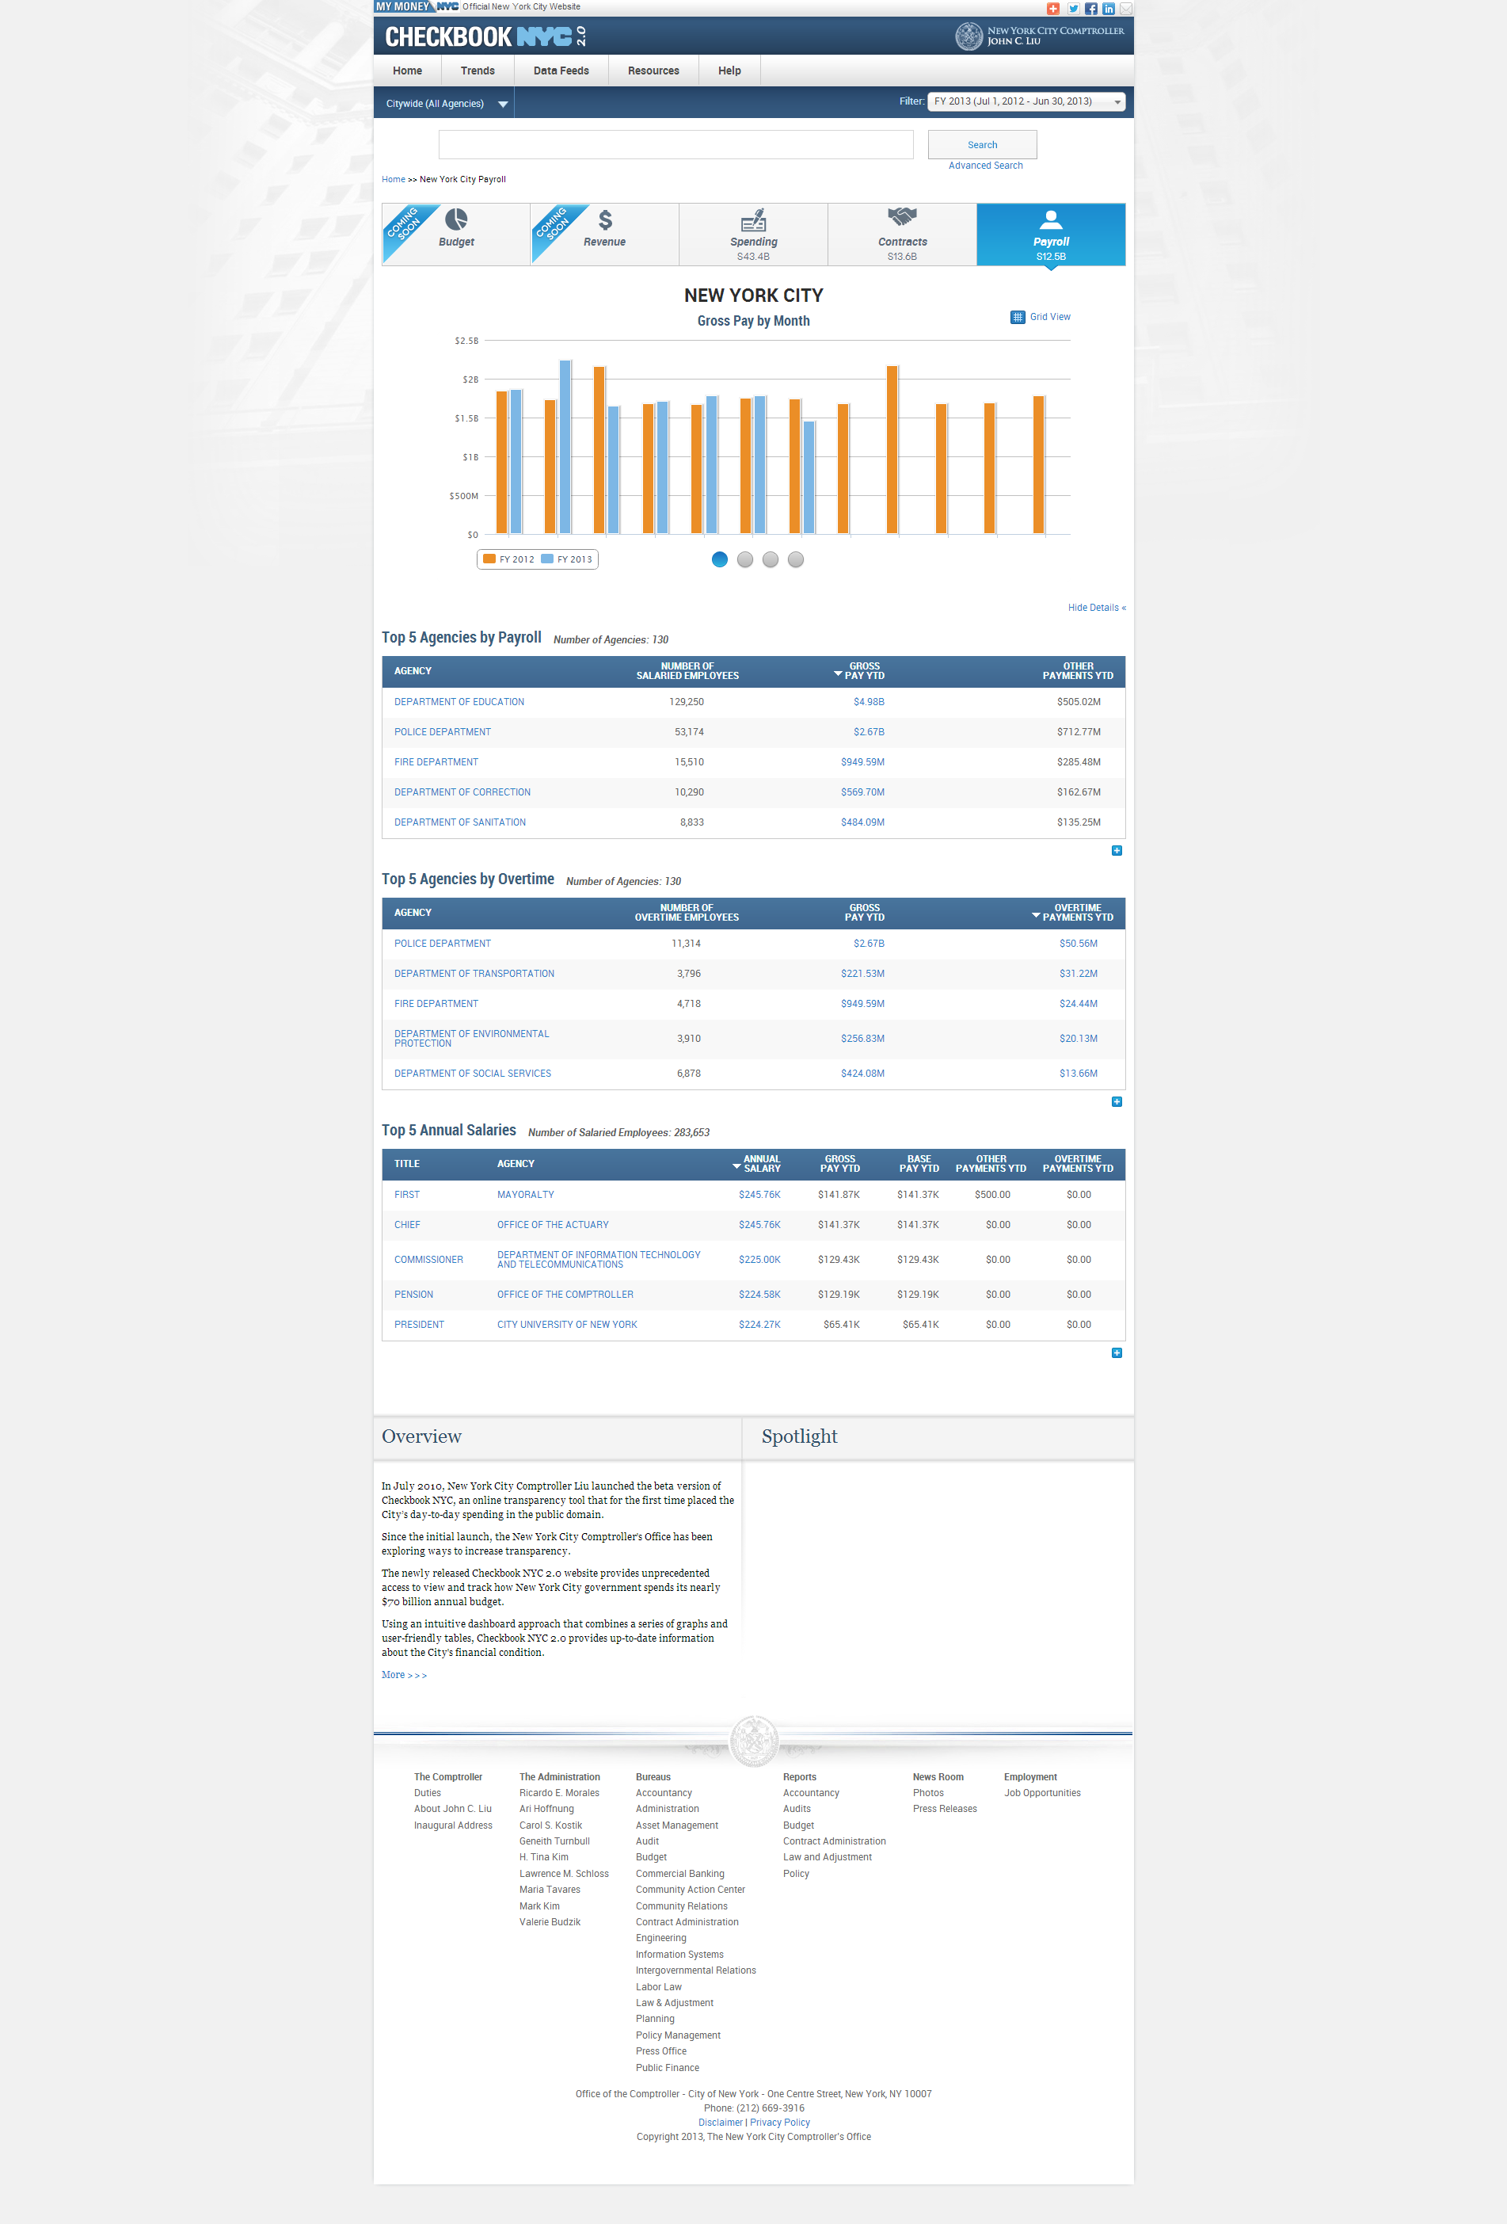

|  |  |  |  |
| --- | --- | --- | --- |
| **ID** | **KEY** | **FEATURE** | **DESCRIPTION** |
| **2.0** |  | **Header** | * The header includes all components above the top menu bar. It should include NYC 2.0 logo, Comptroller logo, my money site logo, social media links like add this, twitter, Facebook, LinkedIn and also includes email option. All these should be hyperlinked including logos. |



|  |  |  |  |  |  |
| --- | --- | --- | --- | --- | --- |
| **ID** | | **KEY** | **FEATURE** | **DESCRIPTION** | |
| **2.1** |  | **Monthly graph (Selected FY/CY vs Previous FY/CY)** | * The system shall display a monthly bar graph of total gross pay. * Title: Gross Pay by Month * Legend: * Previous Year * Current Year * Bar Colors:   - Previous Year (Cadmium Orange [#ED872D])  - Selected Year (Celestial Blue [#4997D0])   * The x-axis scaling: N/A * The y-axis scaling: dollar amounts (Highcharts/Highstocks library shall determine scale unit) |

|  |  |  |  |  |  |
| --- | --- | --- | --- | --- | --- |
| **ID** | | **KEY** | **FEATURE** | **DESCRIPTION** | |
| **2.2** |  | **Monthly graph (Selected FY/CY vs Previous FY/CY)** | * The system shall display a monthly bar graph of total overtime payments. * Title: Overtime Payments by Month * Legend: * Previous Year * Current Year * Bar Colors:   - Previous Year (Cadmium Orange [#ED872D])  - Selected Year (Celestial Blue [#4997D0])   * The x-axis scaling: N/A * The y-axis scaling: dollar amounts (Highcharts/Highstocks library shall determine scale unit) |

|  |  |  |  |  |  |
| --- | --- | --- | --- | --- | --- |
| **ID** | | **KEY** | **FEATURE** | **DESCRIPTION** | |
| **2.3** |  | **Top 10 Agencies (By Gross Pay)** | * The system shall display a ranking bar visualization of the top 10 agencies rated by their gross pay YTD. * Title: Top 10 Agencies by Gross YTD * No legend shall be applicable for this graph. * Bar Color:   (Celestial Blue [#4997D0]   * The x-axis scaling: N/A * The y-axis scaling: dollar amounts (Highcharts/Highstocks library shall determine scale unit) |

|  |  |  |  |  |  |
| --- | --- | --- | --- | --- | --- |
| **ID** | | **KEY** | **FEATURE** | **DESCRIPTION** | |
| **2.4** |  | **Top 10 Agencies (By Overtime Pay)** | * The system shall display a ranking bar visualization of the top 10 agencies rated by their total overtime payment. * Title: Top 10 Agencies by Total Overtime * No legend shall be applicable for this graph. * Bar Color:   (Celestial Blue [#4997D0])   * The x-axis scaling: N/A * The y-axis scaling: dollar amounts (Highcharts/Highstocks library shall determine scale unit) |



|  |  |  |  |  |
| --- | --- | --- | --- | --- |
| **ID** | **KEY** | **FEATURE** | **DESCRIPTION** | |
| **2.5** |  | **Top 5 Annual Salaries widget (must include only salaried employees)** | * The system shall present Employee Name as ‘Title’. The detail interface from Payroll shall contain a new field call Civil Service Title. * The ‘GROSS PAY YTD’ of a selected civil service title = ‘BASE PAY YTD’ of the selected civil service title for selected FY or CY + ‘ OTHER PAYMENTS YTD’ of the selected civil service title for selected FY or CY + ‘OVERTIME PAYMENTS YTD’ of the selected civil service title for selected FY or CY * The system shall align the last column on the right of each widget roughly right to the left side of the ‘+’ indicator at the bottom of the widget. * The system shall display the static content ‘Number of Salaried Employees: x’ located on the right of the widget title. * The system shall display the table headings and the static content in sentence case. The number in the static content shall contain commas when necessary. * Widget Alignment:   + - The system, by default, shall sort the numbers in descending order, i.e, highest on the top and lowest on the bottom. The text, by default shall be sorted in alphabetical order, i.e,A-Z.     - The system shall break the text in the column headings into 2 lines, if it is more than 1 word. If it is 3 or more words, then the characters shall be balanced in 2 lines, prioritizing the first line. The second line shall be in the center of the first line.     - The system shall align the first line of the text-column heading to the left, with second line centered.     - The system shall center-align the number-column headings.     - The system shall align the numbers in the widgets to the right, but centered in the column.     - The system shall align the text in the widgets to the left within the data rows.     - The system shall display the table row text in up to 2 lines. If there is more text than that it shall be truncated by ellipses.     - The system shall align the columns to be roughly equidistant from one other. * The system shall display the title ‘Top Annual Salaries’ if the widget displays less than 5 contracts. |



|  |  |  |  |  |
| --- | --- | --- | --- | --- |
| **ID** | **KEY** | **FEATURE** | **DESCRIPTION** | |
| **2.6** |  | **Top 5 Agencies by Payroll widget** | * The system shall present the ‘NUMBER OF SALARIED EMPLOYEES’ which is obtained by counting all unique employees who are marked as salaried employees from the database. * The system shall align the last column on the right of each widget roughly right to the left side of the ‘+’ indicator at the bottom of the widget. * The system shall display the static content ‘Number of Agencies: x’ located on the right of the widget title. * The system shall display the table headings and the static content in sentence case. The number in the static content shall contain commas when necessary. * Widget Alignment: * The system, by default, shall sort the numbers in descending order, i.e,highest on the top and lowest on the bottom. The text, by default shall be sorted in alphabetical order, i.e,A-Z. * The system shall break the text in the column headings into 2 lines, if it is more than 1 word. If it is 3 or more words, then the characters shall be balanced in 2 lines, prioritizing the first line. The second line shall be in the center of the first line. * The system shall align the first line of the text-column heading to the left, with second line centered. * The system shall center-align the number-column headings. * The system shall align the numbers in the widgets to the right, but centered in the column. * The system shall align the text in the widgets to the left within the data rows. * The system shall display the table row text in up to 2 lines. If there is more text than that it shall be truncated by ellipses. * The system shall align the columns to be roughly equidistant from one other. * The system shall display the title ‘Top Agencies by Payroll’ if the widget displays less than 5 contracts. |



|  |  |  |  |  |
| --- | --- | --- | --- | --- |
| **ID** | **KEY** | **FEATURE** | **DESCRIPTION** | |
| **2.7** |  | **Top 5 Agencies by Overtime widget** | * The system shall present the 'NUMBER OF OVERTIME EMPLOYEES' which is obtained by counting all unique employees who are marked as having overtime for the selected agency during the selected FY or CY. * The system shall present the 'GROSS PAY YTD’ which is obtained by summing the gross pay of all employees working for the selected agency during the selected FY or CY. * The system shall present the 'OVERTIMEPAYMENTS YTD' which is obtained by summing the overtime pay of all employees working for the selected agency during the selected FY or CY. * The system shall align the last column on the right of each widget roughly right to the left side of the ‘+’ indicator at the bottom of the widget. * The system shall display the static content ‘Number of Agencies: x’ located on the right of the widget title. * The system shall display the table headings and the static content in sentence case. The number in the static content shall contain commas when necessary. * Widget Alignment: * The system, by default, shall sort the numbers in descending order, i.e,highest on the top and lowest on the bottom. The text, by default shall be sorted in alphabetical order, i.e,A-Z. * The system shall break the text in the column headings into 2 lines, if it is more than 1 word. If it is 3 or more words, then the characters shall be balanced in 2 lines, prioritizing the first line. The second line shall be in the center of the first line. * The system shall align the first line of the text-column heading to the left, with second line centered. * The system shall center-align the number-column headings. * The system shall align the numbers in the widgets to the right, but centered in the column. * The system shall align the text in the widgets to the left within the data rows. * The system shall display the table row text in up to 2 lines. If there is more text than that it shall be truncated by ellipses. * The system shall align the columns to be roughly equidistant from one other. * The system shall display the title ‘Top Agencies by Overtime’ if the widget displays less than 5 contracts. |

Payroll Landing – Functional Requirements

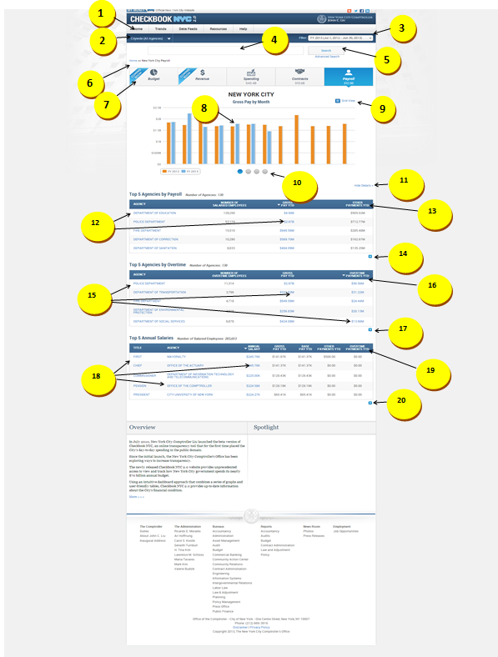



|  |  |  |  |
| --- | --- | --- | --- |
| **ID** | **KEY** | **FEATURE** | **DESCRIPTION** |
| **2.8** |  | **Top Menu Bar** | * + - The system shall present tabs at the top menus bar in the following order: Home, Trends, Data Feeds, Resources, and Help.     - The system shall not contain drop-downs for the Home and Data Feeds tabs.     - The system shall present the drop-down for Trends in the following order – Featured Trends, All Trends, Financial, Revenue Capacity, Debt Capacity, Demographic, and Operational. * Each of the additional trends - Financial, Revenue Capacity, Debt Capacity, Demographic, Operational – have additional groupings of trends, which are opened in the menu call out. * The system shall contain the following drop-downs for help tab: Site Navigation & Glossary, FAQ, Ask a Question, Report a Problem and Share an Idea. * Site Navigation & Glossary would display information for three domains: Contracts, Payroll and Spending. Within contracts domain, agencies list with codes is embedded to be downloaded. |



|  |  |  |  |  |  |  |
| --- | --- | --- | --- | --- | --- | --- |
| **ID** | | **KEY** | **FEATURE** | | **DESCRIPTION** | |
| **2.9** |  | | **Citywide Filter** | * The system shall direct the user to an agency specific landing page if user clicks on any particular agency from the dropdown list. By default, citywide agencies filter shall be preselected. * Once user selects an agency, the top navigation numbers will also update that agency level for the selected year. | |



|  |  |  |  |  |  |
| --- | --- | --- | --- | --- | --- |
| **ID** | **KEY** | **FEATURE** | | **DESCRIPTION** | |
| **2.10** |  | **Date Filter** | * The system shall allow the user to select a particular fiscal year or calendar year. Payroll data, by default, shall display current fiscal year. * When the user navigates through other domains, the date filter shall not carry forward to the other domains. It always defaults to current fiscal year. * The system shall have Budget, Revenue domains not clickable. The amount will update to zero dollars when user selects calendar year. Only Spending, Contracts, and Payroll domains shall update based on calendar year. | |



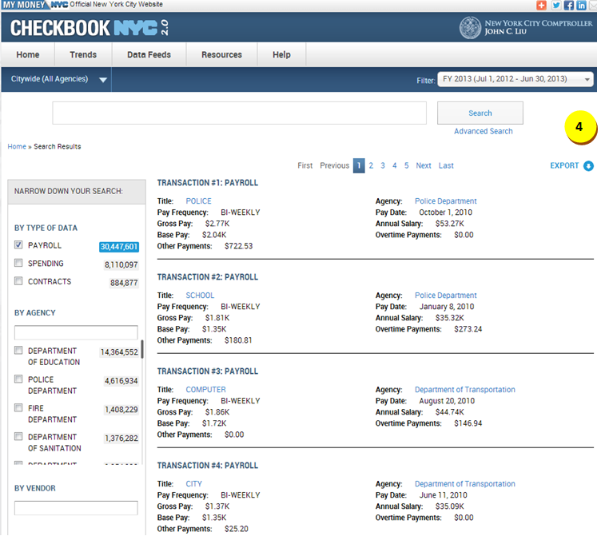

|  |  |  |  |  |  |
| --- | --- | --- | --- | --- | --- |
| **ID** | **KEY** | **FEATURE** | | **DESCRIPTION** | |
| **2.11** |  | **Smart Search** | * + - The system shall place the Smart Search box below Citywide and Date Filter navigation and above top navigation.     - The system shall support all string searches.     - The system shall not present the top navigation upon smart search results.     - The system shall present the citywide filter and Date filter in the smart search results. * The system shall direct the user to NYC Spending page for current FY or the selected FY upon clicking date filter. * The system shall display all resulting fields in two lines with hover- over functionality. * The system shall present export functionality in smart search. * The resulting field names for Payroll domain are Title, Agency, Pay Frequency, Pay Date, Gross Pay, Annual Salary, Base Pay, Overtime Payments and Other Payments. Only Agency and title are hyperlinked. * The narrow-down facet selections are By Type of Data, By Agency, By Vendor, By Expense Category and By Fiscal Year. * The system shall present no sub-categories when user selects payroll domain under type of data. | |



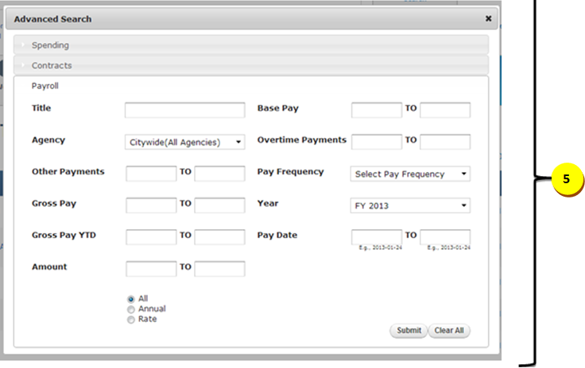

|  |  |  |  |  |  |
| --- | --- | --- | --- | --- | --- |
| **ID** | **KEY** | **FEATURE** | | **DESCRIPTION** | |
| **2.12** |  | **Advanced Search** | * The system shall present the following search criteria with the dropdown functionality: * Agency * Pay Frequency * Year * The system shall present the following search criteria with the text-box functionality: * Other Payments * Gross Pay * Gross Pay YTD * Amount (must select amount rate radio button) * Base Pay * Overtime Payments * The system shall present the following search criteria with the text-box autocomplete functionality: * Title * The system shall present the following search criteria with the calendar functionality: * Pay Date * The system shall support narrow-down functionality for the advanced search based on the dropdown fields. For instance the data within all autocomplete fields will depend on the dropdown selections. * The results page will not have narrow-down facet functionality. * The system shall allow the user to export transactions. * The system shall perform **“exact”** functionality when user selects any result from the dropdown autocomplete list and that search term shall be pre-selected within the narrow down facet if applicable. * The system shall perform **“like”** functionality when user enters search term within text box and clicks submit button. The search term shall not be pre-selected within the narrow down facet. | |

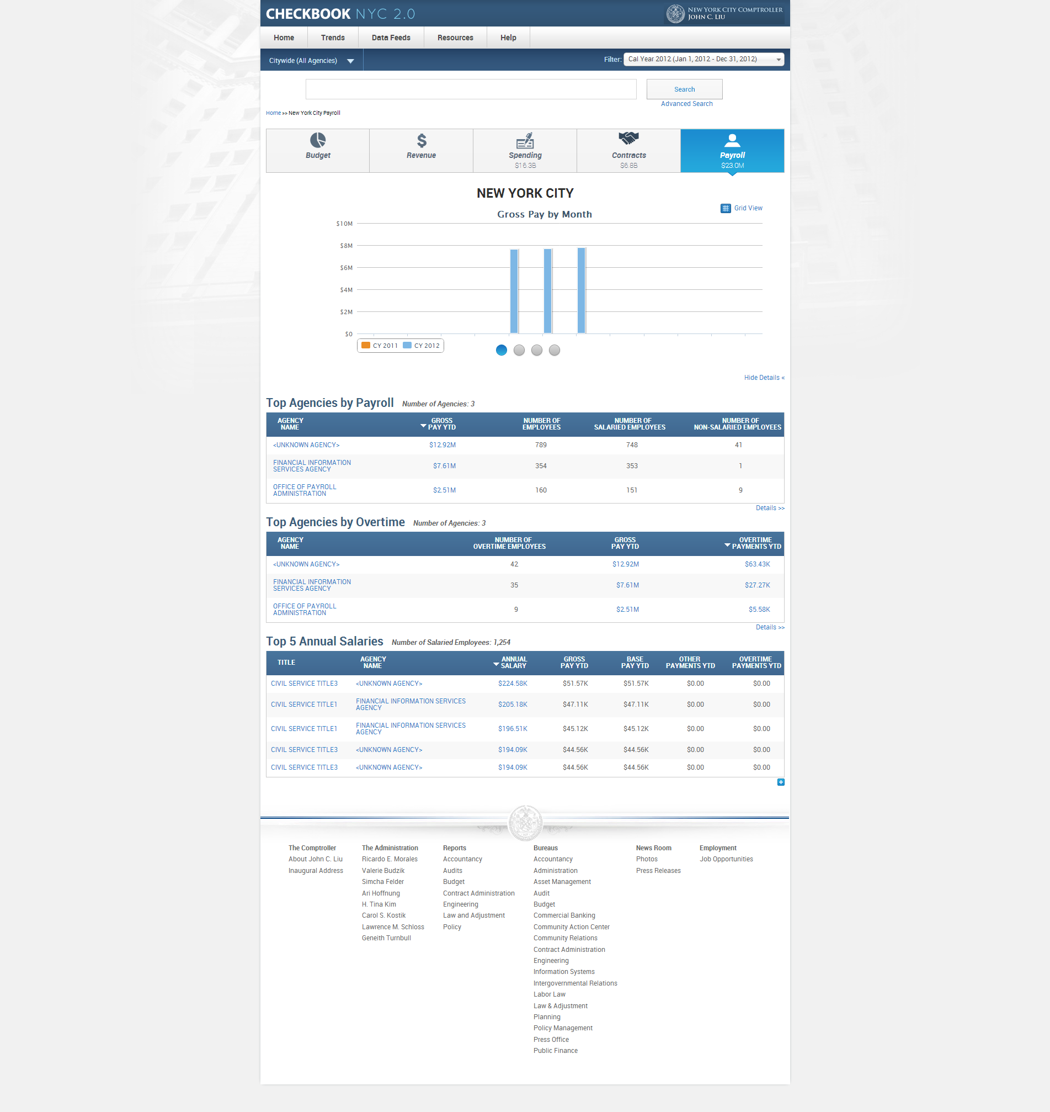

|  |  |  |  |  |
| --- | --- | --- | --- | --- |
| **ID** | **KEY** | **FEATURE** | **DESCRIPTION** | |
| **2.13** |  | **Breadcrumbs** | * The system shall present breadcrumbs which consist of a maximum of eight elements. * Upon initial visit to the application, the first element shall be ‘Home’.  The titles of the breadcrumb elements shall be specific.  The breadcrumbs shall essentially present a historical path of navigation.  Below is an example from contracts domain:   Home > New York City Active Expense Contracts > Department of Defense Active Expense Contracts > Department of Defense Active Expense Contracts Transactions > Active Expense Contracts Greater than $1M > Standardized Services Active Expense Contracts > Active Expense Master Agreements Transactions > CTA1290583294   * Once the user visits the ninth page, the eighth element shall disappear, and shall be replaced by a new element. Only the eighth element will update. * No short names to be used in breadcrumbs. Placement of the breadcrumbs will be above the visualization to the left. |



|  |  |  |  |  |  |
| --- | --- | --- | --- | --- | --- |
| **ID** | **KEY** | **FEATURE** | | **DESCRIPTION** | |
| **2.14** |  | **Top Navigation** | * The system shall display the sum of the payroll (Gross Pay YTD for all employees) for the selected FY/CY on the ‘Payroll button. The amount must have 1 decimal digit. * The user shall be able to navigate from one domain to another by clicking on the desired domain button. * Upon changing domains, the data will be displayed based on current fiscal year. * The system shall present a top navigation with the following categories in order: Revenue, Budget, Spending, Contracts, and Payroll. * The system shall display on each box the Icon, Title of the Domain, and the Number in a 3-line format.   + - The system shall update at NYC, Agency and Vendor level. As vendor is not applicable to Budget, Revenue and Payroll domains, the numbers shall update to zero dollars and not clickable. The user shall be able to click on these domains by clicking on home/agency. | |



|  |  |  |  |  |  |  |
| --- | --- | --- | --- | --- | --- | --- |
| **ID** | | **KEY** | **FEATURE** | | **DESCRIPTION** | |
| **2.15** |  | **Monthly graph (Selected FY/CY vs Previous FY/CY)** | * Monthly graph (Selected FY/CY **vs** Previous FY/CY) * On clicking any bar, user will be linked to the same page as advanced search results page (payroll transactions with static content). Top slider, bottom slider, and visualization should remain constant. The contents below the bottom slider should be refreshed to appropriate transactions table. All records in the resulting transaction table shall have pay date in the selected month (from bar graph). The summation of the amounts (base pay & other payments for Regular Wage, OT payments for Overtime Wage) should be equal to the respective amounts in the graph tooltip. * Hovering over a bar will display a tooltip with the following information: * ‘Month: [selected month]’ * ‘Year: [selected year]’ * ‘Gross Pay Amount: [$amount]’ | |

|  |  |  |  |  |  |  |
| --- | --- | --- | --- | --- | --- | --- |
| **ID** | | **KEY** | **FEATURE** | | **DESCRIPTION** | |
| **2.16** |  | **Monthly graph (Selected FY/CY vs Previous FY/CY)** | * The system shall direct the user to the NYC/Agency payroll transactions upon clicking any bar. Top slider, bottom slider, and visualization shall remain constant. The contents below the bottom slider shall be refreshed to appropriate transactions table. All records in the resulting transaction table shall have pay date in the selected month (from bar graph). The summation of the amounts (OT payments) shall be equal to the respective amounts in the graph tooltip. * The system shall tooltip with the following information upon hovering over a bar: * ‘Month: [selected month]’ * ‘Year: [selected year]’ * ‘Overtime Amount: [$amount]’ | |

|  |  |  |  |  |  |  |
| --- | --- | --- | --- | --- | --- | --- |
| **ID** | | **KEY** | **FEATURE** | | **DESCRIPTION** | |
| **2.17** |  | **Top 10 Agencies (By Gross Pay)** | * The system shall direct the user to agency specific employee landing page upon clicking on a bar. * The system shall tooltip with the following information upon hovering over a bar: * Agency: [selected agency] * Year: [selected year] * Gross Pay Amount: [$amount] | |

|  |  |  |  |  |  |  |
| --- | --- | --- | --- | --- | --- | --- |
| **ID** | | **KEY** | **FEATURE** | | **DESCRIPTION** | |
| **2.18** |  | **Top 10 Agencies (By Overtime Pay)** | * The system shall direct the user to agency specific employee landing page upon clicking on a bar. * The system shall tooltip with the following information upon hovering over a bar: * Agency: [selected agency] * Year: [selected year] * Overtime Amount: [$amount] | |



|  |  |  |  |  |  |  |
| --- | --- | --- | --- | --- | --- | --- |
| **ID** | | **KEY** | **FEATURE** | | **DESCRIPTION** | |
| **2.19** |  | | **Grid View** | * The system shall allow the Grid View to display the information on the graphical visualization as numeric data in a table format within a new browser window. (A new browser window shall display the information)   + - The system shall present the title of the Grid View in upper case, for example NEW YORK CITY, DEPARTMENT OF SANITATION. * The second and third lines underneath shall be in sentence case.   + - The system shall present sorting arrows with rules consistent to those of the widgets (see sorting arrows details listed under, ‘Widgets’).     - The system shall maintain the 2-line standardization and alignment rules described under “Widgets” section of this documentation.     - The system shall support up to 2 decimal places for numbers in the table rows.     - The system shall present Print and Export functionalities for the Grid View. | |



|  |  |  |  |  |
| --- | --- | --- | --- | --- |
| **ID** | **KEY** | **FEATURE** | **DESCRIPTION** | |
| **2.20** |  | **Visualizations Slider** | * The system shall allow theuser to navigate through the available visualizations by maneuvering the pagination feature. |



|  |  |  |  |  |
| --- | --- | --- | --- | --- |
| **ID** | **KEY** | **FEATURE** | **DESCRIPTION** | |
| **2.21** |  | **Show Details link** | * The system shall collapse all contents below the bottom navigation slider upon initial visit to the Contracts page. Clicking on the 'Show Details' link shall expand the page and display all contents and widgets below the bottom navigation slider. The contents shall not be collapsed again, unless user clicks on 'Hide Details'. |



|  |  |  |  |  |
| --- | --- | --- | --- | --- |
| **ID** | **KEY** | **FEATURE** | **DESCRIPTION** | |
| **2.22** |  | **Top 5 Agencies by Payroll widget hyperlinks** | * The system shall direct the user to agency specific payroll landing page upon clicking on agency name link. * The system shall direct the user to the agency specific payroll transactions page upon clicking on a gross pay YTD link. |



|  |  |  |  |  |  |
| --- | --- | --- | --- | --- | --- |
| **ID** | | **KEY** | **FEATURE** | **DESCRIPTION** | |
| **2.23** |  | | **Top 5 Agencies by Payroll widget sorting** | * The system shall, on default, sort the widget by the ‘GROSS PAY YTD’ column. Upon initial visit to the page, the arrow shall appear next to the default-sorted header. If a user hovers over a sortable header, the header shall be underlined. If the user clicks on a header (NOT the default-sorted header), then the arrow which was on the default-sorted header shall disappear and an arrow shall appear on the clicked on header. The direction of the pointing arrow shall change for ascending and descending sorting. |



|  |  |  |  |  |
| --- | --- | --- | --- | --- |
| **ID** | **KEY** | **FEATURE** | **DESCRIPTION** | |
| **2.24** |  | **Top 5 Agencies by Payroll widget ‘+’ / ‘-‘ and ‘Details’** | * The system shall expand the widget to display a maximum of 150 rows of record upon clicking on ‘+’. When expanded, the ‘+’ symbol shall transform to the ‘-‘ symbol and a ‘Details’ link shall appear next to the ‘-‘ symbol; clicking on ‘-‘ shall collapse the widget to its original size. This functionality shall be applicable for all widgets in the payroll landing pages. Clicking on ‘Details’ link shall refresh the contents below the ‘Hide Details’ link into the NYC payroll transactions page (with static content). The title of the transactions table shall be ‘Top Agencies by Payroll Transactions’. |



|  |  |  |  |  |
| --- | --- | --- | --- | --- |
| **ID** | **KEY** | **FEATURE** | **DESCRIPTION** | |
| **2.25** |  | **Top 5 Agencies by Overtime widget hyperlinks** | * The system shall direct the user to agency specific payroll landing page upon clicking on agency name link. * The system shall direct the user to the agency specific payroll transactions page upon clicking on a gross pay YTD link. * • The system shall direct the user to the agency specific payroll transactions page upon clicking on an overtime payments YTD dollar amount link. |



|  |  |  |  |  |  |
| --- | --- | --- | --- | --- | --- |
| **ID** | | **KEY** | **FEATURE** | **DESCRIPTION** | |
| **2.26** |  | | **Top 5 Agencies by Overtime widget sorting** | * The system shall, on default, sort the widget by the ‘OVERTIME PAYMENTS YTD’ column. Upon initial visit to the page, the arrow shall appear next to the default-sorted header. If a user hovers over a sortable header, the header shall be underlined. If the user clicks on a header (NOT the default-sorted header), then the arrow which was on the default-sorted header shall disappear and an arrow shall appear on the clicked on header. The direction of the pointing arrow shall change for ascending and descending sorting. |



|  |  |  |  |  |
| --- | --- | --- | --- | --- |
| **ID** | **KEY** | **FEATURE** | **DESCRIPTION** | |
| **2.27** |  | **Top 5 Agencies by Overtime widget ‘+’ / ‘-‘ and ‘Details’** | * The system shall expand the widget to display a maximum of 150 rows of record upon clicking on ‘+’. When expanded, the ‘+’ symbol shall transform to the ‘-‘ symbol and a ‘Details’ link shall appear next to the ‘-‘ symbol; clicking on ‘-‘ shall collapse the widget to its original size. This functionality shall be applicable for all widgets in the payroll landing pages. Clicking on ‘Details’ link shall refresh the contents below the ‘Hide Details’ link into the NYC payroll transactions page (with static content). The title of the transactions table shall be ‘Top Agencies by Overtime Payroll Transactions’. |



|  |  |  |  |  |
| --- | --- | --- | --- | --- |
| **ID** | **KEY** | **FEATURE** | **DESCRIPTION** | |
| **2.28** |  | **Top 5 Annual Salaries widget (must include only salaried employees) hyperlinks** | * The system shall refresh the contents below the ‘Show Details’ link upon clicking on the Title link to display the employee specific payroll transactions. * The system shall direct the user to agency specific payroll landing page upon clicking on agency name link. * The system shall direct the user to employee specific payroll transactions page upon clicking on the annual salary dollar amount link. |



|  |  |  |  |  |
| --- | --- | --- | --- | --- |
| **ID** | **KEY** | **FEATURE** | **DESCRIPTION** | |
| **2.29** |  | **Top 5 Annual Salaries widget (must include only salaried employees) sorting** | * The system shall, on default, sort the widget by the ‘ANNUAL SALARY’ column. Upon initial visit to the page, the arrow shall appear next to the default-sorted header. If a user hovers over a sortable header, the header shall be underlined. If the user clicks on a header (NOT the default-sorted header), then the arrow which was on the default-sorted header shall disappear and an arrow shall appear on the clicked on header. The direction of the pointing arrow shall change for ascending and descending sorting. |



|  |  |  |  |  |
| --- | --- | --- | --- | --- |
| **ID** | **KEY** | **FEATURE** | **DESCRIPTION** | |
| **2.30** |  | **Top 5 Annual Salaries widget (must include only salaried employees) ‘+’ / ‘-‘ and ‘Details’** | * The system shall expand the widget to display a maximum of 150 rows of record upon clicking on ‘+’. When expanded, the ‘+’ symbol shall transform to the ‘-‘ symbol and a ‘Details’ link shall appear next to the ‘-‘ symbol; clicking on ‘-‘ shall collapse the widget to its original size. This functionality shall be applicable for all widgets in the payroll landing pages. Clicking on ‘Details’ link shall refresh the contents below the ‘Hide Details’ link into the NYC payroll transactions page (with static content). The title of the transactions table shall be ‘Top Annual Salaries Payroll Transactions’. |

Payroll Employee Transactions - Business Rules

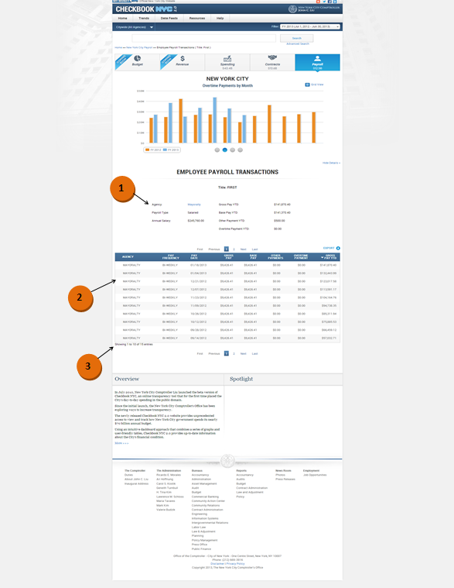

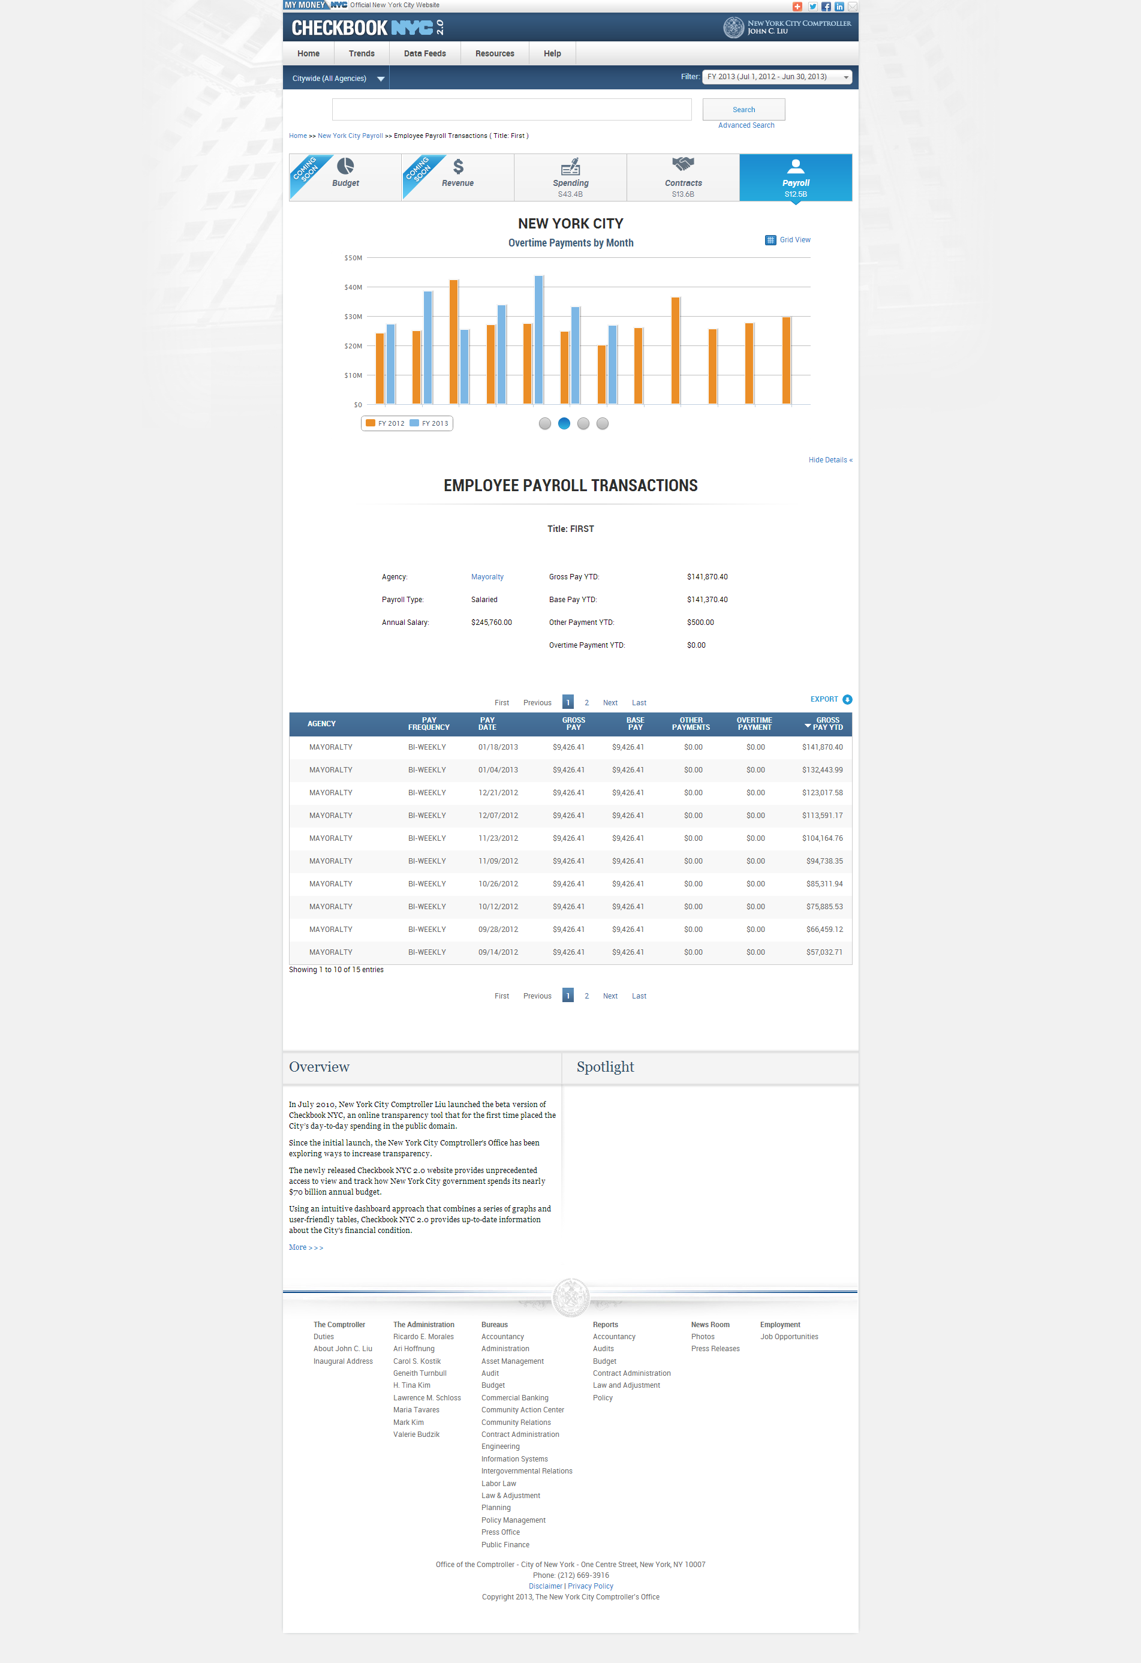

|  |  |  |  |
| --- | --- | --- | --- |
| **ID** | **KEY** | **FEATURE** | **DESCRIPTION** |
| **2.31** |  | **Employee Payroll Transactions Summary Information and Table** | * The system shall display the following static contents above the transactions table as summary information in the employee payroll transactions page: 'AGENCY', 'START DATE', 'PAYROLL TYPE', 'ANNUAL SALARY', 'GROSS PAY YTD', 'BASE PAY YTD', 'OTHER PAYMENTS YTD', 'OVERTIME PAYMENTS YTD'. The set of fields mentioned previously can appear multiple times if the selected employee works for more than 1 agency. If the selected employee is affiliated with more than 1 agency, then the above set of static content shall appear more than once to describe the summary employee payroll information for the multiple affiliations. Only 1 set of the static contents shall be displayed at a time, but maneuvering the pagination arrows located on the left and right shall allow the user to view more sets. The employee name shall be displayed as Civil Service Title #[x] at the top of the transactions page. * The following are the descriptions of the fields:      * The system shall present the following columns in the Employee specific transactions table: ' TITLE', 'AGENCY', 'ANNUAL SALARY', 'PAY FREQUENCY', 'GROSS PAY YTD ', 'BASE PAY YTD', 'OTHER PAYMENTS YTD', 'OVERTIME PAYMENTSYTD'. |



|  |  |  |  |  |
| --- | --- | --- | --- | --- |
| **ID** | **KEY** | **FEATURE** | **DESCRIPTION** | |
| **2.32** |  | **Table Alignment** | * + - The system shall align the numbers in the widgets to the right, but centered in the column.     - The system shall align the text in the widgets to the left within the data rows.     - The system shall align the columns to be roughly equidistant from one other. |



|  |  |  |  |  |
| --- | --- | --- | --- | --- |
| **ID** | **KEY** | **FEATURE** | **DESCRIPTION** | |
| **2.33** |  | **Records Count Static Content** | * The system shall present 'Displaying transactions [x] – [y] of [z]'. X is the order number of the first record within the table, y is the order number of the last record within the table, and z is the total number of records. |

|  |  |  |  |  |
| --- | --- | --- | --- | --- |
| **ID** | **KEY** | **FEATURE** | **DESCRIPTION** | |
| **2.34** |  | **Miscellaneous** | * The system shall not present any hyperlinks that will direct the user out of the domain with the new browser window in the payroll domain. |

Payroll Employee Transactions – Functional Requirements

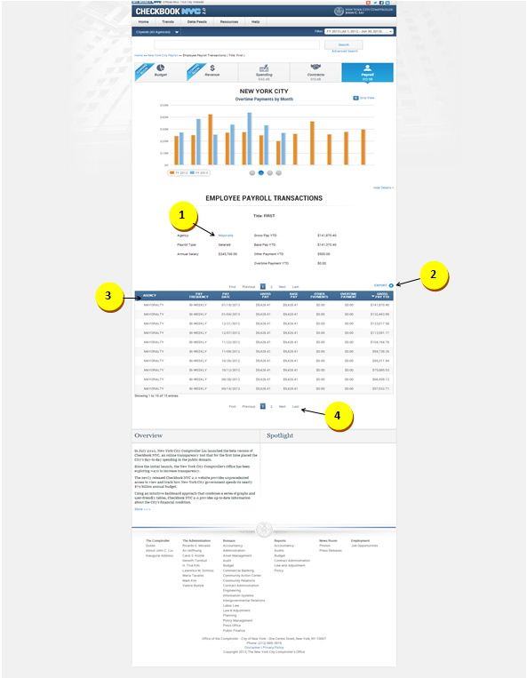



|  |  |  |  |
| --- | --- | --- | --- |
| **ID** | **KEY** | **FEATURE** | **DESCRIPTION** |
| **2.35** |  | **Employee Payroll Transactions Summary Information and Table hyperlinks** | * The system shall direct the user to agency specific payroll landing page upon clicking on agency name link in the summary information section. * The system shall support a table that can display only 35 records in one page. |



|  |  |  |  |  |
| --- | --- | --- | --- | --- |
| **ID** | **KEY** | **FEATURE** | **DESCRIPTION** | |
| **2.36** |  | **Export Link** | * The system shall support an export function in the payroll transactions page which shall allow the user to download part or all of the records in comma delimited format. The user shall have the option of selecting 'CURRENT PAGE', 'ALL PAGES, or PAGES FROM x to y. |

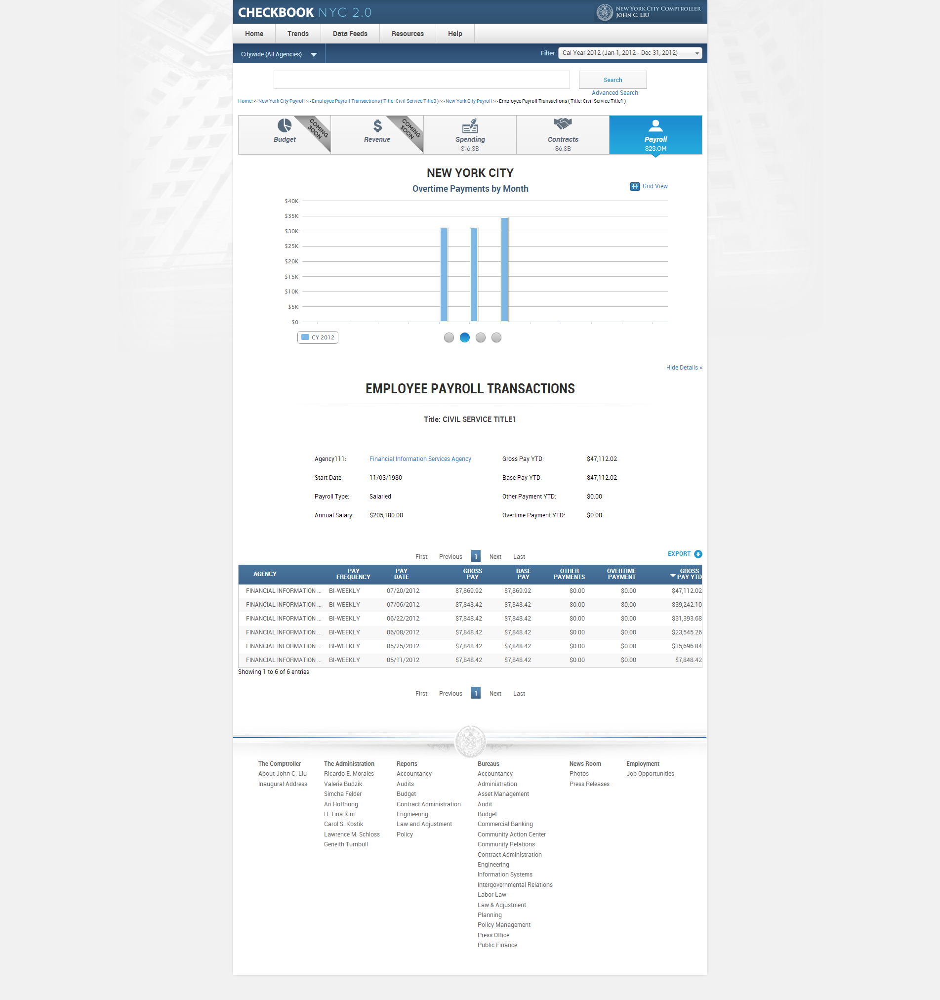

|  |  |  |  |
| --- | --- | --- | --- |
| **ID** | **KEY** | **FEATURE** | **DESCRIPTION** |
| **2.37** |  | **Employee Payroll Transactions Table sorting** | * The system shall present an Employee specific transactions table which consists of the following columns: ' TITLE', 'AGENCY', 'ANNUAL SALARY', 'PAY FREQUENCY', 'GROSS PAY YTD ', 'BASE PAY YTD', 'OTHER PAYMENTS YTD', 'OVERTIME PAYMENTSYTD'. On default, the contents within the table shall be sorted by the gross pay YTD column. However, the user shall be able to manually sort the contents by any of the column fields. |

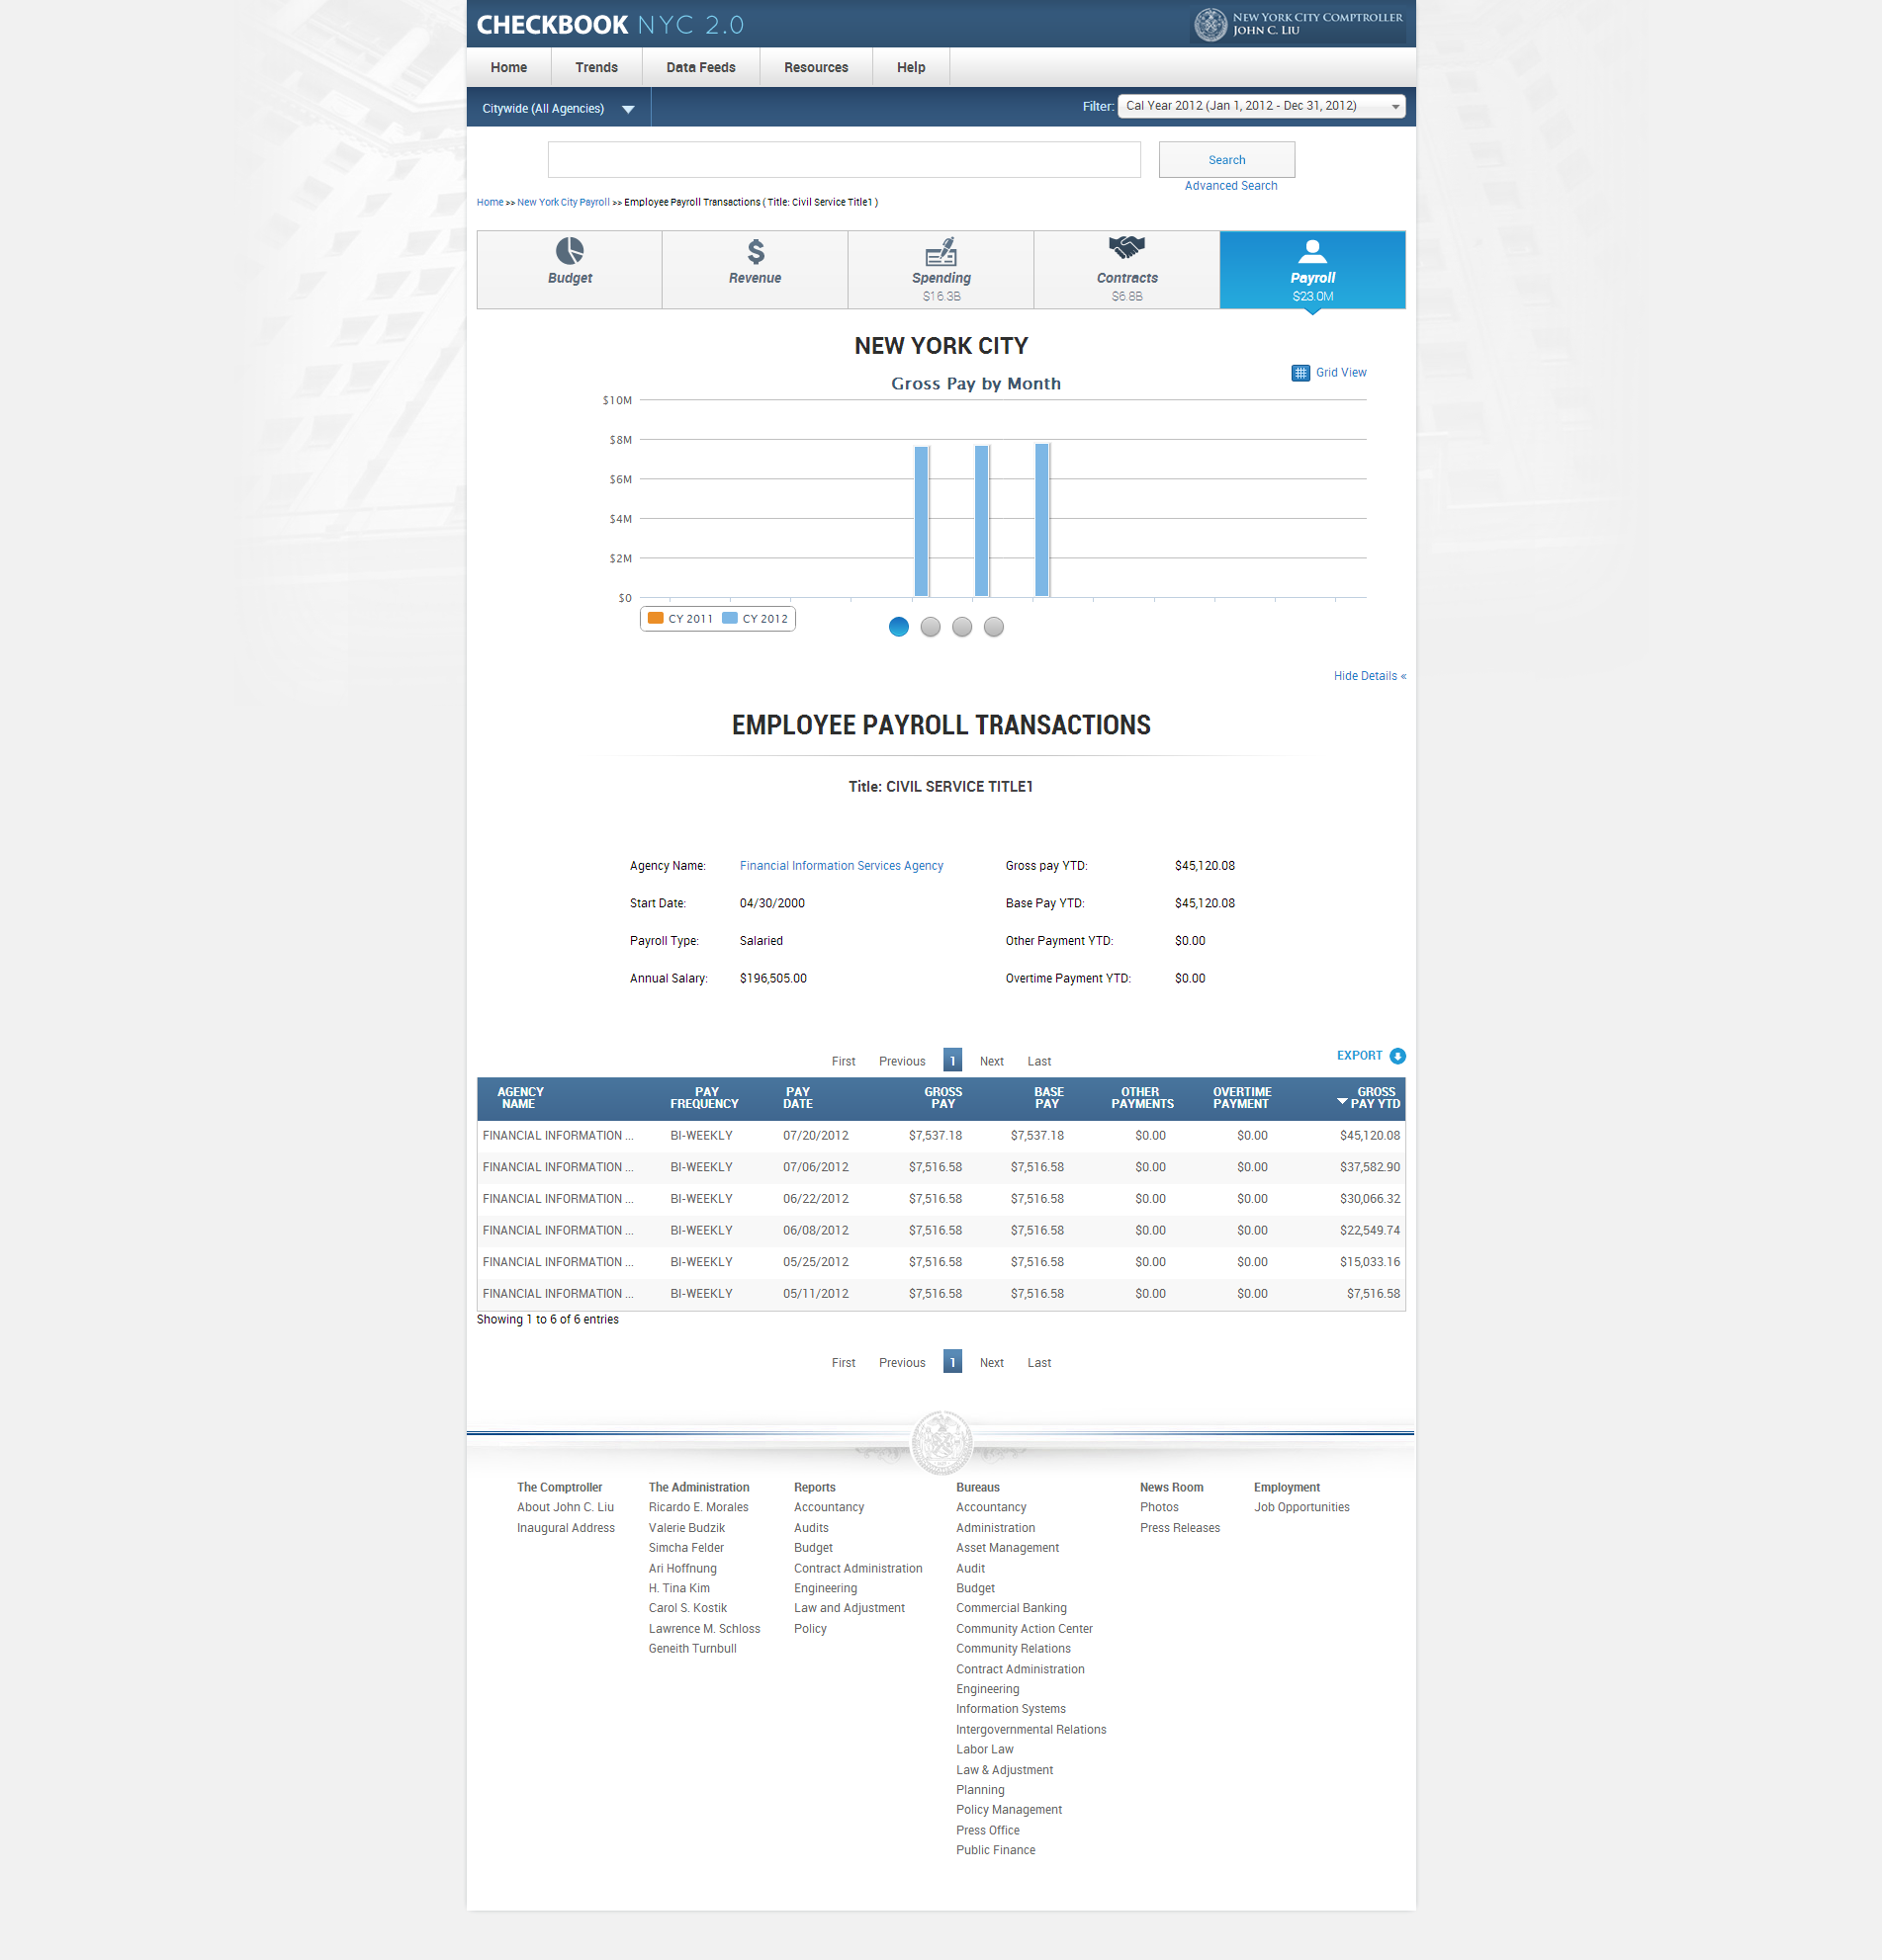

|  |  |  |  |  |  |
| --- | --- | --- | --- | --- | --- |
| **ID** | | **KEY** | **FEATURE** | **DESCRIPTION** | |
| **2.38** |  | | **Pagination** | * The system shall support a pagination feature which allows the user to view more than the initial 10 records displayed. The pagination feature: 'First Previous 1 2 3 4 5 Next Last'. |

Payroll NYC/Agency Transactions – Business Rules

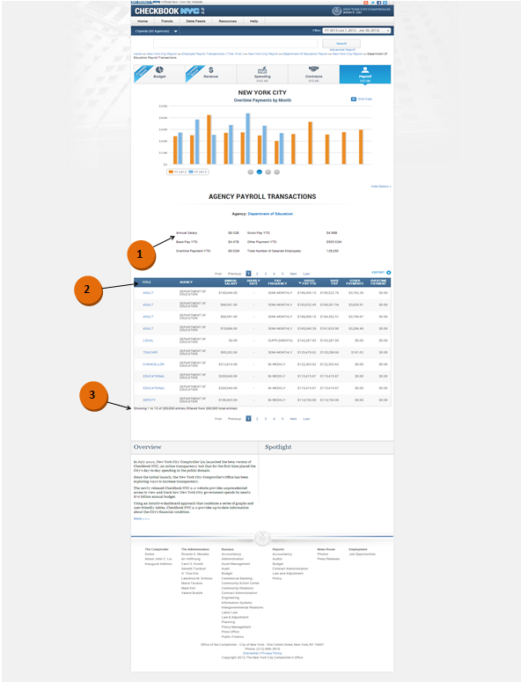

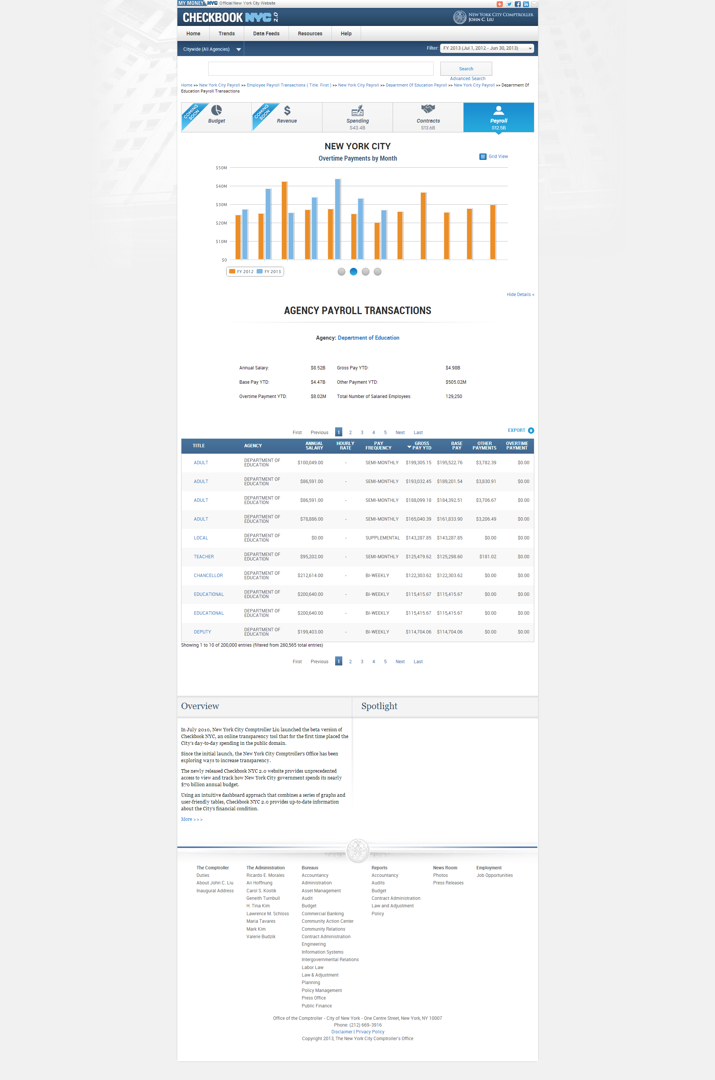

|  |  |  |  |
| --- | --- | --- | --- |
| **ID** | **KEY** | **FEATURE** | **DESCRIPTION** |
| **2.39** |  | **NYC/Agency Payroll Transactions Summary Information and Table** | * The system shall display the following static contents above the transactions table as summary information in the NYC/Agency specific payroll transactions page: 'ANNUAL SALARY', 'GROSS PAY YTD', 'BASE PAY', 'OTHER PAYMENTS YTD', 'OVERTIME PAYMENTS YTD', 'TOTAL NUMBER OF EMPLOYEES', 'TOTAL NUMBER OF SALARIED EMPLOYEES', 'TOTAL NUMBER OF NON-SALARIED EMPLOYEES' (agency shall be linkable; clicking on it shall direct the user to agency specific payroll landing page).   The following are the descriptions of the fields:     * The system shall present the following columns in the NYC/Agency specific transactions table:' TITLE', 'AGENCY', 'ANNUAL SALARY', 'PAY FREQUENCY', 'GROSS PAY YTD ', 'BASE PAY YTD', 'OTHER PAYMENTS YTD', 'OVERTIME PAYMENTSYTD'. * The system shall support a table that can display only 35 records in one page. |



|  |  |  |  |  |
| --- | --- | --- | --- | --- |
| **ID** | **KEY** | **FEATURE** | **DESCRIPTION** | |
| **2.40** |  | **Table Alignment** | * + - The system shall align the numbers in the widgets to the right, but centered in the column.     - The system shall align the text in the widgets to the left within the data rows.     - The system shall align the columns to be roughly equidistant from one other. |



|  |  |  |  |  |
| --- | --- | --- | --- | --- |
| **ID** | **KEY** | **FEATURE** | **DESCRIPTION** | |
| **2.41** |  | **Records Count Static Content** | * The system shall present 'Displaying transactions [x] – [y] of [z]'. X is the order number of the first record within the table, y is the order number of the last record within the table, and z is the total number of records. |

|  |  |  |  |
| --- | --- | --- | --- |
| **2.42** |  | **Miscellaneous** | * The system shall not present any hyperlinks that will direct the user out of the domain with the new browser window in the payroll domain. |

Payroll NYC/Agency Transactions – Functional Requirements

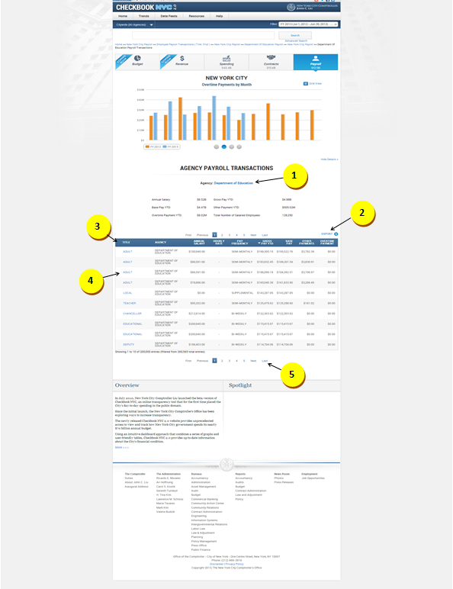



|  |  |  |  |
| --- | --- | --- | --- |
| **ID** | **KEY** | **FEATURE** | **DESCRIPTION** |
| **2.43** |  | **NYC/Agency Payroll Transactions Summary Information and Table hyperlinks** | * + The system shall direct the user to agency specific payroll landing page upon clicking on agency name link in the summary information section. * The system shall direct the user to the employee specific payroll transactions page upon clicking on content under the TITLE column in the transactions table. |

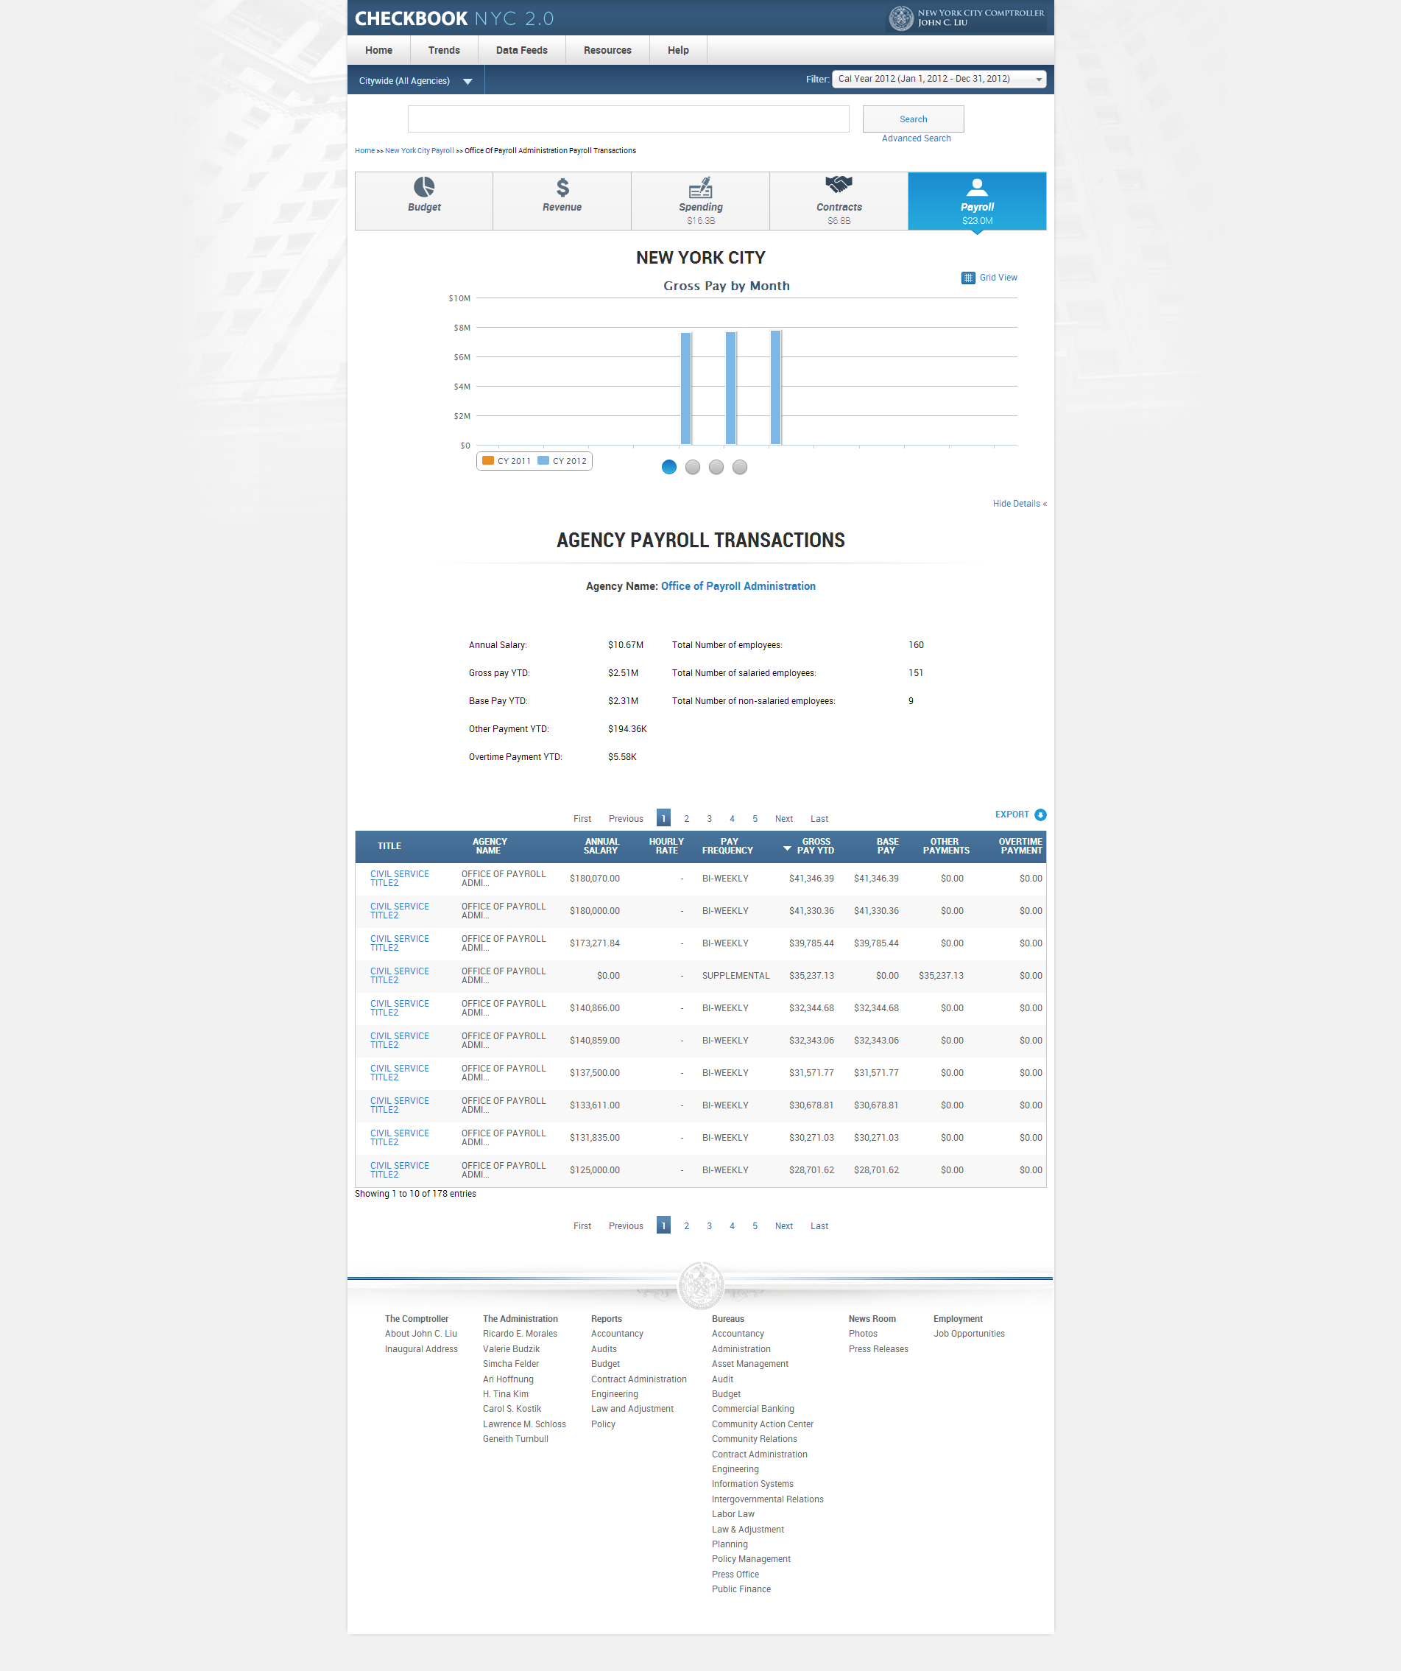

|  |  |  |  |  |
| --- | --- | --- | --- | --- |
| **ID** | **KEY** | **FEATURE** | **DESCRIPTION** | |
| **2.44** |  | **Export Link** | * The system shall support an export function in the payroll transactions page which shall allow the user to download part or all of the records in comma delimited format. The user shall have the option of selecting 'CURRENT PAGE', 'ALL PAGES, or PAGES FROM x to y. |

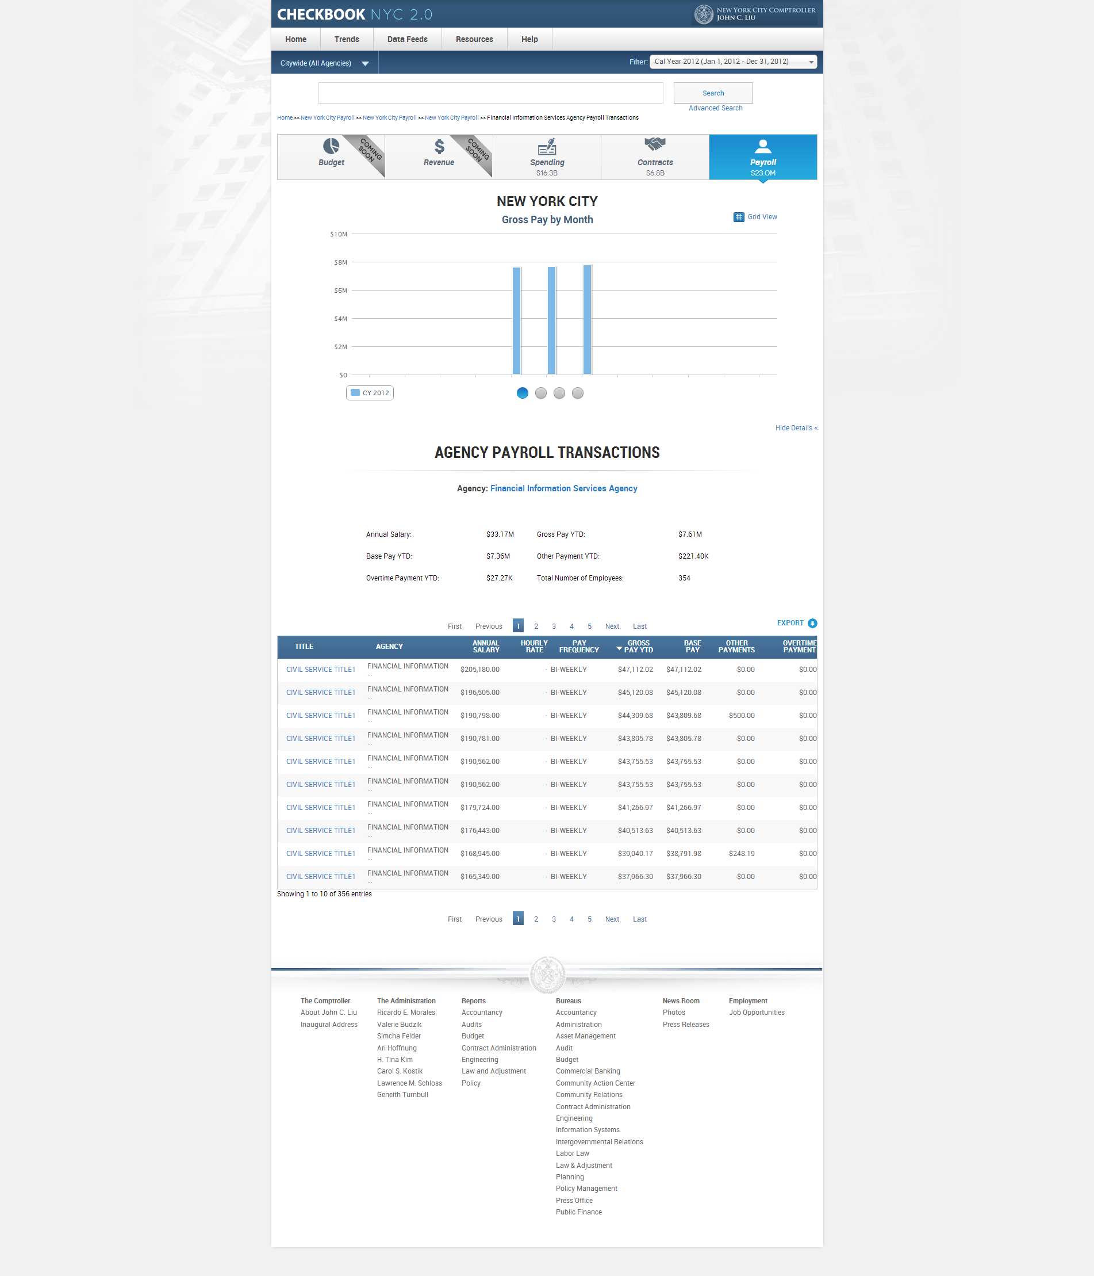

|  |  |  |  |  |
| --- | --- | --- | --- | --- |
| **ID** | **KEY** | **FEATURE** | **DESCRIPTION** | |
| **2.45** |  | **NYC/Agency Payroll Transactions Table sorting** | * The system shall, on default, sort the contents within the table by the gross pay YTD column. However, the user shall be able to manually sort the contents by any of the column fields. * The system shall support a table that can display only 35 records in one page. |



|  |  |  |  |  |  |
| --- | --- | --- | --- | --- | --- |
| **ID** | | **KEY** | **FEATURE** | **DESCRIPTION** | |
| **2.46** |  | | **Pagination** | * The system shall support a pagination feature that allows the user to view more than the initial 10 records displayed. The pagination feature: 'First Previous 1 2 3 4 5 Next Last'. |

Advanced Search Results Payroll Transactions – Business Rules

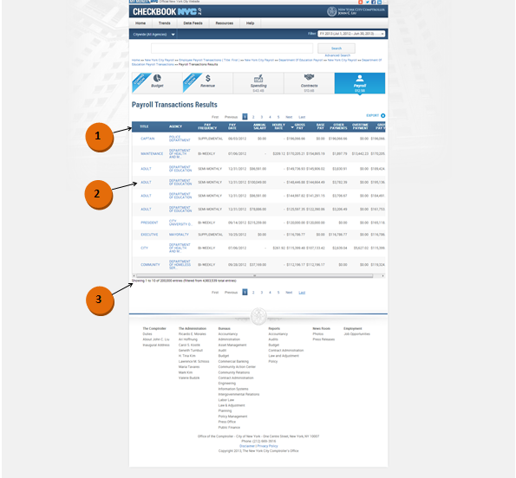

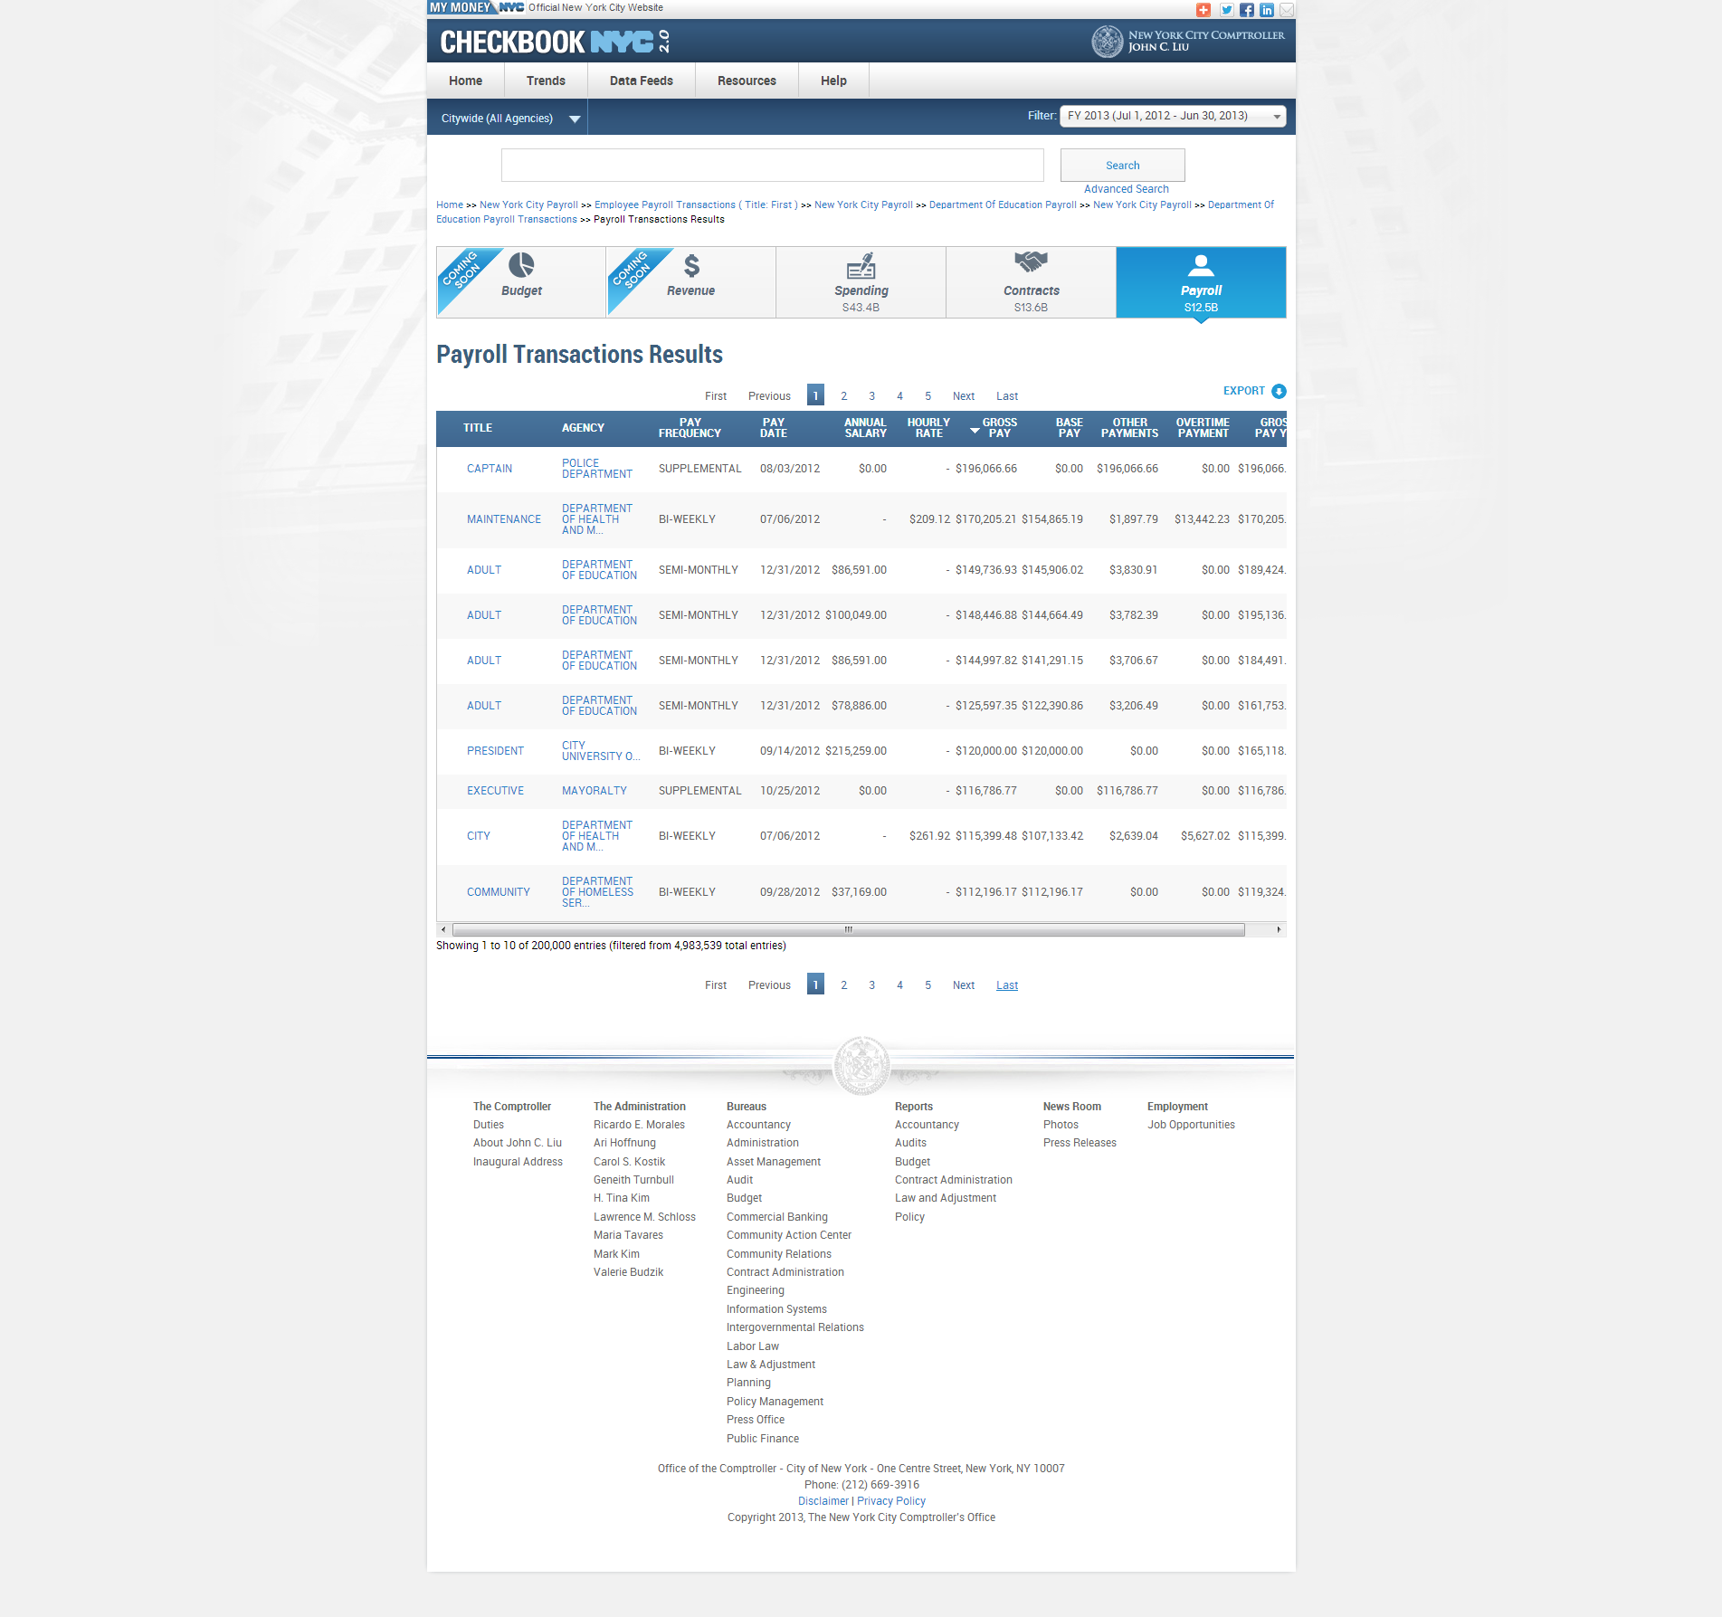

|  |  |  |  |
| --- | --- | --- | --- |
| **ID** | **KEY** | **FEATURE** | **DESCRIPTION** |
| **2.47** |  | **Advanced Search Payroll Transactions Results Table** | * The system shall display no static contents (summary information) for payroll transactions page resulting from an advanced search. * The system shall present the following columns in the transactions table, resulting from an advanced search: 'TITLE', ‘AGENCY’, ‘PAY FREQUENCY’, ‘PAY DATE’, ‘ANNUAL SALARY’, ‘GROSS PAY’, ‘BASE PAY’, ‘OTHER PAYMENTS’, ‘OVERTIME PAYMENTS’, ‘GROSS PAY YTD’. * The system shall support a table that can display only 35 records in one page. |



|  |  |  |  |  |
| --- | --- | --- | --- | --- |
| **ID** | **KEY** | **FEATURE** | **DESCRIPTION** | |
| **2.48** |  | **Table Alignment** | * + - The system shall align the numbers in the widgets to the right, but centered in the column.     - The system shall align the text in the widgets to the left within the data rows.     - The system shall align the columns to be roughly equidistant from one other. |



|  |  |  |  |  |
| --- | --- | --- | --- | --- |
| **ID** | **KEY** | **FEATURE** | **DESCRIPTION** | |
| **2.49** |  | **Records Count Static Content** | * The system shall present 'Displaying transactions [x] – [y] of [z]'. X is the order number of the first record within the table, y is the order number of the last record within the table, and z is the total number of records. |

|  |  |  |  |  |
| --- | --- | --- | --- | --- |
| **ID** | **KEY** | **FEATURE** | **DESCRIPTION** | |
| **2.50** |  | **Miscellaneous** | * The system shall not present any hyperlinks that will direct the user out of the domain with the new browser window in the payroll domain. |

Advanced Search Results Payroll Transactions – Functional Requirements

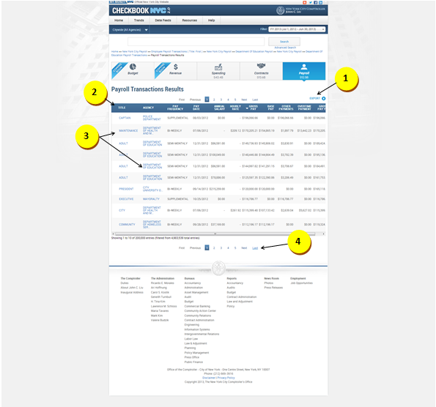



|  |  |  |  |
| --- | --- | --- | --- |
| **ID** | **KEY** | **FEATURE** | **DESCRIPTION** |
| **2.51** |  | **Export Link** | * The system shall support an export function in the payroll transactions page which shall allow the user to download part or all of the records in comma delimited format. The user shall have the option of selecting 'CURRENT PAGE', 'ALL PAGES, or PAGES FROM x to y. |

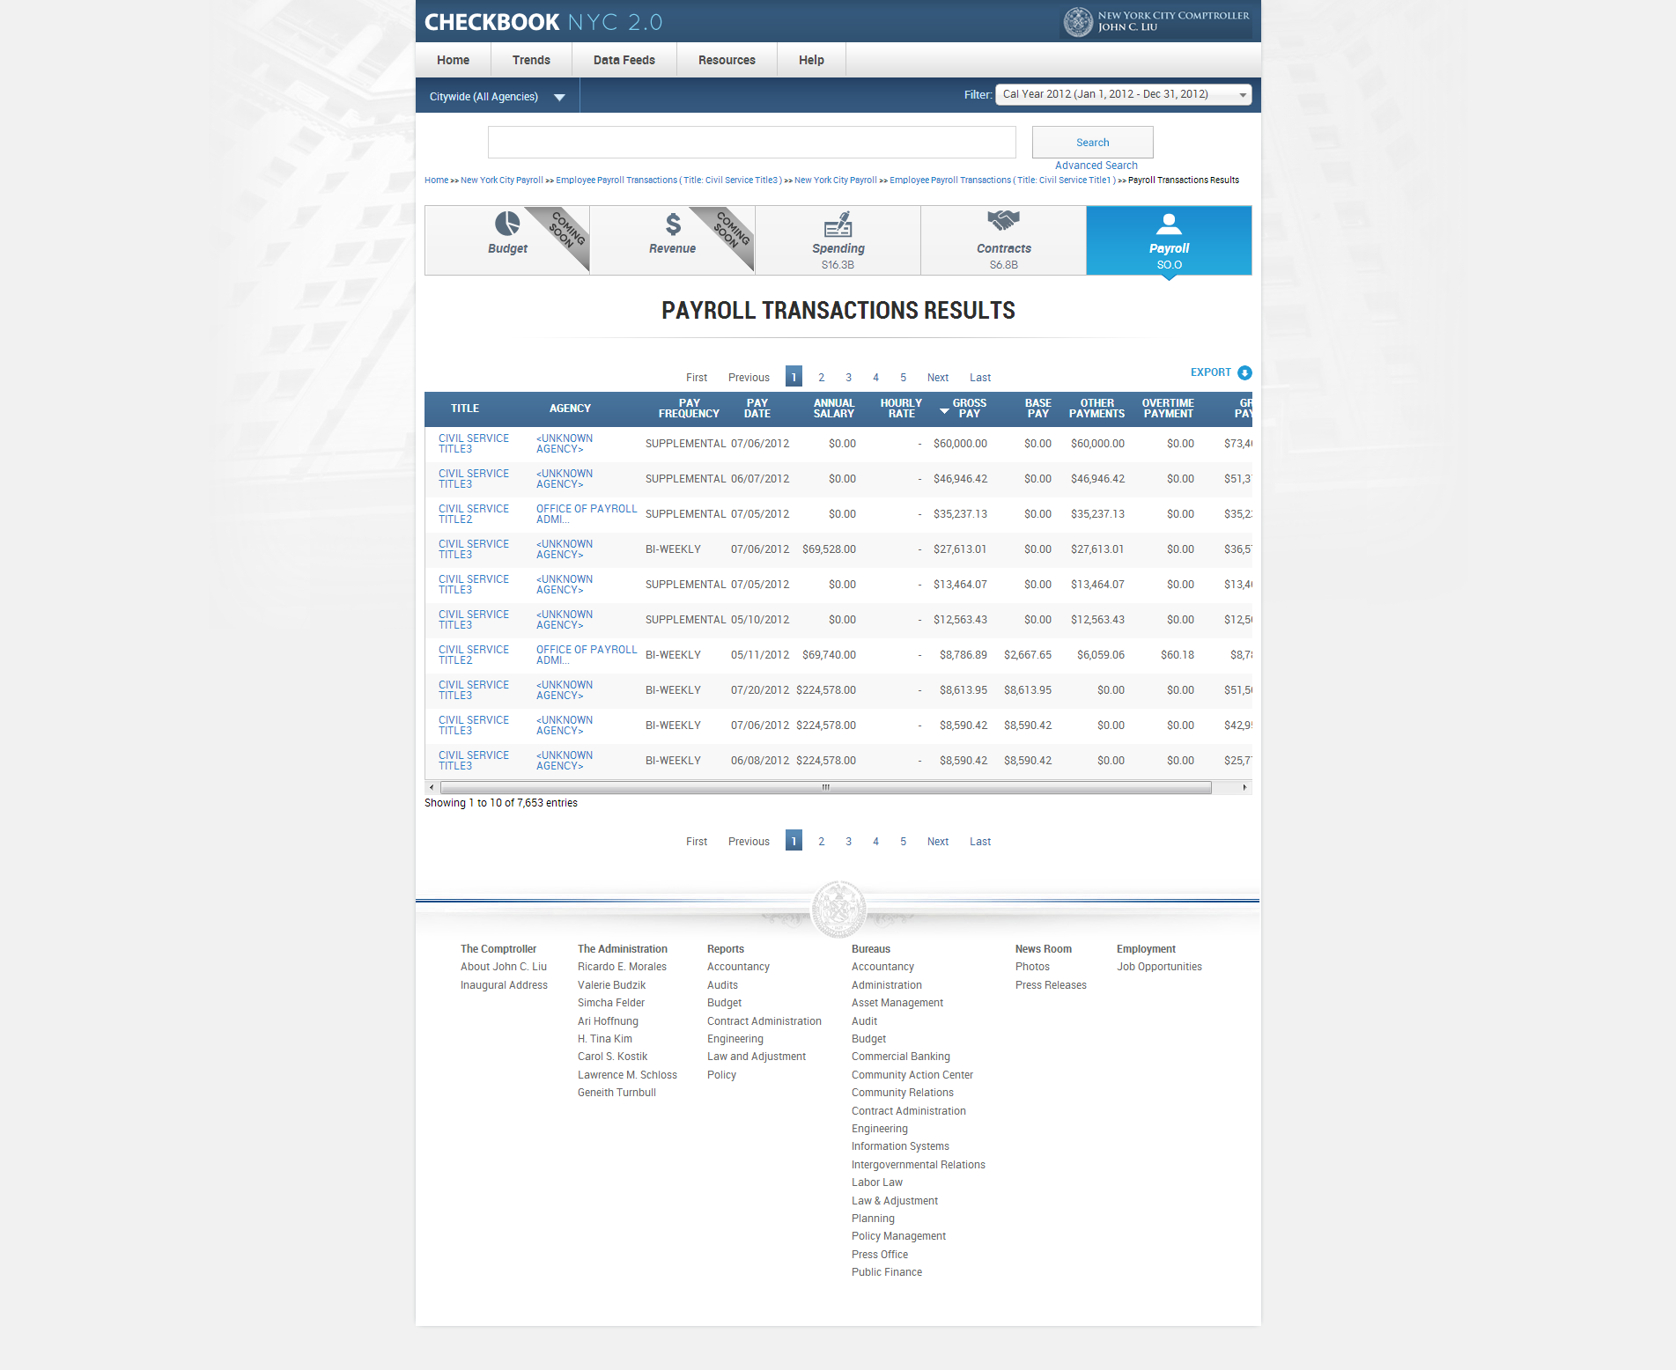

|  |  |  |  |  |
| --- | --- | --- | --- | --- |
| **ID** | **KEY** | **FEATURE** | **DESCRIPTION** | |
| **2.52** |  | **Advanced Search Payroll Transactions Results Table sorting** | * The system shall, on default, sort the contents within the table by the gross pay YTD column. However, the user shall be able to manually sort the contents by any of the column fields. |



|  |  |  |  |  |
| --- | --- | --- | --- | --- |
| **ID** | **KEY** | **FEATURE** | **DESCRIPTION** | |
| **2.53** |  | **Advanced Search Payroll Transactions Results Table hyperlinks** | * The system shall direct the user to the employee specific transactions page and the agency specific payroll landing page upon clicking on content links under TITLE column and AGENCY NAME column, respectively. |



|  |  |  |  |  |  |
| --- | --- | --- | --- | --- | --- |
| **ID** | | **KEY** | **FEATURE** | **DESCRIPTION** | |
| **2.54** |  | | **Pagination** | * The system shall support a pagination feature which allows the user to view more than the initial 10 records displayed. The pagination feature: 'First Previous 1 2 3 4 5 Next Last'. |

* 1. Spending

Spending Landing - Business Rules

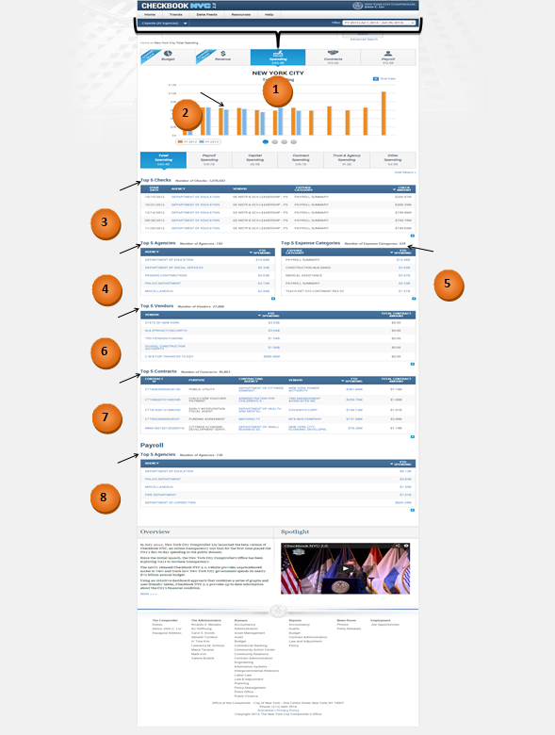



|  |  |  |  |
| --- | --- | --- | --- |
| **ID** | **KEY** | **FEATURE** | **DESCRIPTION** |
| **3.1** |  | **Header** | * The header includes all components above the top menu bar. It should include NYC 2.0 logo, Comptroller logo, my money site logo, social media links like add this, twitter, Facebook, LinkedIn and also includes email option. All these should be hyperlinked including logos. |

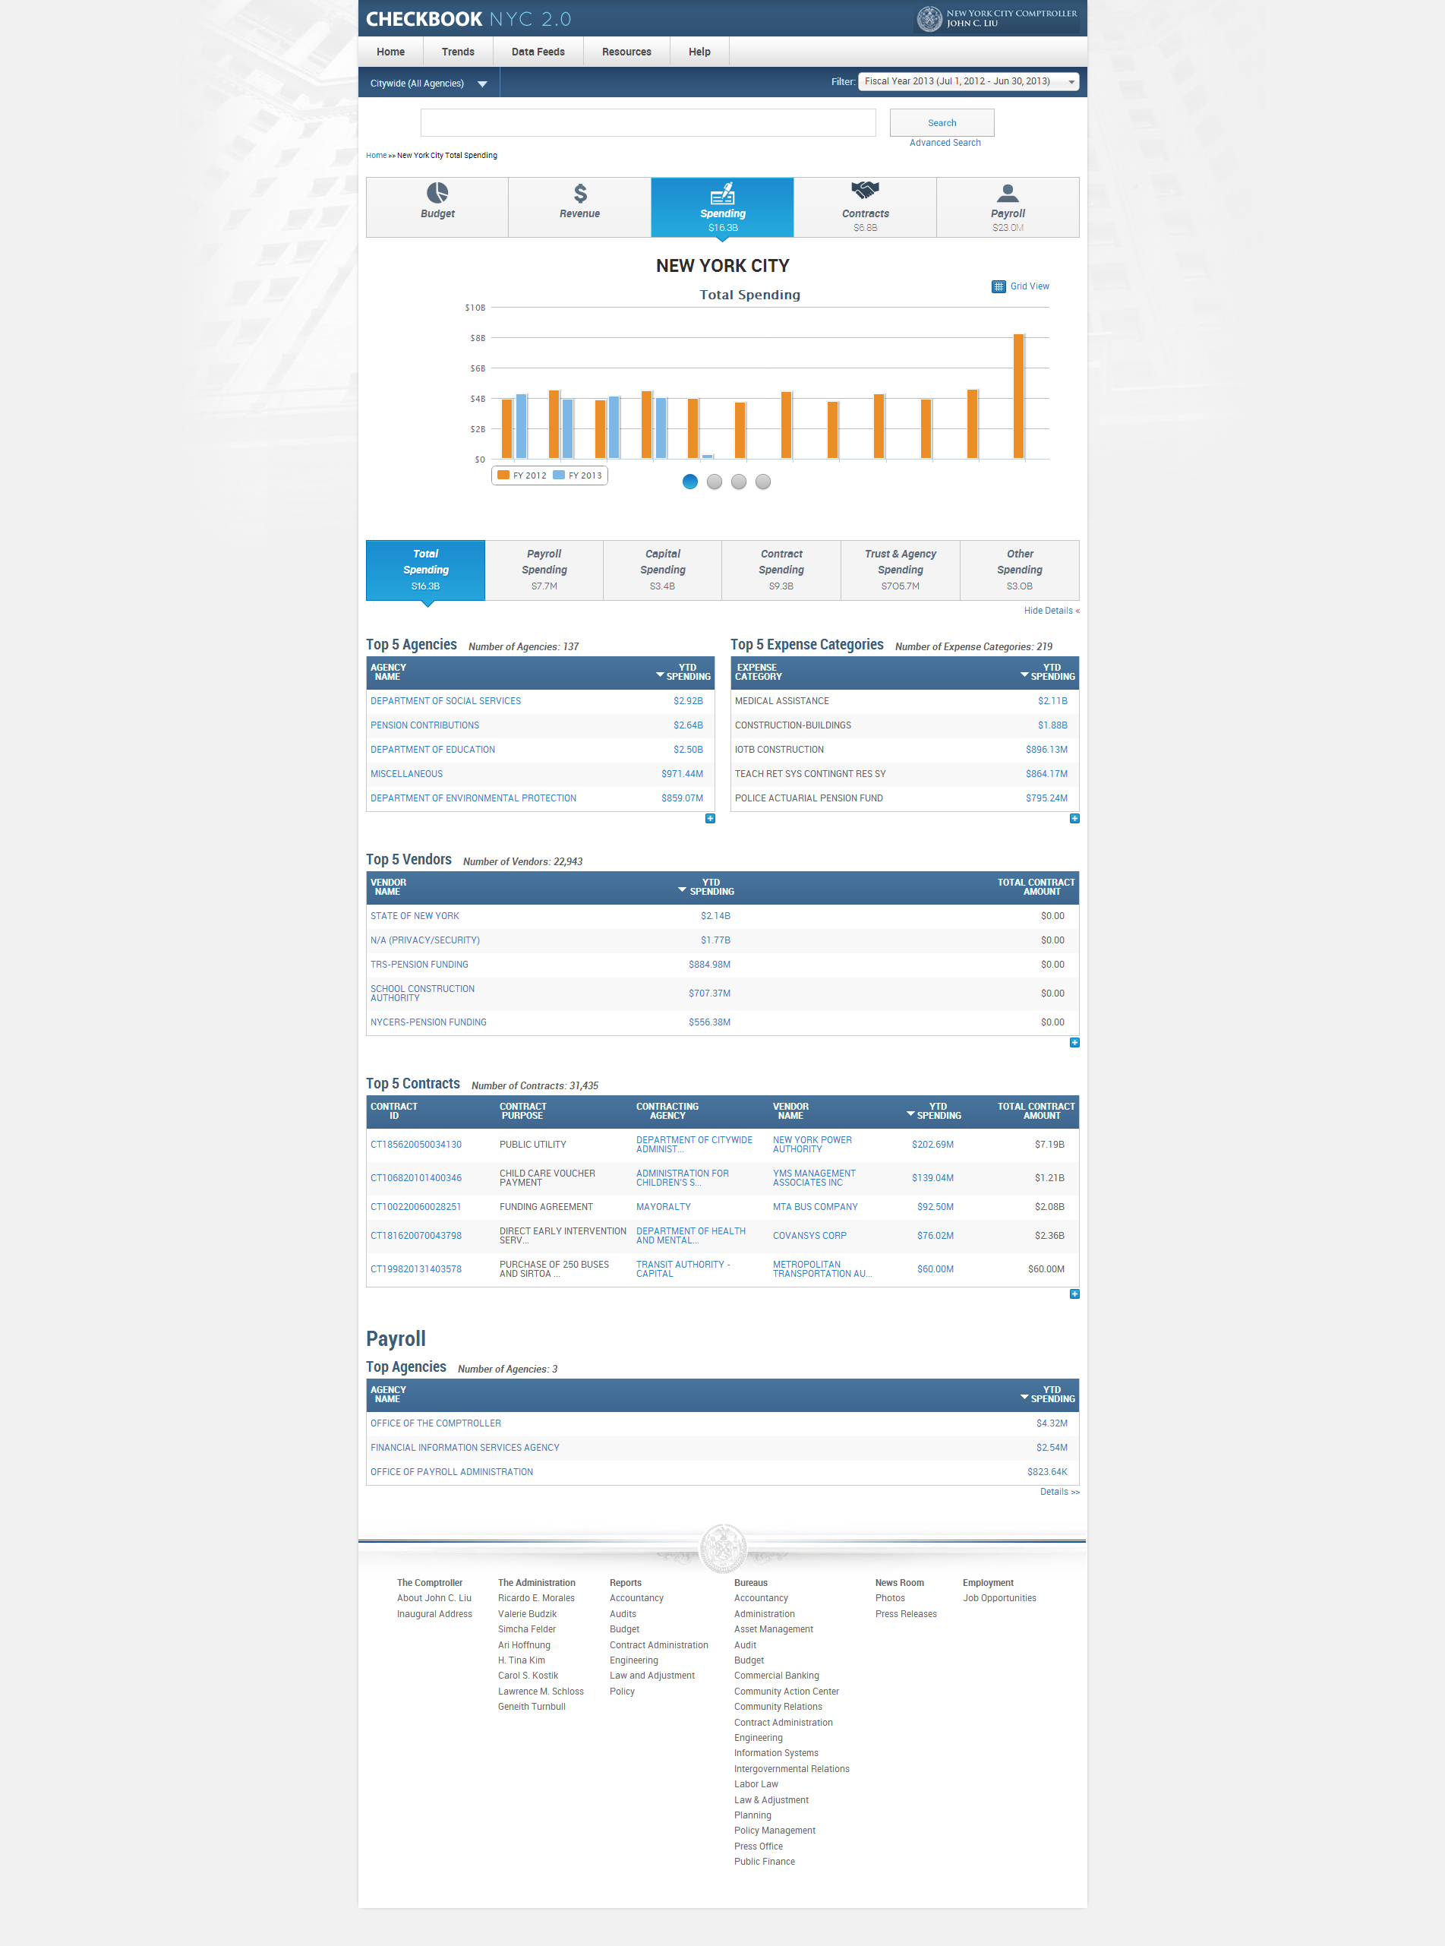

|  |  |  |  |  |  |
| --- | --- | --- | --- | --- | --- |
| **ID** | | **KEY** | **FEATURE** | **DESCRIPTION** | |
| **3.2** |  | **Total Spending visualization** | The system shall display a bar graph comparing spending of current FY to that of last FY in a monthly basis.   * Title:Total Spending * The system shall not include axis titles for X and Y axes. * Legend: * Previous Year * Current Year * Bar Colors:   - Previous Year (Cadmium Orange [#ED872D])  - Selected Year (Celestial Blue [#4997D0]) |

|  |  |  |  |  |  |
| --- | --- | --- | --- | --- | --- |
| **ID** | | **KEY** | **FEATURE** | **DESCRIPTION** | |
| **3.3** |  | **Top Ten Agencies by disbursement amount visualization** | * The system shall display a bar graph of the top 10 agencies, ranked by disbursement amount. * Title: Top Ten Agencies by Disbursement Amount * The system shall not include axis titles for X and Y axes. * No legend shall be applicable for this graph. * Bar Color:   (Celestial Blue [#4997D0]) |

|  |  |  |  |  |  |
| --- | --- | --- | --- | --- | --- |
| **ID** | | **KEY** | **FEATURE** | **DESCRIPTION** | |
| **3.4** |  | **Top Ten Contracts by disbursement amount visualization** | * The system shall display a bar graph of the top 10 contracts, ranked by disbursement amount. * Title: Top Ten Contracts by Disbursement Amount * The system shall not include axis titles for X and Y axes. * No legend shall be applicable for this graph. * Bar Color:   (Celestial Blue [#4997D0]) |

|  |  |  |  |  |  |
| --- | --- | --- | --- | --- | --- |
| **ID** | | **KEY** | **FEATURE** | **DESCRIPTION** | |
| **3.5** |  | **Top Ten Vendors by disbursement amount visualization** | * The system shall display a bar graph of the top 10 vendors, ranked by disbursement amount. * Title: Top Ten Contracts by Disbursement Amount * The system shall not include axis titles for X and Y axes. * No legend shall be applicable for this graph. * Bar Color:   (Celestial Blue [#4997D0]) |

|  |  |  |  |  |  |
| --- | --- | --- | --- | --- | --- |
| **ID** | | **KEY** | **FEATURE** | **DESCRIPTION** | |
| **3.6** |  | **Top 5 Checks widget** | * ***Data rule****-* System shall display checks associated to agency, vendor, and expense category for the selected FY/CY along with the selected spending category filter. * The system shall display the static content ‘Number of Checks: x’ to the right of the title ‘Top 5 Checks’. * The system shall replace all 'N/A' under the VENDOR column with the corresponding department name. |

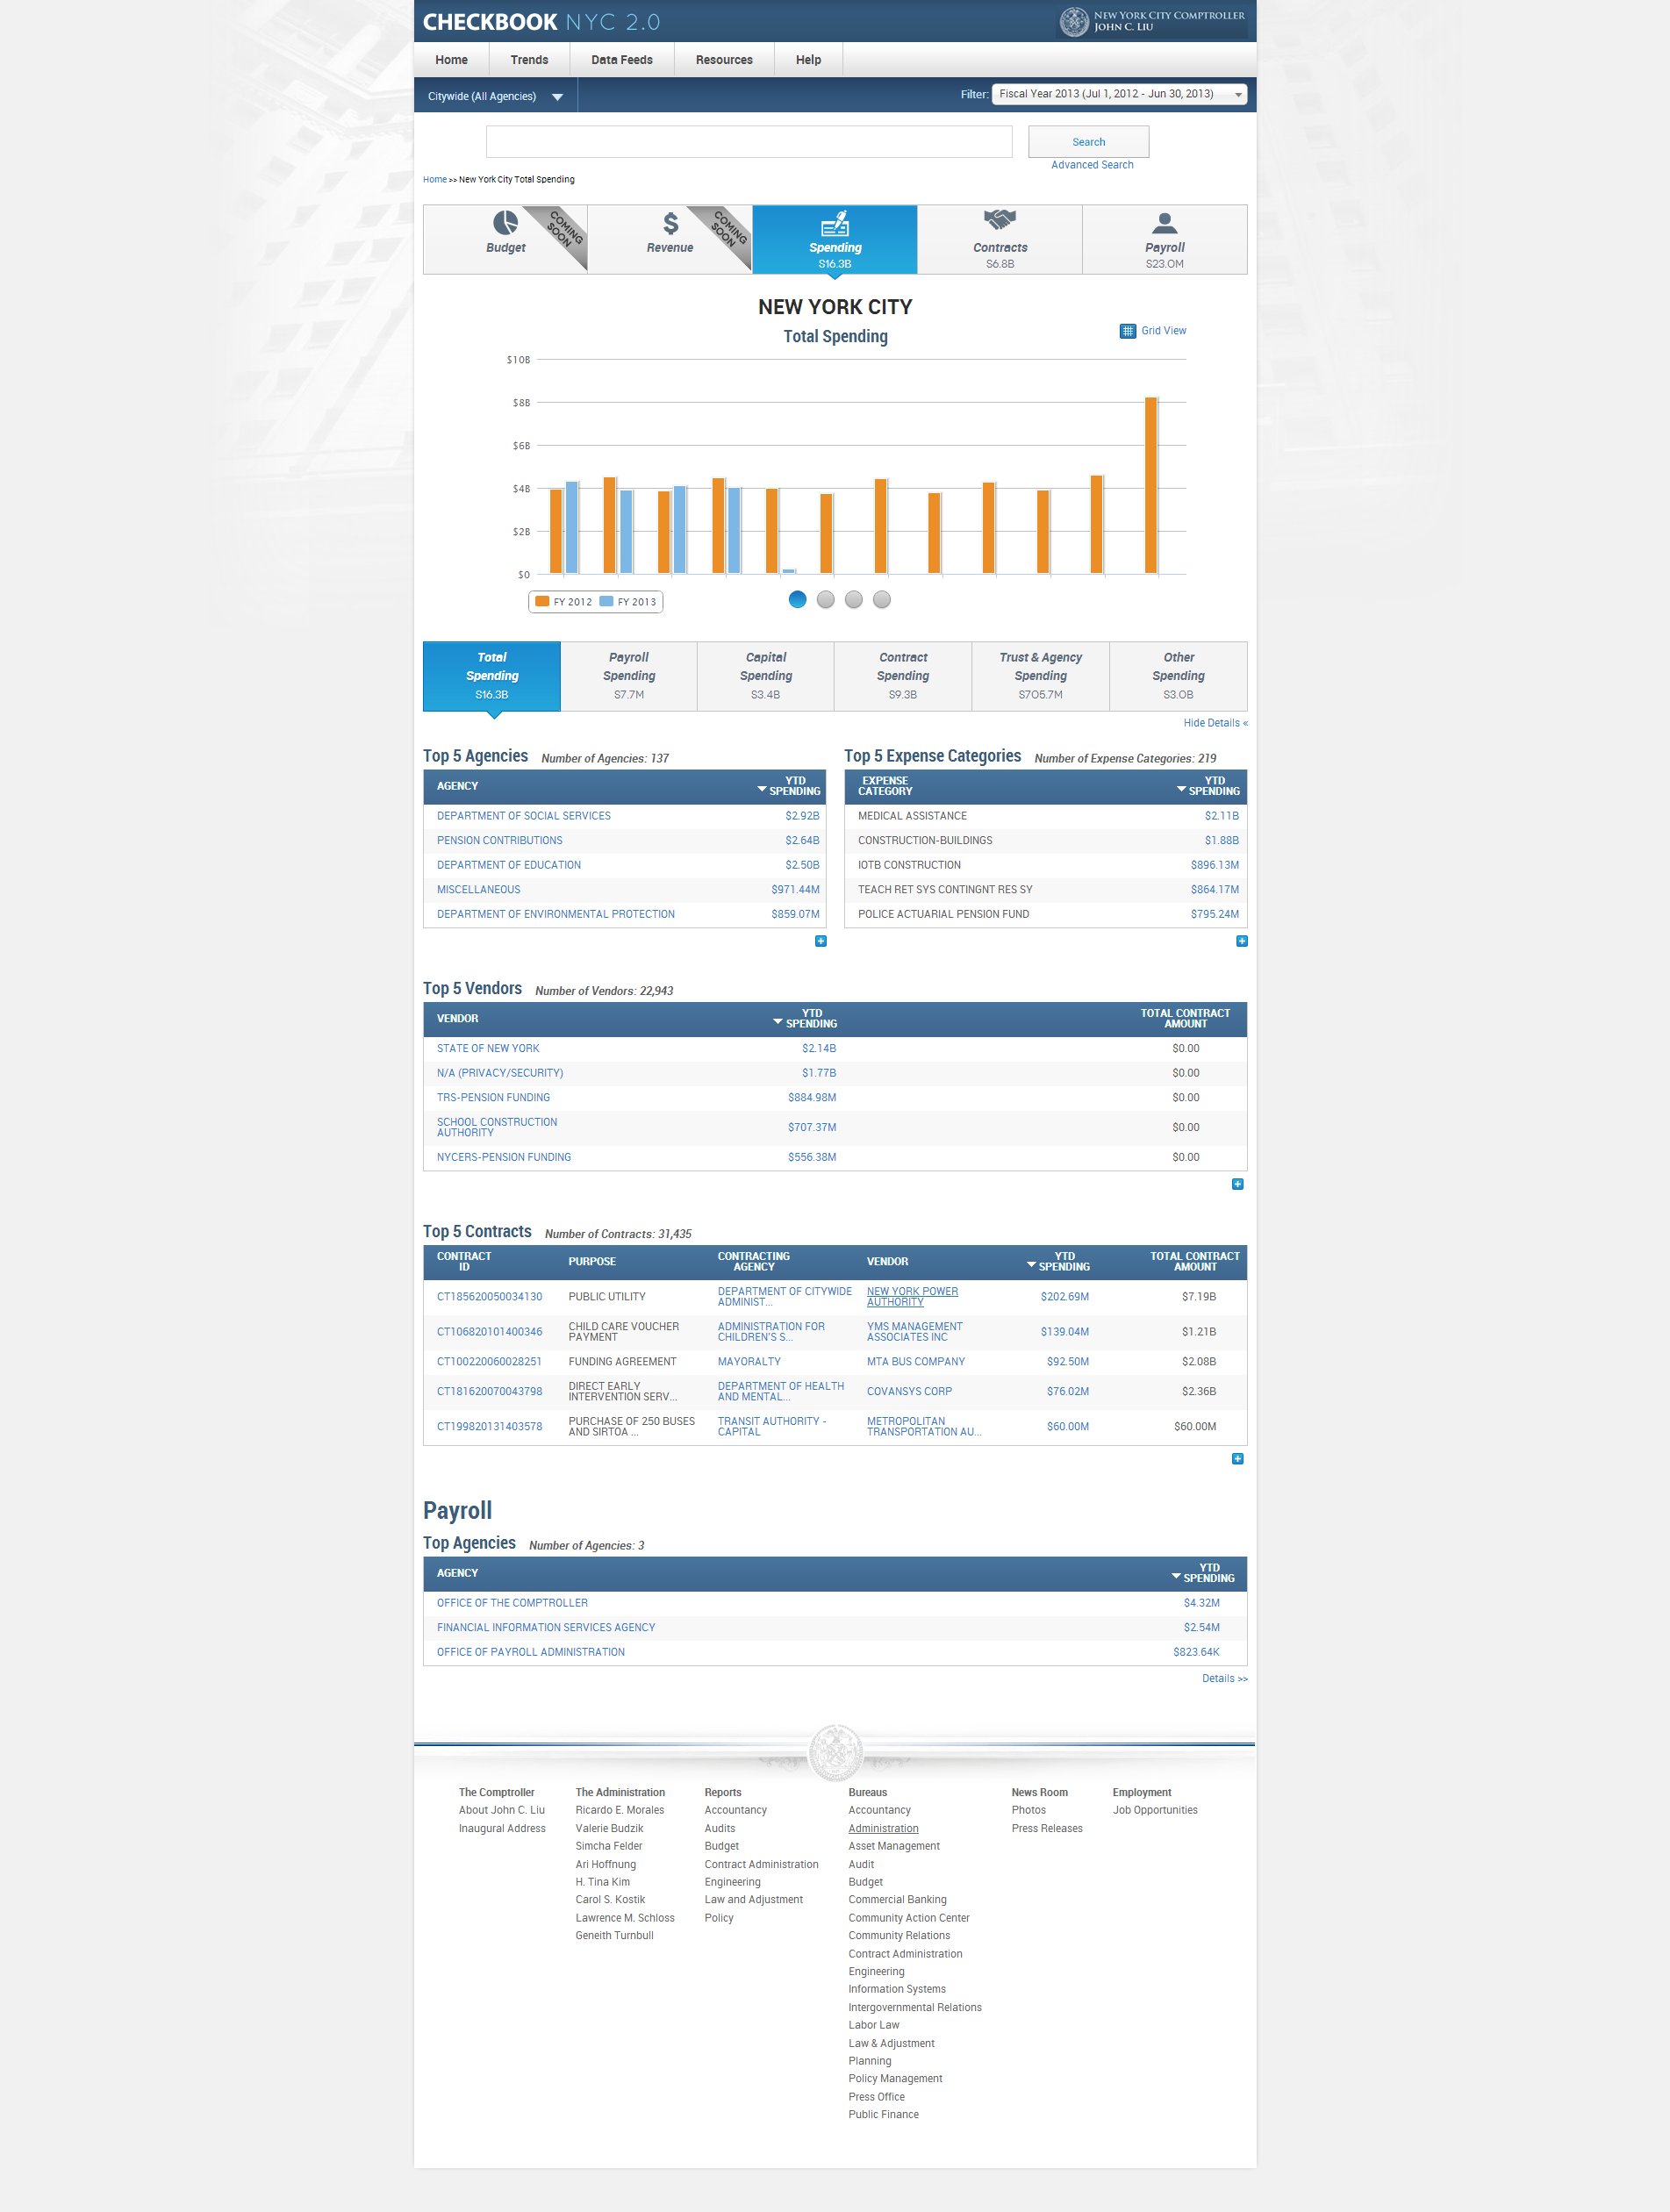

|  |  |  |  |  |  |
| --- | --- | --- | --- | --- | --- |
| **ID** | | **KEY** | **FEATURE** | **DESCRIPTION** | |
| **3.7** |  | **Top 5 Agencies widget** | * **Data rule-** System shall display total disbursements associated to an agency for a selected FY/CY along with the selected spending category filter. * The system shall display the static content ‘Number of Agencies: x’ to the right of the title ‘Top 5 Agencies’. |



|  |  |  |  |  |  |
| --- | --- | --- | --- | --- | --- |
| **ID** | | **KEY** | **FEATURE** | **DESCRIPTION** | |
| **3.8** |  | **Top 5 Expense Categories widget** | * Data rule- System shall display total disbursements associated to an expense category for a selected FY/CY along with the selected spending category filter. * The system shall display the static content ‘Number of Expense Categories: x’ to the right of the title ‘Top 5 Expense Categories. |



|  |  |  |  |  |  |
| --- | --- | --- | --- | --- | --- |
| **ID** | | **KEY** | **FEATURE** | **DESCRIPTION** | |
| **3.9** |  | **Top 5 Vendors widget** | * Data rule- System shall display total disbursements associated to a vendor for a selected FY/CY along with the selected spending category filter. * The system shall consider CT1, CTA1, POD, POC, PCC1, and DO1 contract types for the widget. * The system shall display the static content ‘Number of Vendors: x’ to the right of the title ‘Top 5 Vendors’. |



|  |  |  |  |  |  |
| --- | --- | --- | --- | --- | --- |
| **ID** | | **KEY** | **FEATURE** | **DESCRIPTION** | |
| **3.10** |  | **Top 5 Contracts widget** | * Data rule- System shall display total disbursements associated to a contract for a selected FY/CY along with the selected spending category filter. * The system shall consider CT1, CTA1, POD, POC, PCC1, and DO1 contract types for the widget. * The system shall display the static content ‘Number of Contracts: x’ to the right of the title ‘Top 5 Contracts’. |



|  |  |  |  |  |  |
| --- | --- | --- | --- | --- | --- |
| **ID** | | **KEY** | **FEATURE** | DESCRIPTION | |
| **3.11** |  | ***Payroll domain*** | * Data rule- System shall display total payroll disbursements associated to an agency for a selected FY/CY. * The system shall display the static content ‘Number of Agencies: x’ to the right of the title ‘Top 5 Agencies’. |

|  |  |  |  |  |  |
| --- | --- | --- | --- | --- | --- |
| **ID** | | **KEY** | **FEATURE** | **DESCRIPTION** | |
| **3.12** |  | **Transactions Page Overview** | * The system shall display the top slider/visualization/bottom slider when the spending transactions are presented. * The system also includes the following other columns in the table: document id, issue date, department, check amount, expense category, and contract purpose, capital project, spending category, contract ID and vendor. * The system shall not include any contracts data under others and payroll spending. |

Spending Landing - Functional Requirements

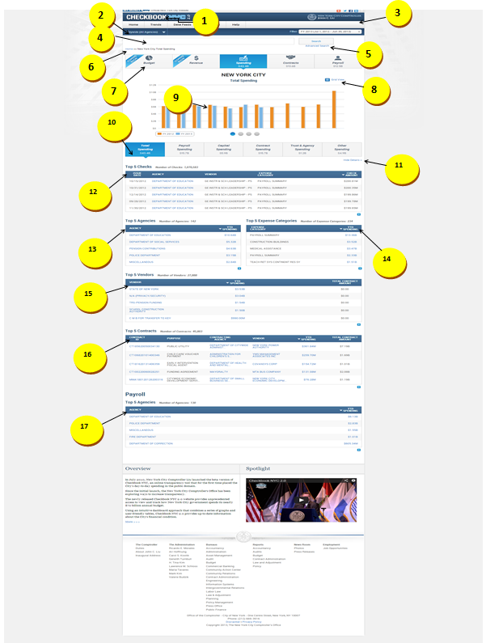



|  |  |  |  |
| --- | --- | --- | --- |
| **ID** | **KEY** | **FEATURE** | **DESCRIPTION** |
| **3.13** |  | **Top Menu Bar** | * + - The system shall present tabs at the top menus bar in the following order: Home, Trends, Data Feeds, Resources, and Help.     - The system shall not contain drop-downs for the Home and Data Feeds tabs.     - The system shall present the drop-down for Trends in the following order – Featured Trends, All Trends, Financial, Revenue Capacity, Debt Capacity, Demographic, and Operational. * Each of the additional trends - Financial, Revenue Capacity, Debt Capacity, Demographic, Operational – have additional groupings of trends, which are opened in the menu call out. * The system shall contain the following drop-downs for help tab: Site Navigation & Glossary, FAQ, Ask a Question, Report a Problem and Share an Idea. * Site Navigation & Glossary would display information for three domains: Contracts, Payroll and Spending. Within contracts domain, agencies list with codes is embedded to be downloaded. |



|  |  |  |  |  |  |
| --- | --- | --- | --- | --- | --- |
| **ID** | | **KEY** | **FEATURE** | **DESCRIPTION** | |
| **3.14** |  | **Citywide Filter** | * The system shall direct the user to an agency specific landing page if user clicks on any particular agency from the dropdown list. By default, citywide agencies filter shall be preselected. * Once user selects an agency, the top navigation numbers will also update that agency level for the selected year. |



|  |  |  |  |  |  |
| --- | --- | --- | --- | --- | --- |
| **ID** | | **KEY** | **FEATURE** | **DESCRIPTION** | |
| **3.15** |  | **Date filter** | * The system shall allow the user to select a particular fiscal year or calendar year. Contracts data, by default, shall display current fiscal year. * When the user navigates through other domains, the date filter shall not carry forward to the other domains. It always defaults to current fiscal year. * The system shall have Budget, Revenue and Payroll domains not clickable. The amount will update to zero dollars when user selects calendar year. Only Spending, Contracts, and Payroll domains shall update based on calendar year. |



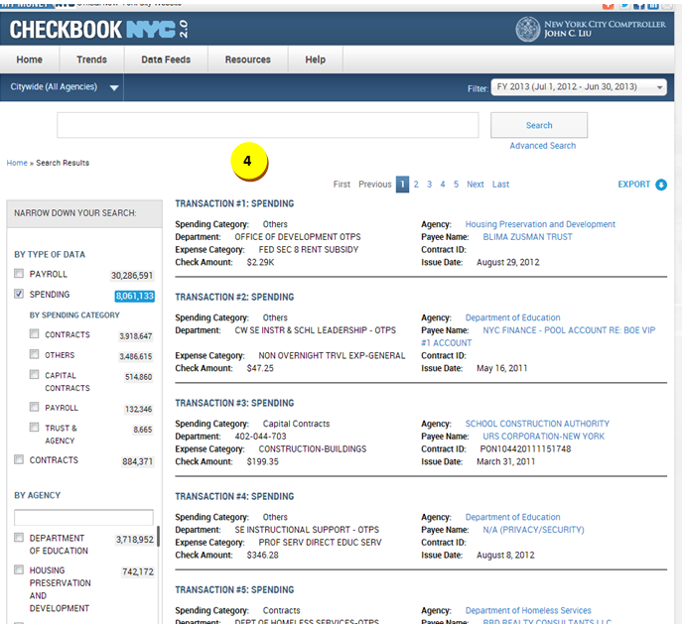

|  |  |  |  |  |  |
| --- | --- | --- | --- | --- | --- |
| **ID** | | **KEY** | **FEATURE** | **DESCRIPTION** | |
| **3.16** |  | **Smart search** | * + - The system shall place the Smart Search below Citywide and Date Filter navigation and above top navigation.     - The system shall support ALL string searches.     - The system shall not present the top navigation upon smart search results.     - The system shall present the citywide filter and Date filter in the smart search results. * Clicking on the Date filter shall take the user to NYC Spending page for current FY or the selected FY. * All resulting fields in smart search shall be displayed in two lines with hover over functionality * The system shall present export functionality in smart search. * The resulting field names for spending domain are Spending Category, Agency, Department, Payee Name, Expense Category, Contract ID, Check Amount, and Issue Date. Only Agency and Payee name will be hyperlinked. * The narrow-down facet selections are By Type of Data, By Agency, By Vendor, By Expense Category and By Fiscal Year. * On clicking spending domain within type of data, by spending category sub-category will be displayed indented. The items under the sub-category will not be selected by default. |



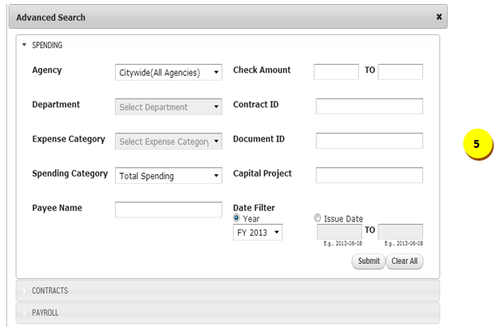

|  |  |  |  |  |  |
| --- | --- | --- | --- | --- | --- |
| **ID** | | **KEY** | **FEATURE** | **DESCRIPTION** | |
| **3.17** |  | **Advanced search** | * Different tabs within the advanced search pop-up shall allow the user to search in different domains. * The system shall present the following search criteria with the dropdown functionality:   + Agency   + Spending Category   + Department (only applicable when an agency is selected)   + Expense Category (only applicable when an agency is selected) * The system shall present the following search criteria with the text-box functionality:   + Check Amount * The system shall present the following search criteria with the text-box autocomplete functionality:   + Payee Name   + Contract ID   + Document ID   + Capital Project * The system shall present the following search criteria with the calendar functionality:   + Issue Date * Date filter is a radio button option with year and issue date as the two options. Year button will be pre-selected by default with current fiscal year * The user shall enter the agency name to enable department and expense categories. * By default, department and expense category fields will be grayed out. * The advance search results page shall display top navigation bar, with spending domain highlighted. Once the user selects an agency, the top navigation numbers will update based on the selected agency. Once the user selects an agency, department and expense category list will include data with respect to that agency. * Once the user selects an agency and then selects department, then the list for expense category will include data for both agency and department together. * From the contract ID field, master contracts (MMA1 and MA1) are excluded. * Once the user starts typing MMA1, the system shall display “No matches found” in the autocomplete. If a user types MMA1 or MA1 and submits the request, a message shall be displayed in the resulting transaction screen to search for master contracts in contracts advanced search. * The system shall support narrow-down functionality for the advanced search. For instance, if a specific agency is selected from the ‘AGENCY’ criteria then the autocomplete and dropdown options will only be applicable for the selected agency. * The system shall perform **“exact”** functionality when user selects any result from the dropdown autocomplete list and that search term shall be pre-selected within the narrow down facet if applicable. * The system shall perform **“like”** functionality when user enters search term within text box and clicks submit button. The search term shall not be pre-selected within the narrow down facet. |



|  |  |  |  |  |  |
| --- | --- | --- | --- | --- | --- |
| **ID** | | **KEY** | **FEATURE** | **DESCRIPTION** | |
| **3.18** |  | **Breadcrumbs** | * The system shall present breadcrumbs which consist of a maximum of eight elements. * Upon initial visit to the application, the first element shall be ‘Home’.  The titles of the breadcrumb elements shall be specific.  The breadcrumbs shall essentially present a historical path of navigation.  Below is an example:   Home > New York City Active Expense Contracts > Department of Defense Active Expense Contracts > Department of Defense Active Expense Contracts Transactions > Active Expense Contracts Greater than $1M > Standardized Services Active Expense Contracts > Active Expense Master Agreements Transactions > CTA1290583294   * Once the user visits the 9th page, the eighth element shall disappear, and shall be replaced by a new element. Only the eighth element will update. * No short names to be used in breadcrumbs. Placement of the breadcrumbs will be above the visualization to the left. |

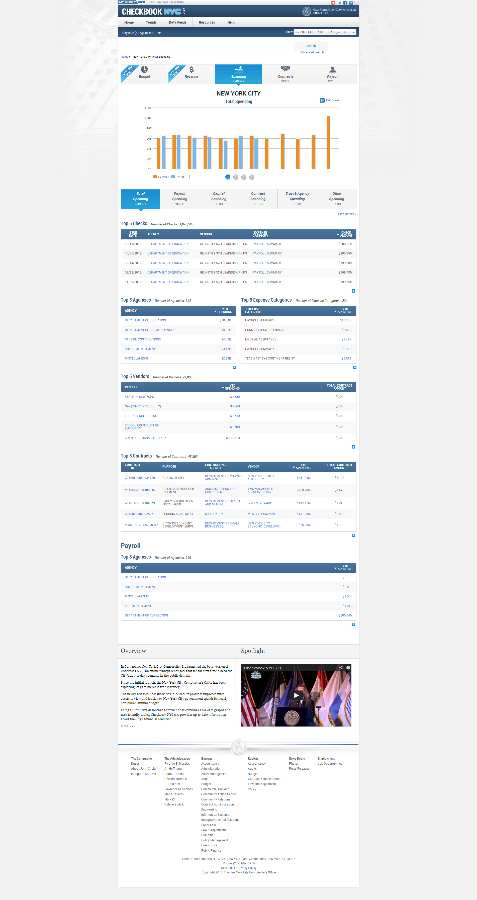

|  |  |  |  |  |  |
| --- | --- | --- | --- | --- | --- |
| **ID** | | **KEY** | **FEATURE** | **DESCRIPTION** | |
| **3.19** |  | **Top Navigation** | * The system shall, by default, display the amount for the current fiscal year. The “$” spending shall be the total spending for the selected FY or CY for NYC level by default. The amount must contain 1 decimal digit. * User will be able to navigate from one domain to another by clicking on the desired domain button. * Upon changing domains, the data will be displayed based on current fiscal year. * The system shall present a top navigation with the following categories in order: Revenue, Budget, Spending, Contracts and payroll. * The system shall display on each box the Icon, Title of the Domain, and the Number in a 3-line format. * The system shall update at NYC, Agency and Vendor level. |



|  |  |  |  |  |  |
| --- | --- | --- | --- | --- | --- |
| **ID** | | **KEY** | **FEATURE** | **DESCRIPTION** | |
| **3.20** |  | | **Grid View** | * The system shall allow the Grid View to display the information on the graphical visualization as numeric data in a table format within a new browser window. (A new browser window shall display the information)   + - The system shall present the title of the Grid View in upper case, for example NEW YORK CITY, DEPARTMENT OF SANITATION. * The second and third lines underneath shall be in sentence case.   + - The system shall present sorting arrows with rules consistent to those of the widgets (see sorting arrows details listed under, ‘Widgets’).     - The system shall maintain the 2-line standardization and alignment rules described under “Widgets” section of this documentation.     - The system shall support up to 2 decimal places for numbers in the table rows.     - The system shall present Print and Export functionalities for the Grid View. |



|  |  |  |  |  |  |
| --- | --- | --- | --- | --- | --- |
| **ID** | | **KEY** | **FEATURE** | **DESCRIPTION** | |
| **3.21** |  | **Total Spending visualization** | * The system shall direct the user to the spending transaction upon clicking any bar. The transactions shall only be of the selected month. * Hovering over a bar will display a tooltip with the following information: * ‘Month: [selected month]’ * Amount: [$disbursement amount] |

|  |  |  |  |  |  |
| --- | --- | --- | --- | --- | --- |
| **ID** | | **KEY** | **FEATURE** | **DESCRIPTION** | |
| **3.22** |  | **Top Ten Agencies by disbursement amount visualization** | * The system shall direct the user to agency specific contracts landing page upon clicking any bar. * The system shall tooltip with the following information upon hovering over a bar: * Agency: [selected agency] * Amount: [$disbursement amount] |

|  |  |  |  |  |  |
| --- | --- | --- | --- | --- | --- |
| **ID** | | **KEY** | **FEATURE** | **DESCRIPTION** | |
| **3.23** |  | **Top Ten Contracts by disbursement amount visualization** | * The system shall direct the user to contracts details page upon clicking any bar. * The system shall tooltip with the following information upon hovering over a bar:   + Contract ID: [selected contract ID]   + Amount: [$disbursement amount]   + Vendor: [associated vendor]   + Agency: [associated agency] |

|  |  |  |  |  |  |
| --- | --- | --- | --- | --- | --- |
| **ID** | | **KEY** | **FEATURE** | **DESCRIPTION** | |
| **3.24** |  | **Top Ten Vendors by disbursement amount visualization** | * The system shall direct the user to vendor specific spending landing page upon clicking any bar. * The system shall tooltip with the following information upon hovering over a bar: * Vendor: [selected vendor] * Amount: [$disbursement amount] |



|  |  |  |  |  |  |
| --- | --- | --- | --- | --- | --- |
| **ID** | | **KEY** | **FEATURE** | **DESCRIPTION** | |
| **3.25** |  | **Bottom Navigation (Spending Category Filter)** | * The system shall divide up the spending categories into **six filter boxes.** * The system shall display the category name and the total disbursement amount for each filter box. * The system shall update the page contents corresponding to the selected filter box. * The system shall update the disbursement amount in the filter boxes at citywide agency level, individual agency and vendor level. |

|  |  |  |  |  |  |
| --- | --- | --- | --- | --- | --- |
| **ID** | | **KEY** | **FEATURE** | **DESCRIPTION** | |
| **3.26** |  | **Bottom Navigation (Spending Category Filter)** | * The system shall present ***‘Total Spending’*** as the **first category filter box** and the disbursement amount displayed shall be the summation of the disbursement amounts of Payroll Spending, Capital Spending, contract spending, Other Spending and Trust & Agency spending. By default, the disbursement amount shall be filtered on citywide agency and on current fiscal year. The amount in the button shall only update at citywide agency level, agency level, and vendor level. * The system shall present ***‘Payroll Spending’*** as the **second category filter box** and the disbursement amount displayed shall be the total payroll spending. By default, data shall be filtered on citywide agency level and on current fiscal year. The amount in the button shall update at citywide agency level and individual agency level. * The system shall display ***‘Capital Spending’*** as the **third category filter box** and the disbursement amount shall be the total capital spending. By default, the disbursement amount shall be filtered on citywide agency and on current fiscal year. The amount in the button shall only update at citywide agency level, agency level, and vendor level. * The system shall present ***‘Contract Spending’*** as the **fourth category filter box** and the disbursement amount shall be the total spending associated to contracts. By default, the disbursement amount shall be filtered on citywide agency and on current fiscal year. The amount in the button shall only update at citywide agency level, agency level, and vendor level. * The system shall present ***‘Other Spending’*** as the **fifth category filter box** and the disbursement amount shall include the total other spending. By default, the disbursement amount shall be filtered on citywide agency and on current fiscal year. The amount in the button shall only update at citywide agency level, agency level, and vendor level. * The system shall display ***‘Trust & Agency’*** as the **sixth category filter box** and the disbursement amount shall be associated to total trust & agency spending. By default, the disbursement amount shall be filtered on citywide agency and on current fiscal year. The amount in the button shall only update at citywide agency level, agency level, and vendor level. |



|  |  |  |  |  |  |
| --- | --- | --- | --- | --- | --- |
| **ID** | | **KEY** | **FEATURE** | **DESCRIPTION** | |
| **3.27** |  | **Show Details** | * The system shall collapse all contents below the bottom navigation slider upon initial visit to the spending page. Clicking on the 'Show Details' link shall expand the page and display all contents and widgets below the bottom navigation slider. The contents shall not be collapsed again, unless user clicks on 'Hide Details'. |



|  |  |  |  |  |  |
| --- | --- | --- | --- | --- | --- |
| **ID** | | **KEY** | **FEATURE** | **DESCRIPTION** | |
| **3.28** |  | **Top 5 Checks widget** | * The system shall, on default, sort the widget by the ‘AMOUNT’ column. Upon initial visit to the page, the arrow shall appear next to the default-sorted header. If a user hovers over a sortable header, the header will be underlined. If the user clicks on a header (NOT the default-sorted header), then the arrow which was on the default-sorted header shall disappear and an arrow shall appear on the clicked on header. The direction of the pointing arrow shall change for ascending and descending sorting. * The system shall allow the user to click on an agency link, which shall refresh the page to agency specific spending page. The contents of the top slider, the visualization, the bottom slider, and the widgets shall be updated based on the agency selected. The agency widget shall not be present in the refresh. ***The Top 5 Checks widget shall still be displayed with checks for the selected agency, spending category, and FY/CY.*** * **Applicable Visualizations*:*** The visualizations which are applicable shall be the total spending, the top 10 vendors, and the top 10 contracts for the selected agency. * **Top 5 Departments**: The widget shall include department name and YTD spending columns. Department name shall not be hyperlinked. Clicking on an YTD spending link shall refresh the bottom half of the page to spending transactions for the selected department with the title ***“[Department Name] Spending Transactions” and YTD spending amount as the static content.*** * The system shall allow the user to click on a vendor link, which shall refresh the page to vendor specific spending page. The contents of the visualization, the bottom slider, and the widgets shall be updated based on the vendor selected. ***The Top 5 Checks widget shall still be displayed with checks for the selected vendor, spending category, and FY/CY.*** * **Applicable Visualizations:** The visualizations which are applicable shall be the total spending, the top 10 agencies, and the top 10 contracts for the selected vendor. * The system shall expand the widget to display a maximum of 150 rows of record upon clicking on ‘+’. When expanded, the ‘+’ symbol shall transform to the ‘-‘ symbol and a ‘Details’ link shall appear next to the ‘-‘ symbol; clicking on ‘-‘ shall collapse the widget to its original size. This functionality shall be applicable for all widgets in the payroll landing pages. Clicking on ‘Details’ link shall refresh the contents below the ‘Hide Details’ link into the payroll transactions page (with static content). The title of the transactions table shall be ‘***Checks Total Spending Transactions’***. * Within the transactions page, the system shall display the static content ‘**Total [selected spending category] Spending Amount**’. |



|  |  |  |  |  |  |
| --- | --- | --- | --- | --- | --- |
| **ID** | | **KEY** | **FEATURE** | **DESCRIPTION** | |
| **3.29** |  | **Top 5 Agencies widget** | * The system shall, on default, sort the widget by the ‘YTD SPENDING’ column. Upon initial visit to the page, the arrow shall appear next to the default-sorted header. If a user hovers over a sortable header, the header will be underlined. If the user clicks on a header (NOT the default-sorted header), then the arrow which was on the default-sorted header shall disappear and an arrow shall appear on the clicked on header. The direction of the pointing arrow shall change for ascending and descending sorting. * The system shall allow the user to click on an agency link, which shall refresh the page to agency specific spending page. The contents of the top slider, the visualization, the bottom slider, and the widgets shall be updated based on the agency selected. The agency widget shall not be present in the refresh. * **Applicable Visualizations*:*** The visualizations which are applicable shall be the total spending, the top 10 vendors, and the top 10 contracts for the selected agency. * **Top 5 Departments**: The widget shall include department name and YTD spending columns. Department name shall not be hyperlinked. Clicking on an YTD spending link shall refresh the bottom half of the page to spending transactions for the selected department with the title ***“[Department Name] Spending Transactions” and YTD spending amount as the static content.*** * The system shall allow the user to click on a YTD spending link, which shall refresh the bottom half of the page to spending transactions page. The title of this page shall be “[***Agency name] Spending Transactions” and YTD spending amount as the static content.*** * The system shall expand the widget to display a maximum of 150 rows of record upon clicking on ‘+’. When expanded, the ‘+’ symbol shall transform to the ‘-‘ symbol and a ‘Details’ link shall appear next to the ‘-‘ symbol; clicking on ‘-‘ shall collapse the widget to its original size. This functionality shall be applicable for all widgets in the payroll landing pages. Clicking on ‘Details’ link shall refresh the contents below the ‘Hide Details’ link into the NYC payroll transactions page (with static content). The title of the transactions table shall be **‘*Agencies Total Spending Transactions’***. * Within the transactions page, the system shall display the static content ‘**Total [selected spending category] Spending Amount**’. |



|  |  |  |  |  |  |
| --- | --- | --- | --- | --- | --- |
| **ID** | | **KEY** | **FEATURE** | **DESCRIPTION** | |
| **3.30** |  | **Top 5 Expense Categories widget** | * The system shall, on default, sort the widget by the ‘YTD SPENDING’ column. Upon initial visit to the page, the arrow shall appear next to the default-sorted header. If a user hovers over a sortable header, the header will be underlined. If the user clicks on a header (NOT the default-sorted header), then the arrow which was on the default-sorted header shall disappear and an arrow shall appear on the clicked on header. The direction of the pointing arrow shall change for ascending and descending sorting. * The system shall allow the user to click on an YTD spending link, which shall refresh the bottom half of the page to spending transactions page. The title of this page shall be “[***Expense category name] Spending Transactions“ and YTD spending amount as the static content.*** * The system shall expand the widget to display a maximum of 150 rows of record upon clicking on ‘+’. When expanded, the ‘+’ symbol shall transform to the ‘-‘ symbol and a ‘Details’ link shall appear next to the ‘-‘ symbol; clicking on ‘-‘ shall collapse the widget to its original size. This functionality shall be applicable for all widgets in the payroll landing pages. Clicking on ‘Details’ link shall refresh the contents below the ‘Hide Details’ link into the NYC payroll transactions page (with static content). The title of the transactions table shall be ***‘Expense Categories Total Spending Transactions’***. * Within the transactions page, the system shall display the static content ‘**Total [selected spending category] Spending Amount**’. |



|  |  |  |  |  |  |
| --- | --- | --- | --- | --- | --- |
| **ID** | | **KEY** | **FEATURE** | **DESCRIPTION** | |
| **3.31** |  | **Top 5 Vendors widget** | * The system shall consider CT1, CTA1, POD, POC, PCC1, and DO1 contract types for the widget. * The system shall, on default, sort the widget by the ‘YTD SPENDING’ column. Upon initial visit to the page, the arrow shall appear next to the default-sorted header. If a user hovers over a sortable header, the header will be underlined. If the user clicks on a header (NOT the default-sorted header), then the arrow which was on the default-sorted header shall disappear and an arrow shall appear on the clicked on header. The direction of the pointing arrow shall change for ascending and descending sorting. * The system shall allow the user to click on a vendor name link, which shall refresh the page to vendor specific spending page. The visualization, bottom slider, and the widgets shall be updated based on the vendor selected.   + **Applicable Visualizations*:*** The visualizations which are applicable shall be the total spending, the top 10 agencies, and the top 10 contracts for the selected vendor. * The system shall allow the user to click a YTD spending link, which shall refresh the bottom half of the page to spending transactions page. The title of the page shall be “[***Vendor name] Spending Transactions” and YTD spending amount as the static content.*** * *The total spending amount is the sum of the disbursements of* CT1, CTA1, POD, POC, PCC1, and DO1 contracts *associated to the selected vendor of the selected FY/CY.* * The system shall expand the widget to display a maximum of 150 rows of record upon clicking on ‘+’. When expanded, the ‘+’ symbol shall transform to the ‘-‘ symbol and a ‘Details’ link shall appear next to the ‘-‘ symbol; clicking on ‘-‘ shall collapse the widget to its original size. This functionality shall be applicable for all widgets in the payroll landing pages. Clicking on ‘Details’ link shall refresh the contents below the ‘Hide Details’ link into the NYC payroll transactions page (with static content). The title of the transactions table shall be ***‘Vendors Total Spending Transactions’***. * Within the transactions page, the system shall display the static content ‘**Total [selected spending category] Spending Amount**’. |



|  |  |  |  |  |  |
| --- | --- | --- | --- | --- | --- |
| **ID** | | **KEY** | **FEATURE** | **DESCRIPTION** | |
| **3.32** |  | **Top 5 Contracts widget** | * The system shall consider CT1, CTA1, POD, POC, PCC1, and DO1 contract types for the widget. * The system shall, on default, sort the widget by the ‘YTD SPENDING’ column. Upon initial visit to the page, the arrow shall appear next to the default-sorted header. If a user hovers over a sortable header, the header will be underlined. If the user clicks on a header (NOT the default-sorted header), then the arrow which was on the default-sorted header shall disappear and an arrow shall appear on the clicked on header. The direction of the pointing arrow shall change for ascending and descending sorting. * The system shall present a tooltip when a user hovers over a content under the ‘PURPOSE’ column to display the full purpose description. * The system shall allow the user to click on a contract ID link, which shall open the contract ID page in a new browser window. * The system shall allow the user to click on an agency link, which shall refresh the page to agency specific spending page. * **Applicable Visualizations*:*** The visualizations which are applicable shall be the total spending, the top 10 vendors, and the top 10 contracts for the selected agency. * The system shall allow the user to click on a YTD spending, which shall refresh the page to spending transactions page. The title of the page shall be “***Contract Spending Transactions” and the static contents shall be contract purpose, contract ID, agency name, vendor name, and total contract amount.*** * The system shall allow the user to click on a vendor link, which shall refresh the page to vendor specific spending page. * **Applicable Visualizations*:*** The visualizations which are applicable shall be the total spending, the top 10 agencies, and the top 10 contracts for the selected vendor. * The system shall expand the widget to display a maximum of 150 rows of record upon clicking on ‘+’. When expanded, the ‘+’ symbol shall transform to the ‘-‘ symbol and a ‘Details’ link shall appear next to the ‘-‘ symbol; clicking on ‘-‘ shall collapse the widget to its original size. This functionality shall be applicable for all widgets in the payroll landing pages. Clicking on ‘Details’ link shall refresh the contents below the ‘Hide Details’ link into the NYC payroll transactions page (with static content). The title of the transactions table shall be ***‘Contracts Total Spending Transactions’***. * Within the transactions page, the system shall display the static content ‘**Total [selected spending category] Spending Amount**’. |



|  |  |  |  |  |  |
| --- | --- | --- | --- | --- | --- |
| **ID** | | **KEY** | **FEATURE** | **DESCRIPTION** | |
| **3.33** |  | ***Payroll domain*** | * The system shall allow the user to click on an agency link, which shall refresh the page to agency specific spending page. The contents of the top slider, the visualization, the bottom slider, and the widgets shall be updated based on the agency selected. The agency widget shall not be present in the refresh. * **Applicable Visualizations*:*** The visualizations which are applicable shall be the total spending and top ten departments. * **Top 5 Departments**: The widget shall include department name and YTD spending columns. Department name shall not be hyperlinked. Clicking on a YTD spending link shall refresh the bottom half of the page to spending transactions for the selected department with the title ***“[Department Name] Spending Transactions” and YTD spending amount as the static content.*** * The system shall allow the user to click on a YTD spending link, which shall refresh the bottom half of the page to spending transactions page. The title of this page shall be “[***Agency name] Payroll Spending Transactions” and YTD spending amount as the static content.*** * The system shall expand the widget to display a maximum of 150 rows of record upon clicking on ‘+’. When expanded, the ‘+’ symbol shall transform to the ‘-‘ symbol and a ‘Details’ link shall appear next to the ‘-‘ symbol; clicking on ‘-‘ shall collapse the widget to its original size. This functionality shall be applicable for all widgets in the payroll landing pages. Clicking on ‘Details’ link shall refresh the contents below the ‘Hide Details’ link into the NYC payroll transactions page (with static content). The title of the transactions table shall be ***‘Agencies Payroll Spending Transactions’***. * Within the transactions page, the system shall display the static content ‘**Total [selected spending category] Spending Amount**’. |

Spending Transactions – Business Rules

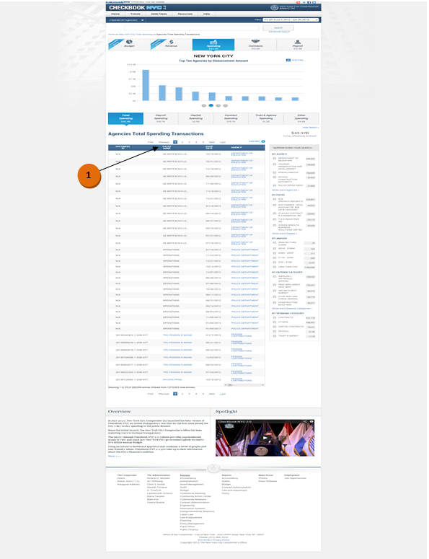

|  |  |  |  |
| --- | --- | --- | --- |
| **ID** | **KEY** | **FEATURE** | **DESCRIPTION** |
| **3.34** |  | **Data Alteration** | * The system shall replace all 'N/A' under the PAYEE NAME column with the corresponding department name. |

Spending Transactions – Functional Requirements

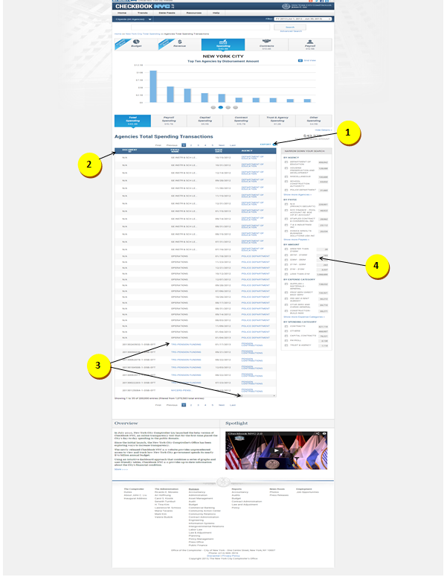



|  |  |  |  |
| --- | --- | --- | --- |
| **ID** | **KEY** | **FEATURE** | **DESCRIPTION** |
| **3.35** |  | **Export** | * The system shall allow the user to export the contents in the table in **CSV format.** |

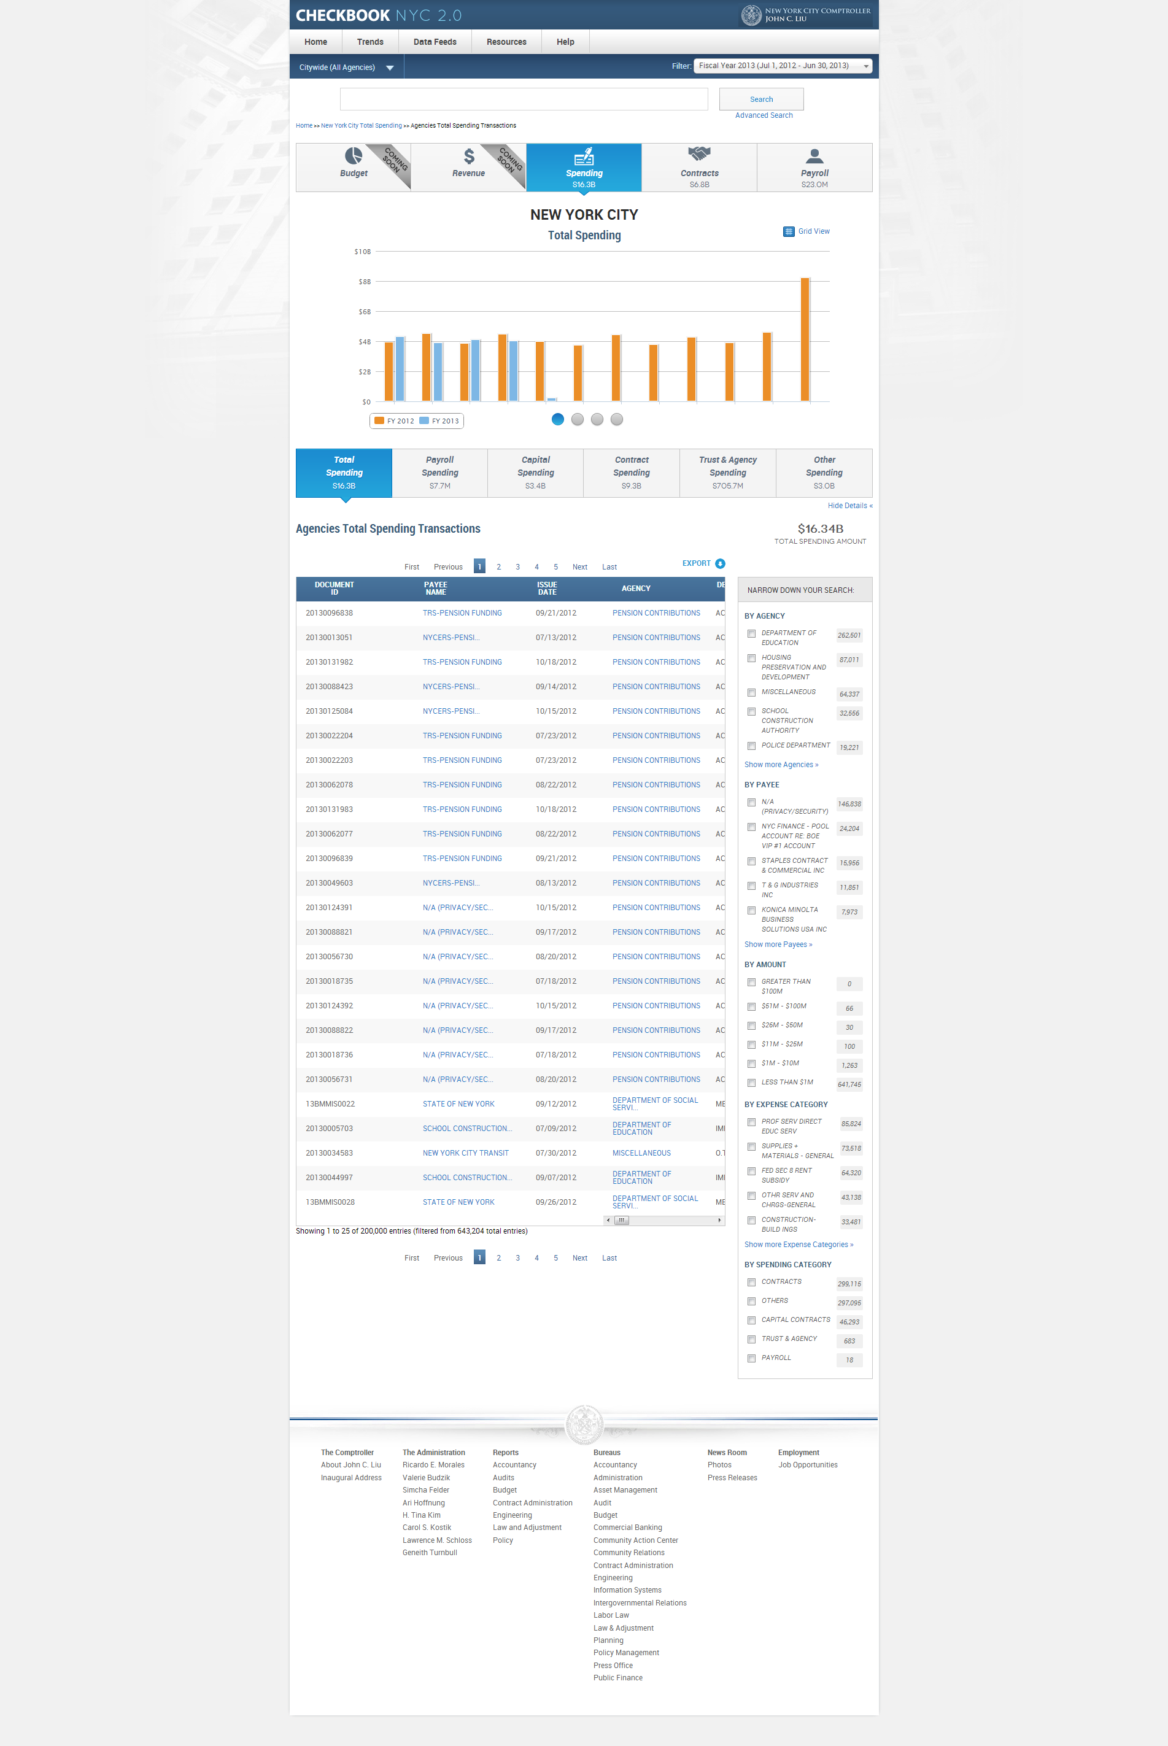

|  |  |  |  |  |  |
| --- | --- | --- | --- | --- | --- |
| **ID** | | **KEY** | **FEATURE** | **DESCRIPTION** | |
| **3.36** |  | **Transactions Table sorting** | * The systems shall allow all transactions table columns to be sortable. On default, the table shall be sorted on Check Amount. |



|  |  |  |  |  |  |
| --- | --- | --- | --- | --- | --- |
| **ID** | | **KEY** | **FEATURE** | **DESCRIPTION** | |
| **3.37** |  | **Transactions Table hyperlinks** | * The system shall refresh the page to vendor specific spending landing page upon clicking on a payee name link. * The system shall refresh the page to agency specific spending landing page upon clicking on an agency name link. * The system shall support a table which can display only 35 records in one page. |

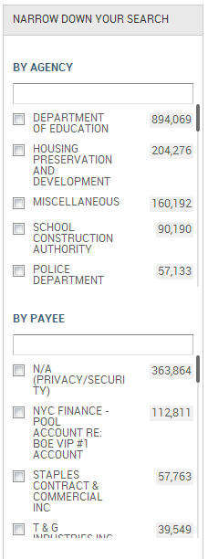

|  |  |  |  |  |  |
| --- | --- | --- | --- | --- | --- |
| **ID** | | **KEY** | **FEATURE** | **DESCRIPTION** | |
| **3.38** |  | **Narrow-down Facet** | * + The system shall support a narrow-down facet, located to the left of the transactions table.   + The system shall support smart search with all string search.   + The system shall include full population of data within all facets.   + The user shall be able to view the total number of records that are available in a category, such as number of agencies, vendors, expense categories. The number of transactions displayed next to each record shall be updated as the user makes selections.   + The facets that are applicable for spending domain are By Agency, By Payee, By Amount, By Expense Category and By Spending Category. |

* 1. Trends

Trends - Business Rules

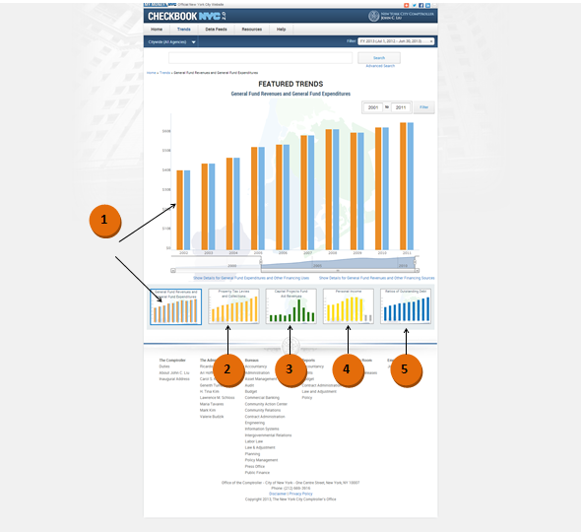

|  |  |  |  |
| --- | --- | --- | --- |
| **ID** | **KEY** | **FEATURE** | **DESCRIPTION** |
| **4.0** |  | **General Rules** | * The system shall not present x and y axes titles in featured trends visualizations. |

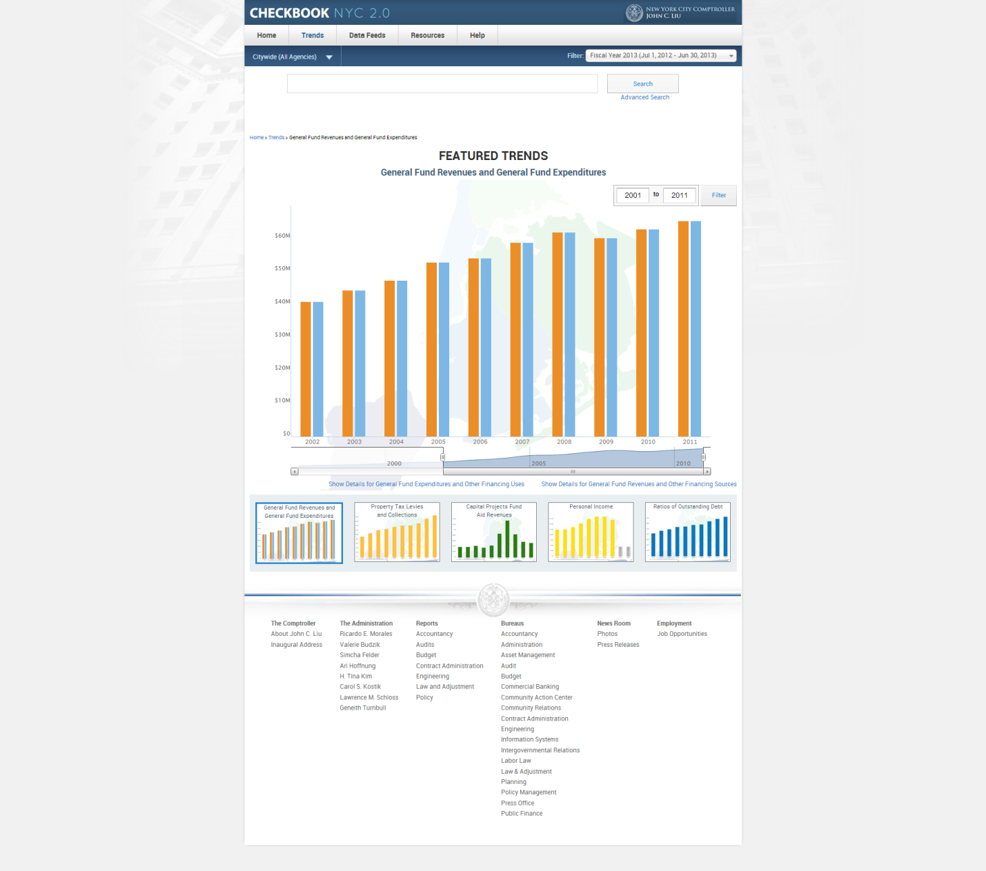

|  |  |  |  |  |
| --- | --- | --- | --- | --- |
| **ID** | **KEY** | **FEATURE** | **DESCRIPTION** | |
| **4.1** |  | **General Fund Revenues and General Fund Expenditures** | * **Page title: Featured Trends** *[must be in upper case].* * **Graph Title:** General Fund Revenues and General Fund Expenditures * **Bar colors:** * Total Revenue Bar -  (Cadmium Orange [#ED872D]) * Total Expenditure Bar -  (Celestial Blue [#4997D0]) * **Legend:** No legends shall be displayed in trends visualizations. * **Axes Scale Labeling:** * x-axis scale labeling – years * y-axis scale labeling – dollar amounts in billions |



|  |  |  |  |
| --- | --- | --- | --- |
| **ID** | **KEY** | **FEATURE** | **DESCRIPTION** |
| **4.2** |  | **Property Tax Levies and Collections** | * **Page title: Featured Trends** *[must be in upper case].* * **Graph Title:** Property Tax Levies and Collections * **Bar colors:** * Bar 1 -  (Amber [#FFBF00]) * **Legend:** No legends shall be displayed in trends visualizations. * **Axes Scale Labeling:** * x-axis scale labeling – years * Y-axis scale labeling – dollar amounts in millions or in billions. |



|  |  |  |  |  |  |
| --- | --- | --- | --- | --- | --- |
| **ID** | **KEY** | | **FEATURE** | | **DESCRIPTION** |
| **4.3** | |  | | **Capital Projects Fund Aid Revenues** | * **Page title: Featured Trends** *[must be in upper case].* * **Graph Title:** Capital Projects Fund Aid Revenues * **Data Displayed:** * **Bar color:** * Bar 1 -  (Forest Green [#228B22]) * **Legend:** No legends shall be displayed in trends visualizations. * **Axes Scale Labeling:** * x-axis scale labeling – years * Y-axis scale labeling – dollar amounts in millions or in billions. |



|  |  |  |  |  |
| --- | --- | --- | --- | --- |
| **ID** | **KEY** | | **FEATURE** | **DESCRIPTION** |
| **4.4** | |  | **Personal Income** | * **Page title: Featured Trends** *[must be in upper case].* * **Graph Title:** Personal Income * **Bar colors:** * Bar 1 -  (Cadmium Yellow [#FFF600]) * **Legend:** No legends shall be displayed in trends visualizations. * **Axes Scale Labeling:** * x-axis scale labeling – years * Y-axis scale labeling – dollar amounts in millions or in billions. |



|  |  |  |  |
| --- | --- | --- | --- |
| **ID** | **KEY** | **FEATURE** | **DESCRIPTION** |
| **4.5** |  | **Ratios of Outstanding Debt by Type** | * **Page title: Featured Trends** [must be in upper case]. * **Graph Title:** Ratios of Outstanding Debt * **Bar colors:** * Bar 1 -  (Cobalt [#0047AB]) * **Legend:** No legends shall be displayed in trends visualizations. * **Axes Scale Labeling:** * x-axis scale labeling – years * Y-axis scale labeling – dollar amounts in millions or in billions. |

|  |  |  |  |
| --- | --- | --- | --- |
| **ID** | **KEY** | **FEATURE** | **DESCRIPTION** |
| **4.6** |  | **Additional Trends Details Page** | * The system shall include a total of 26 trends in the application. These trends shall include the 5 featured trends. * The system shall apply the format of the tabular view to be consistent with the view displayed on CAFR. * The system shall support the export function which will allow the user to download all records of available 26 trends in comma delimited format. * The system shall align the top row with headers with top lines matching evenly. * The system shall center align all the numeric data contents of a column with a text header. * The system shall right align all the numeric data contents of a column with a numeric header. * The system shall left align all the text data contents of a column. |

Trends - Functional Requirements

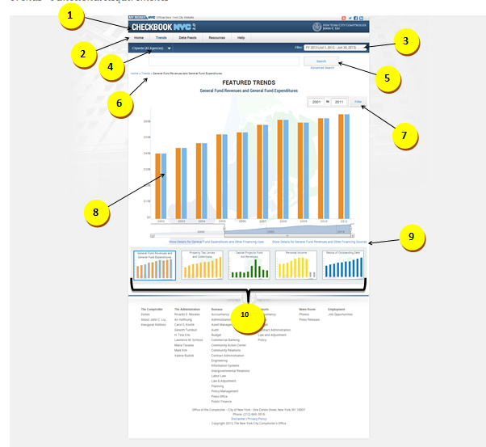



|  |  |  |  |
| --- | --- | --- | --- |
| **ID** | **KEY** | **FEATURE** | **DESCRIPTION** |
| **4.7** |  | **Main Menu Tab** | * The system shall direct the user to the Featured Trends page upon clicking on ‘Trends’. * The system shall present a dropdown of the following options upon hovering over the ‘Trends’ section of the tab:   1. Featured Trends   2. All Trends   3. Financial   4. Revenue Capacity   5. Debt Capacity   6. Demographic   7. Operational * The system shall present sub-dropdown of the sub-categories under each option (Except for ‘Featured Trends’ and ‘All Trends List’); the sub-category options shall be links to the corresponding Trend specific pages. * The system shall direct the user to the main Trends page with the Featured Trend visualizations upon clicking on the ‘Featured Trends’ option. Following are the Featured Trends, in the following order: * General Fund Revenues and General Fund Expenditures * Property Tax Levies and Collections * Capital Projects Fund Aid Revenues * Personal Income Tax Revenues * Ratios of Outstanding Debt by Type * The system shall direct the user to a page that provides a full list of links to all available Trend specific pages upon clicking on the ‘All Trends’ option. |



|  |  |  |  |
| --- | --- | --- | --- |
| **ID** | **KEY** | **FEATURE** | **DESCRIPTION** |
| **4.8** |  | **Citywide filter** | * The system shall allow the user to select any agency from the dropdown list. On clicking any particular agency, it shall take the user to agency specific spending page by default. By default, citywide agencies filter shall be preselected. |



|  |  |  |  |
| --- | --- | --- | --- |
| **ID** | **KEY** | **FEATURE** | **DESCRIPTION** |
| **4.9** |  | **Date filter** | * The system shall present the citywide filter and FY date filter for Trends. By default current FY shall be applied. When the user clicks on this FY, the application shall display data for spending domain, for the current FY. |



|  |  |  |  |
| --- | --- | --- | --- |
| **ID** | **KEY** | **FEATURE** | **DESCRIPTION** |
| **4.10** |  | **Smart search** | * + - The system shall place the Smart Search below Citywide and Date Filter navigation and above top navigation.     - The system shall support ALL string searches.     - The system shall not present the top navigation upon smart search results. * The system shall present the citywide filter and Date filter upon smart search results. * Clicking on the Date filter shall take the user to NYC Spending page for current FY or the selected FY. * All resulting fields in smart search shall be displayed in two lines with hover over functionality * The system shall present export functionality in smart search. |



|  |  |  |  |
| --- | --- | --- | --- |
| **ID** | **KEY** | **FEATURE** | **DESCRIPTION** |
| **4.11** |  | **Advanced search** | * The system, by default, shall open up the Spending domain advanced search. * The advanced search shall be placed on the right hand side of the smart search box. |



|  |  |  |  |
| --- | --- | --- | --- |
| **ID** | **KEY** | **FEATURE** | **DESCRIPTION** |
| **4.12** |  | **Breadcrumbs** | * The system shall present breadcrumbs which shall consist of a maximum of eight elements. Upon initial visit to the application, the first element shall be ‘Home’. The titles of the breadcrumb elements shall be specific. The breadcrumbs shall essentially present a hierarchical path of navigation. * Only the eighth element will update. * The system shall support the following breadcrumbs order - Home, Trends, Name of the Featured Trend, and Name of the Trend Details.   Below are two examples:  Home > Trends > General fund revenues and General fund expenditures  Home > Trends > General fund revenues and General fund expenditures> General fund revenues and General fund expenditures details   * The system shall always direct the user to General Fund Revenues and General Fund Expenditures featured trends page upon clicking on the menu bar title Trends. * The system shall place the breadcrumbs immediately above the top slider and below the smart search. |



|  |  |  |  |
| --- | --- | --- | --- |
| **ID** | **KEY** | **FEATURE** | **DESCRIPTION** |
| **4.13** |  | **Date Range Filter** | * + The system shall allow the user to select begin and end year to view Trends for a specified year range.   + The system shall pre-populate the ‘date filter text-boxes’ to reflect the range of years considered on the presented visualization. * The date range shall not be carried forward to other featured trends. All featured trends shall be defaulted to 10 years from the latest year’s trend. * As the user navigates through the trends data, using the bottom scroll bar, the number of years shall be reflected in the Trends Date Filter. * The user shall have the ability enter any number of years in the Trends Date Filter, and the data shall be reflected in the visualization. * The graph shall display, by default, a total of 10 years beginning with the latest year available.   + If the range inputted in the data filter textboxes contains a year in which no data is available, then the visualization shall present a ‘No Data Available’ message on the year bar.   + The dates in the filter table shall change when the user moves the slide bar below. |

|  |  |  |  |
| --- | --- | --- | --- |
| **ID** | **KEY** | **FEATURE** | **DESCRIPTION** |
| **4.14** | |  | **Bottom Navigation** | * The system shall not present a bottom navigation in any of the ‘Trends’ pages. |

|  |  |  |  |
| --- | --- | --- | --- |
| **ID** | **KEY** | **FEATURE** | **DESCRIPTION** |
| **4.15** |  | **Show/Hide Details Link** | * The system shall not support the Show/Hide Details functionality in any of the ‘Trends’ pages. But the show details link shall be applicable for viewing trends details pages. |



|  |  |  |  |  |  |
| --- | --- | --- | --- | --- | --- |
| **ID** | | **KEY** | **FEATURE** | **DESCRIPTION** | |
| **4.16** |  | | **General Fund Revenues and General Fund Expenditures** | * **Hover over:** Standardize hover over based on design of tool tip in contracts domain. * For each Revenue bar, the hover over shall display the following:   + 1. Total Revenue     2. Amount:  $[x.xx]B * For each Expenditure bar, the hover over shall display the following:   + 1. Total Expenditures     2. Amount:  $[x.xx]B |

|  |  |  |  |
| --- | --- | --- | --- |
| **ID** | **KEY** | **FEATURE** | **DESCRIPTION** |
| **4.17** |  | **Property Tax Levies and Collections** | * **Hover over:** Standardize hover over based on design of tool tip in contracts domain. * For each bar, the hover over shall display the following:  1. Levied Amount: $[x.xx]B |

|  |  |  |  |
| --- | --- | --- | --- |
| **ID** | **KEY** | **FEATURE** | **DESCRIPTION** |
| **4.18** |  | **Capital Projects Fund Aid Revenues** | * **Hover over:** Standardize hover over based on design of tool tip in contracts domain**.** * For each bar, the hover over shall display the following:  1. Total Fund Aid Revenues Amount -$B |

|  |  |  |  |
| --- | --- | --- | --- |
| **ID** | **KEY** | **FEATURE** | **DESCRIPTION** |
| **4.19** |  | **Personal Income** | * **Hover over:** Standardize hover over based on design of tool tip in contracts domain. * For each bar, the hover over shall display the following:   1. Tax Revenue Amount: $[x.xx] B |

|  |  |  |  |
| --- | --- | --- | --- |
| **ID** | **KEY** | **FEATURE** | **DESCRIPTION** |
| **4.20** |  | **Ratios of Outstanding Debt by Type** | * **Hover over:** Standardize hover over based on design of tool tip in contracts domain. * For each bar, the hover over shall display the following:   1. Total Primary Government Debt   2. Amount: $[x.xx]B |



|  |  |  |  |
| --- | --- | --- | --- |
| **ID** | **KEY** | **FEATURE** | **DESCRIPTION** |
| **4.21** |  | **Trend Details link** | * The system shall direct the user to the Trend specific page which displays the detailed numeric data of the selected Trend upon clicking on the ‘show details’ link located immediately below the featured Trend main visualization. The order of the data variables in the Trend specific page shall be identical to the order of the data variables presented in the corresponding Trend within the CAFR. * ALL trends details page shall have the Export button on the right side of the page above the data table. The page should be downloadable in CSV format. The trends table exported should match with the csv file once downloaded. |



|  |  |  |  |
| --- | --- | --- | --- |
| **ID** | **KEY** | **FEATURE** | **DESCRIPTION** |
| **4.22** |  | **Miniature Graphs** | * The system shall apply a blue border around the selected featured trend mini graph. * The system shall display all 5 Featured Trends as miniature graphs located below the main presented visualization. The miniature graphs shall be static and will be clickable. Clicking on a miniature graph shall refresh the page and display the selected graph as the main enlarged visualization in the page. The selected miniature graph shall be displayed in gray color. The scale of the fonts shall be smaller based on the size of the visualizations. |

* 1. Resource

Resources - Business Rules

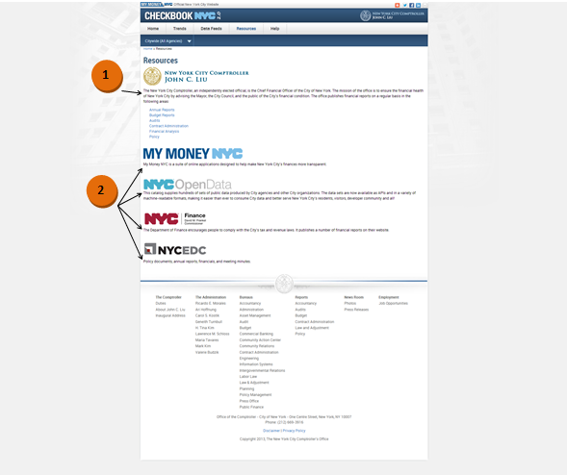

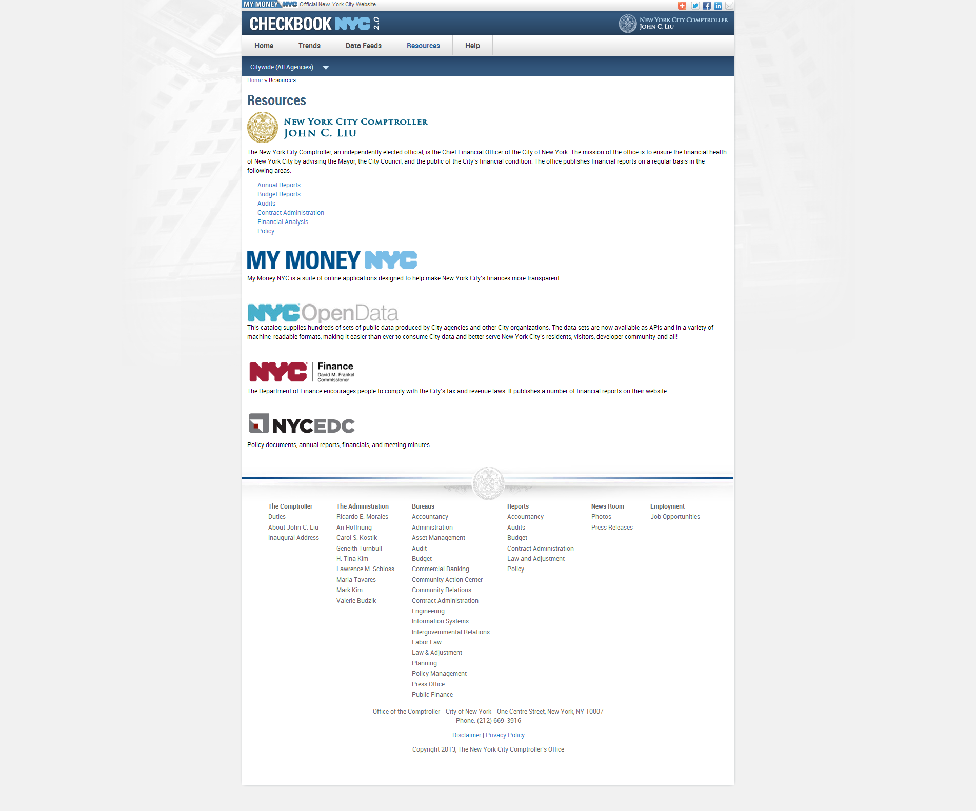

|  |  |  |  |
| --- | --- | --- | --- |
| **ID** | **KEY** | **FEATURE** | **DESCRIPTION** |
| **5.1** |  | **Introduction to additional NYC financial reports** | * The system shall present an introduction to the list of additional NYC financial reports that will be available to the public. |



|  |  |  |  |
| --- | --- | --- | --- |
| **ID** | **KEY** | **FEATURE** | **DESCRIPTION** |
| **5.2** |  | **Description of other NYC financial related websites** | * The system shall present descriptions of other NYC financial related websites. |

Resources – Functional Requirements

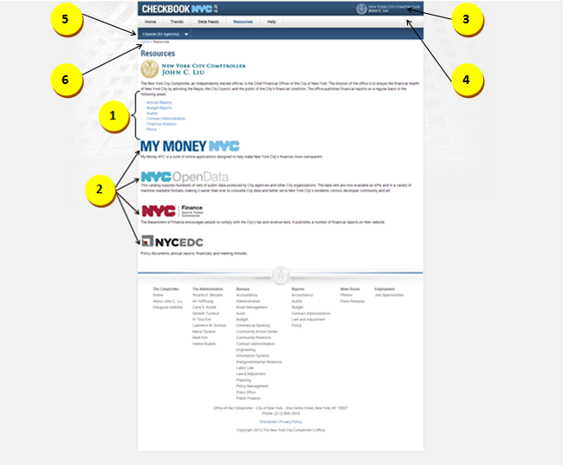



|  |  |  |  |
| --- | --- | --- | --- |
| **ID** | **KEY** | **FEATURE** | **DESCRIPTION** |
| **5.3** |  | **Links to NYC financial reports** | * The system shall present a list of links for additional NYC financial reports that will be available to the public. |



|  |  |  |  |
| --- | --- | --- | --- |
| **ID** | **KEY** | **FEATURE** | **DESCRIPTION** |
| **5.4** |  | **Links other NYC financial related websites** | * The system shall present links to other NYC financial related websites. |
| **5.5** |  | **Header** | * The header includes all components above the top menu bar. It should include NYC 2.0 logo, Comptroller logo, my money site logo, social media links like add this, twitter, Facebook, LinkedIn and also includes email option. All these should be hyperlinked including logos. |
| **5.6** |  | **Top Menu Bar** | * + - The system shall present tabs at the top menus bar in the following order: Home, Trends, Data Feeds, Resources, and Help.     - The system shall not contain drop-downs for the Home and Data Feeds tabs.     - The system shall present the drop-down for Trends in the following order – Featured Trends, All Trends, Financial, Revenue Capacity, Debt Capacity, Demographic, and Operational. * Each of the additional trends - Financial, Revenue Capacity, Debt Capacity, Demographic, Operational – have additional groupings of trends, which are opened in the menu call out. * The system shall contain the following drop-downs for help tab: Site Navigation & Glossary, FAQ, Ask a Question, Report a Problem and Share an Idea. * Site Navigation & Glossary would display information for three domains: Contracts, Payroll and Spending. Within contracts domain, agencies list with codes is embedded to be downloaded. |
| **5.7** |  | **Citywide filter** | * The system shall direct the user to an agency specific landing page if user clicks on any particular agency from the dropdown list. By default, citywide agencies filter shall be preselected. * Once user selects an agency, the top navigation numbers will also update that agency level for the selected year. |
| **5.8** |  | **Breadcrumbs** | * The system shall present breadcrumbs which consist of a maximum of eight elements. * Upon initial visit to the application, the first element shall be ‘Home’. The titles of the breadcrumb elements shall be specific. The breadcrumbs shall essentially present a historical path of navigation. * Once the user visits the ninth page, the eighth element shall disappear, and shall be replaced by a new element. Only the eighth element will update. * No short names to be used in breadcrumbs. Placement of the breadcrumbs will be above the visualization to the left. |

* 1. Help

Site Navigation and Glossary – Functional Requirements

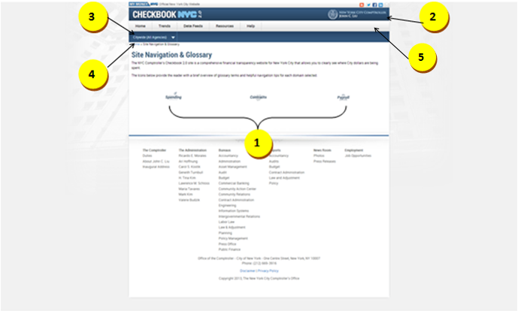

|  |  |  |  |
| --- | --- | --- | --- |
| **ID** | **KEY** | **FEATURE** | **DESCRIPTION** |
| **6.1** |  | **Links to Glossary of terms** | * The system shall present a pop up new window of a list of glossary terms when a user clicks on an icon. * For contracts domain, agency list with codes is embedded for download. |
| **6.2** |  | **Header** | * The header includes all components above the top menu bar. It should include NYC 2.0 logo, Comptroller logo, my money site logo, social media links like add this, twitter, Facebook, LinkedIn and also includes email option. All these should be hyperlinked including logo. |
| **6.3** |  | **Citywide Filter** | * The system shall direct the user to an agency specific landing page if user clicks on any particular agency from the dropdown list. By default, citywide agencies filter shall be preselected. * Once user selects an agency, the top navigation numbers will also update that agency level for the selected year. |
| **6.4** |  | **Breadcrumbs** | * The system shall present breadcrumbs which consist of a maximum of eight elements. * Upon initial visit to the application, the first element shall be ‘Home’. The titles of the breadcrumb elements shall be specific. The breadcrumbs shall essentially present a historical path of navigation. * Once the user visits the ninth page, the eighth element shall disappear, and shall be replaced by a new element. Only the eighth element will update. * No short names to be used in breadcrumbs. Placement of the breadcrumbs will be above the visualization to the left. |
| **6.5** |  | **Top Menu Bar** | * + - The system shall present tabs at the top menus bar in the following order: Home, Trends, Data Feeds, Resources, and Help.     - The system shall not contain drop-downs for the Home and Data Feeds tabs.     - The system shall present the drop-down for Trends in the following order – Featured Trends, All Trends, Financial, Revenue Capacity, Debt Capacity, Demographic, and Operational. * Each of the additional trends - Financial, Revenue Capacity, Debt Capacity, Demographic, Operational – have additional groupings of trends, which are opened in the menu call out. * The system shall contain the following drop-downs for help tab: Site Navigation & Glossary, FAQ, Ask a Question, Report a Problem and Share an Idea. * Site Navigation & Glossary would display information for three domains: Contracts, Payroll and Spending. Within contracts domain, agencies list with codes is embedded to be downloaded. |

Help – Functional Requirements

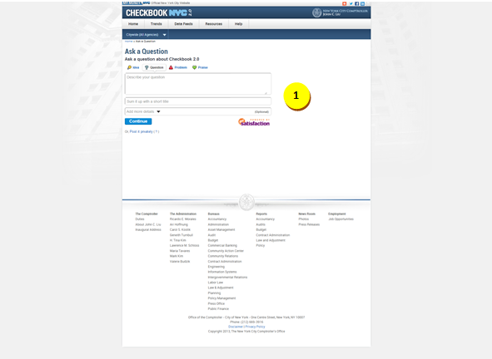

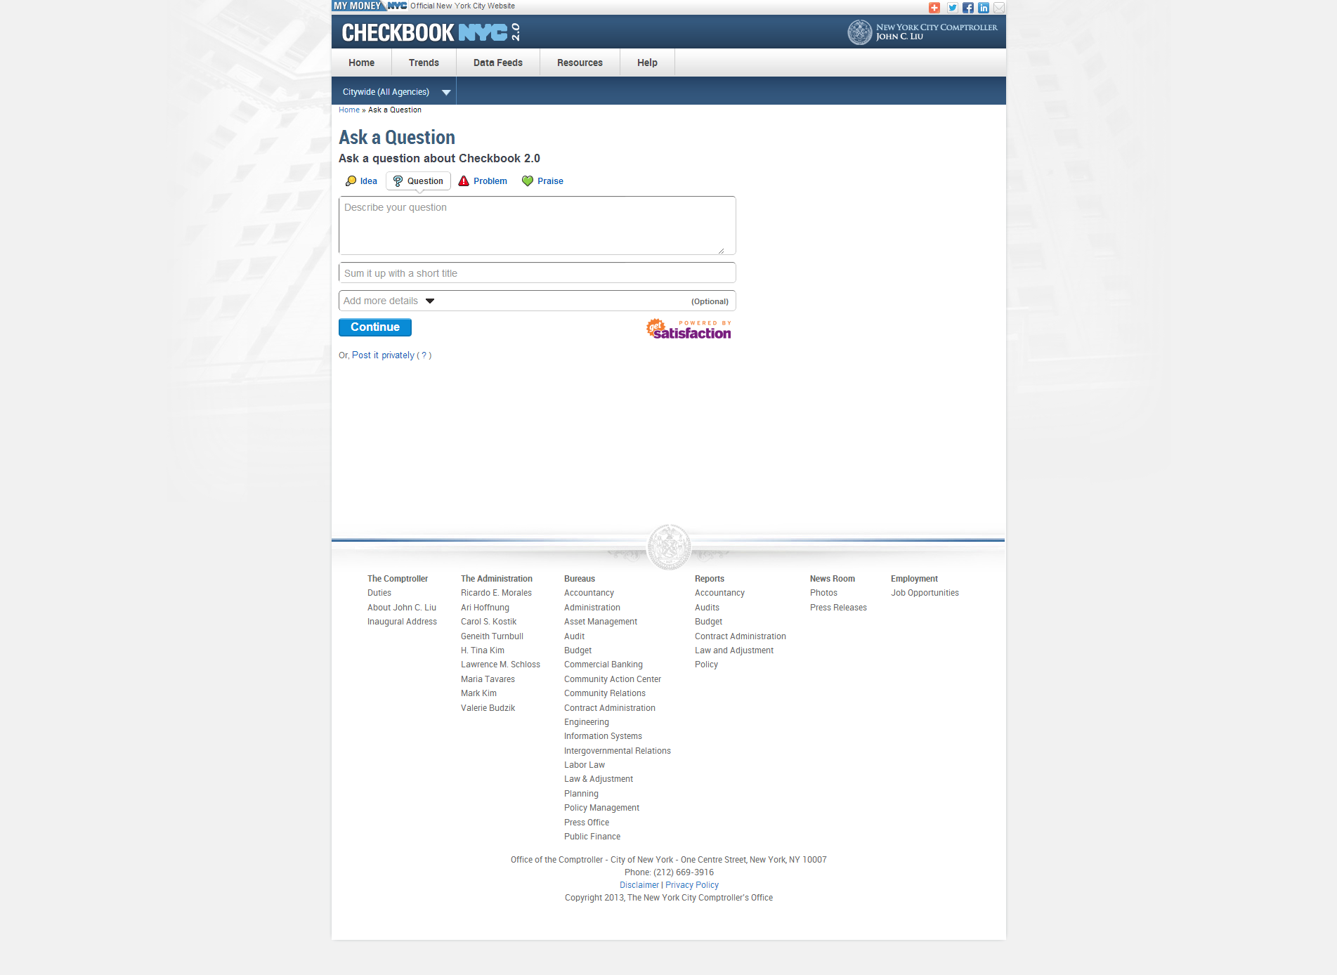

|  |  |  |  |
| --- | --- | --- | --- |
| **ID** | **KEY** | **FEATURE** | **DESCRIPTION** |
| **7.1** |  | **User Interface tool** | * The system shall a user interface tool which allows users to post their opinions, questions, etc. in text. The same interface will be provided for the ‘Ask a Question’ page, ‘Report a Problem’ page, and ‘Share an Idea’ page. |

1. Non-Functional Requirements
   1. Hardware Requirements

The NYC Checkbook 2.0 application can be deployed on either virtual or physical servers (Req ID: 8.1).

* 1. Software Requirements

The following list of software packages are required to develop the system (Req ID: 8.2):

* Linux
* Apache Webserver 2.x
* MySQL 5.x
* PHP 5.x
* Apache Solr
  1. Web Accessibility Requirements

The NYC Checkbook 2.0 application shall be accessible by the following web browsers (Req ID: 8.3):

* Internet Explorer 7
* Internet Explorer 8
* Mozilla Firefox 16.0.1
* Google Chrome 22.0.1229.94
* Safari 6.0
  1. Security and Privacy Requirements

The NYC Checkbook 2.0 application shall not be dependent on persistent cookies stored in browsers (Req ID: 8.4).

The NYC Checkbook 2.0 application shall not require administrative users to provide personal information to utilize the system (e.g. System shall not require user to provide SSN to create an account) (Req ID: 8.5).

Public and private data shall be stored in independent data tables on Greenplum. The separation of data types shall minimize the possibility of exposing private information to the public (Req ID: 8.6).

* 1. Reliability/Disaster Recovery Requirements

All data shall be stored in a source back-up file to support disaster recovery (Req ID: 8.7).

1. Performance Requirements
   1. System Capacity (Req ID 9.1)

With 20 users in 2 hours:

1. Avg. Response Time must be at most 450ms
2. Min. Response Time must be at most 30ms
3. Max. Response Time must be at most 15,000ms
4. Throughput (pages/sec) must be at least 50
5. Throughput (kb/sec) must be at least 100,000

With 40 users in 2 hours:

* + 1. Avg. Response Time must be at most 700ms
    2. Min. Response Time must be at most 40ms
    3. Max. Response Time must be at most 20,000ms
    4. Throughput (pages/sec) must be at least 70
    5. Throughput (kb/sec) must be at least 180,000

With 60 users in 2 hours:

1. Avg. Response Time must be at most 1,750ms
2. Min. Response Time must be at most 20ms
3. Max. Response Time must be at most 33,000ms
4. Throughput (pages/sec) must be at least 90
5. Throughput (kb/sec) must be at least 250,000
6. Smart Search Requirements

* **Header:** (Req ID: 10.1)
* The header includes all components above the top menu bar. It should include NYC 2.0 logo, Comptroller logo, my money site logo, social media links like add this, twitter, Facebook, LinkedIn and also includes email option. All these should be hyperlinked including logos.
* **Top Menu Bar:** (Req ID: 10.2)
* The system shall present tabs at the top menus bar in the following order – Home, Trends, Data Feeds, Resources, and Help.
* The system shall not contain dropdowns for the Home and Data Feeds tabs.
* The system shall present the dropdown for Trends in the following order – Featured Trends, All Trends, Financial, Revenue Capacity, Debt Capacity, Demographic, and Operational.
* Each of the additional trends - Financial, Revenue Capacity, Debt Capacity, Demographic, Operational – have additional groupings of trends, which are opened in the menu call out.
* The system shall contain following dropdowns for help tab-Site Navigation & Glossary, FAQ, Ask a question, Report a problem and Share an idea.
* Site Navigation & Glossary shall display information for three domains-Contracts, Payroll and Spending. Within contracts domain, agencies list with codes is embedded to be downloaded.
* **Citywide filter:** (Req ID: 10.2)
* The system shall direct the user to an agency specific spending landing page if user clicks on any particular agency from the dropdown list. By default, citywide agencies filter shall be preselected.
* **Date Filter:** (Req ID: 10.3)
* The system shall present the citywide filter and FY date filter for smart search.By default current FY shall be pre-selected. When the user clicks on this FY, the application shall display data for spending domain, for the current FY.
* **Advanced search:** .(Req ID: 10.4)
* Different tabs within the advanced search pop-up shall allow the user to search in different domains. Spending domain shall open by default.
* **Breadcrumbs:**
* The Breadcrumb for smart search should be Home > Search Results. (Req ID: 10.5)
* **Narrow-down search:** (Req ID: 10.6)
* The system shall allow the user to narrow-down the search results by type of data, Agency, vendor, expense category, and fiscal years.
* **Smart Search box: (**Req ID: 10.7)
* The system shall support all string search functionality.
* User shall be able to input characters or strings into the textbox.
* **Search-Autocomplete behavior: (**Req ID: 10.8)
* The system shall present a dropdown of relevant items once the user inputs a string or set of strings. The items shall be divided by the following categories in the autocomplete dropdown.
  + Agency
  + Vendor
  + Expense Category
* Search autocomplete shall search for words anywhere within the phrase.
* If a user types in “a” in the autocomplete, the system shall render all results that have the letter “a” anywhere in the phrase within the autocomplete dropdown list.
* If two words are given in the autocomplete box, the system shall render all results that match first word or second word or two words together anywhere within the phrase.
* Maximum of ten items shall be displayed within the dropdown list. The order of the list shall be based on the count of transactions associated to the items (highest to lowest).
* **Selecting from the dropdown autocomplete list:** Once the user starts selecting any result from the dropdown list of auto complete, the system shall search for that word “Exactly”. The resulting facet shall be pre-selected in the results page. On selecting any result from the dropdown it shall direct the user to the results page automatically.
* **Using Search button behavior**: (Req ID: 10.9)
* If a user enter one word and clicks search button, the system shall render all results that match that word anywhere in the anywhere in the phrase across domains.
* If a user enter multiple words and clicks search button, the system shall render all results that match the words individually or together anywhere in the phrase across domains.
* The narrow-down facet shall not be pre-selected in the resulting page when user submits request using search button.
* **Wild Card Search:** (Req ID: 10.10)
* The system shall be able to search certain wild card search characters. The list of wild card search capabilities applicable is embedded here for reference.



* **Export:** (Req ID: 10.11)

The system shall allow the user to export the search results. The rules for smart search export are listed below.

* The export box shall have three options displayed, type of data, download data, and cancel button.
* Type of data shall display all domains, download data in csv format.
* If the results include data for all three domains, it is mandatory for the user to select a domain in the export box to download the data. A message shall be included in the export box to let users know that it is mandatory to select at least one domain to download the data.
* If the results include data for only one domain, then the export shall have that domain preselected, with other domains being disabled.
* If the user selects more than one domain, then the export box shall have only one domain selected giving message to the users that only one domain can be downloaded at a time.
* Based on the search results, the domain names will be enabled and/or disabled.
* The user shall be able to download transactions for only **one** domain at a time.
* Budget and Revenue shall be disabled at all times, until we develop these domains.
* A maximum of 200,000 records will be available for download per domain.

1. Narrow-down Facet Requirements

* The system shall divide the narrow-down facet into different categories. The grouping of the categories will depend on selected domain. (Req ID: 11.1).
* Department facet shall only be applicable when agency is selected. This is only applicable for spending domain. In spending domain, once an agency is selected, remaining agencies and the smart search box will be disabled within the facet. Only one agency can be selected at a time. Contracts domain and Smart Search will not have department facet, multiple agencies can be selected at a time. (Req ID: 11.2).
* A maximum of 5 items can be selected within each category. Once the user selects 5 records within a category, remaining results within the category will be disabled. The user can un-check any record and select other agency (Req ID: 11.3).
* The system shall separate the checked and unchecked items under each category. The transaction count within the checked items shall be highlighted in blue. (Req ID: 11.4).
* As the user checks more items under a single category, the space with the checked items shall increase. Essentially, the narrow-down facet will expand vertically as the user checks more items. (Req ID: 11.5).
* Smart search box shall be applicable within each category. (Req ID: 11.6)
* The system shall support the All-String search functionality for the search textbox. Each facet within the narrow-down facet will have the smart search box. .
* Search autocomplete shall search for words anywhere within the phrase.
* If a user types in “a” in the autocomplete, the system shall render all results that have letter “a” anywhere in the phrase within the autocomplete dropdown list.
* If two words are given in the autocomplete box, the system shall render all results that match first word or second word or two words together anywhere within the phrase.
* Maximum of ten items will be displayed within the dropdown list. The order of the list shall be based on the count of transactions associated to the items (highest to lowest).
* **Selecting from the dropdown: Once** the user starts selecting any result from the dropdown list of auto complete, the system shall search for that word “Exactly”. On selecting any result from the dropdown it shall direct update the resulting transaction table automatically. The item shall be placed as the first item in the space with the checked items (The item will automatically be checked).
* The system shall narrow-down the transactions presented in the table to reflect the items that have been checked from the narrow-down facet. (Req ID: 11.7).
* The counts located immediately right of items under a category of the narrow-down facet can only be narrowed down if an item is selected from a different category of the facet. The order of the unchecked items under a category must be sorted by the count (highest to lowest). (Req ID: 11.8).
* If a user selects an item under a category, the counts of all the items under the same category must not be updated. (Req ID: 11.9).
* The narrow-down facet shall support only the ‘AND’ functionality of filtering the transactions list. For example, if the user checks ‘Department of Education’ from the Agency category and checks ‘Human Resources’ from the Department category, then the displayed transactions must be of Human Resources of the Department of Education only . (Req ID: 11.10).
* By default, 5 items will be displayed under each category. The user can use the scroll bar to select more records. (Req ID: 11.11).
* In the smart search results page, the ‘By Type of data’ facet comprises of Spending, Contracts, and Payroll. (Req ID: 11.12).
* Upon checking the Spending option, sub-category options shall be presented below which is “By spending category” which displays all five spending categories unchecked.
* Upon checking the Contracts option, sub-category options shall be presented below which are “By Status” and “By Category”. ‘By Status’ shall include Active, Registered and pending. Active category will be included as a sub-category for registered contracts. By Category shall include two Expense and Revenue. By Status’
* Once a user checks a sub-category option from any domain, the remaining domains shall disappear. As the sub-categories can be associated to only its domain.

1. API/Data Feeds Requirements

** **

1. Data Requirements

* 1. Data Model



*Note: The data model depicts the layout of the database in complete detail.*

* 1. Data Dictionary



*Note: The data dictionary identifies and describes all the variables that reside in the database.*

* 1. Data Mapping



*Note: The data mapping illustrates where UI elements acquire their information from the database.*

1. Design Requirements

**

1. Appendices

***Appendix A: Custom List of Agencies***

|  |  |  |
| --- | --- | --- |
| **DeptName** | **DepartmentID** | **DeptCode** |
| ADMIN FOR CHILDREN'S SERVICES | **61** | 68 |
| BOARD OF CORRECTION | **67** | 73 |
| BOARD OF ELECTIONS | **115** | 3 |
| BOARD OF WATER SUPPLY | **81** | 85 |
| BOROUGH PRESIDENT – BROOKLYN | **38** | 12 |
| BOROUGH PRESIDENT - MANHATTAN | **131** | 10 |
| BOROUGH PRESIDENT - QUEENS | **15** | 13 |
| BOROUGH PRESIDENT BRONX | **39** | 11 |
| BOROUGH PRESIDENT STATEN ISLAND | **53** | 14 |
| BRONX COMMUNITY BOARD #1 | **42** | 381 |
| BRONX COMMUNITY BOARD #10 | **90** | 390 |
| BRONX COMMUNITY BOARD #11 | **87** | 391 |
| BRONX COMMUNITY BOARD #12 | **48** | 392 |
| BRONX COMMUNITY BOARD #2 | **126** | 382 |
| BRONX COMMUNITY BOARD #3 | **65** | 383 |
| BRONX COMMUNITY BOARD #4 | **17** | 384 |
| BRONX COMMUNITY BOARD #5 | **98** | 385 |
| BRONX COMMUNITY BOARD #6 | **130** | 386 |
| BRONX COMMUNITY BOARD #7 | **74** | 387 |
| BRONX COMMUNITY BOARD #8 | **7** | 388 |
| BRONX COMMUNITY BOARD #9 | **123** | 389 |
| BROOKLYN COMMUNITY BOARD #1 | **63** | 471 |
| BROOKLYN COMMUNITY BOARD #10 | **91** | 480 |
| BROOKLYN COMMUNITY BOARD #11 | **29** | 481 |
| BROOKLYN COMMUNITY BOARD #12 | **27** | 482 |
| BROOKLYN COMMUNITY BOARD #13 | **10** | 483 |
| BROOKLYN COMMUNITY BOARD #14 | **92** | 484 |
| BROOKLYN COMMUNITY BOARD #15 | **80** | 485 |
| BROOKLYN COMMUNITY BOARD #16 | **22** | 486 |
| BROOKLYN COMMUNITY BOARD #17 | **8** | 487 |
| BROOKLYN COMMUNITY BOARD #18 | **93** | 488 |
| BROOKLYN COMMUNITY BOARD #2 | **118** | 472 |
| BROOKLYN COMMUNITY BOARD #3 | **72** | 473 |
| BROOKLYN COMMUNITY BOARD #4 | **113** | 474 |
| BROOKLYN COMMUNITY BOARD #5 | **132** | 475 |
| BROOKLYN COMMUNITY BOARD #6 | **134** | 476 |
| BROOKLYN COMMUNITY BOARD #7 | **105** | 477 |
| BROOKLYN COMMUNITY BOARD #8 | **66** | 478 |
| BROOKLYN COMMUNITY BOARD #9 | **26** | 479 |
| BROOKLYN PUBLIC LIBRARY | **58** | 38 |
| BUSINESS INTEGRITY COMMISSION | **37** | 829 |
| CAMPAIGN FINANCE BOARD | **46** | 4 |
| CITY CLERK | **49** | 103 |
| CITY COUNCIL | **97** | 102 |
| CITY UNIVERSITY OF NEW YORK | **62** | 42 |
| CIVIL SERVICE COMMISSION | **16** | 134 |
| CIVILIAN COMPLAINT REVIEW BOARD | **117** | 54 |
| COMMISSION ON HUMAN RIGHTS | **79** | 226 |
| CONFLICTS OF INTEREST BOARD | **25** | 312 |
| DEBT SERVICE | **55** | 99 |
| DEPARTMENT FOR THE AGING | **104** | 125 |
| DEPARTMENT OF BUILDINGS | **108** | 810 |
| DEPARTMENT OF CITY PLANNING | **84** | 30 |
| DEPARTMENT OF CITYWIDE ADMIN SERVICE | **138** | 856 |
| DEPARTMENT OF CONSUMER AFFAIRS | **88** | 866 |
| DEPARTMENT OF CORRECTION | **1** | 72 |
| DEPARTMENT OF CULTURAL AFFAIRS | **129** | 126 |
| DEPARTMENT OF DESIGN & CONSTRUCTION | **112** | 850 |
| DEPARTMENT OF EDUCATION | **101** | 40 |
| DEPARTMENT OF EMERGENCY MANAGEMENT | **100** | 17 |
| DEPARTMENT OF ENVIRONMENTAL PROTECT. | **5** | 826 |
| DEPARTMENT OF FINANCE | **45** | 836 |
| DEPARTMENT OF HEALTH AND MENTAL HYGIENE | **102** | 816 |
| DEPARTMENT OF HOMELESS SERVICES | **137** | 71 |
| DEPARTMENT OF INFO TECH & TELECOMM | **18** | 858 |
| DEPARTMENT OF INVESTIGATION | **109** | 32 |
| DEPARTMENT OF JUVENILE JUSTICE | **64** | 130 |
| DEPARTMENT OF PARKS AND RECREATION | **34** | 846 |
| DEPARTMENT OF PROBATION | **4** | 781 |
| DEPARTMENT OF RECORDS & INFORMATION SVS | **35** | 860 |
| DEPARTMENT OF SANITATION | **95** | 827 |
| DEPARTMENT OF SMALL BUSINESS SERVICES | **107** | 801 |
| DEPARTMENT OF TRANSPORTATION | **120** | 841 |
| DEPARTMENT OF YOUTH & COMMUNITY DEV | **71** | 260 |
| DISTRICT ATTORNEY BRONX COUNTY | **11** | 902 |
| DISTRICT ATTORNEY KINGS COUNTY | **73** | 903 |
| DISTRICT ATTORNEY NEW YORK COUNTY | **52** | 901 |
| DISTRICT ATTORNEY QUEENS COUNTY | **140** | 904 |
| DISTRICT ATTORNEY RICHMOND COUNTY | **28** | 905 |
| EQUAL EMPLOYMENT PRACTICES COMMISSION | **96** | 133 |
| FINANCIAL INFORMATION SERVICE AGENCY | **83** | 127 |
| FIRE DEPARTMENT | **19** | 57 |
| HEALTH AND HOSPITALS CORP | **94** | 819 |
| HEALTH PAYMENTS | **12** | 214 |
| HOUSING PRESERVATION AND DEVELOPMENT | **13** | 806 |
| HUMAN RESOURCES ADMINISTRATION | **82** | 96 |
| INDEPENDENT BUDGET OFFICE | **36** | 132 |
| LANDMARKS PRESERVATION COMM. | **44** | 136 |
| LAW DEPARTMENT | **60** | 25 |
| MANHATTAN COMMUNITY BOARD #1 | **111** | 341 |
| MANHATTAN COMMUNITY BOARD #10 | **76** | 350 |
| MANHATTAN COMMUNITY BOARD #11 | **89** | 351 |
| MANHATTAN COMMUNITY BOARD #12 | **77** | 352 |
| MANHATTAN COMMUNITY BOARD #2 | **122** | 342 |
| MANHATTAN COMMUNITY BOARD #3 | **110** | 343 |
| MANHATTAN COMMUNITY BOARD #4 | **57** | 344 |
| MANHATTAN COMMUNITY BOARD #5 | **51** | 345 |
| MANHATTAN COMMUNITY BOARD #6 | **136** | 346 |
| MANHATTAN COMMUNITY BOARD #7 | **68** | 347 |
| MANHATTAN COMMUNITY BOARD #8 | **59** | 348 |
| MANHATTAN COMMUNITY BOARD #9 | **47** | 349 |
| MAYORALTY | **116** | 2 |
| MISCELLANEOUS | **32** | 98 |
| NEW YORK PUBLIC LIBRARY | **70** | 37 |
| NEW YORK RESEARCH LIBRARIES | **127** | 35 |
| NYC TAXI AND LIMOUSINE COMM | **133** | 156 |
| OFFICE OF ADMIN TRIALS & HEARINGS | **145** | 820 |
| OFFICE OF ADMINISTRATIVE TAX APPEALS | **23** | 21 |
| OFFICE OF COLLECTIVE BARGAINING | **50** | 313 |
| OFFICE OF PAYROLL ADMINISTRATION | **41** | 131 |
| OFFICE OF PROSECUTION SPEC NARCO | **125** | 906 |
| OFFICE OF THE ACTUARY | **69** | 8 |
| OFFICE OF THE COMPTROLLER | **86** | 15 |
| PENSION CONTRIBUTIONS | **3** | 95 |
| POLICE DEPARTMENT | **75** | 56 |
| PUBLIC ADMINISTRATOR- QUEENS COUNTY | **142** | 944 |
| PUBLIC ADMINISTRATOR-BRONX COUNTY | **143** | 942 |
| PUBLIC ADMINISTRATOR-KINGS COUNTY | **144** | 943 |
| PUBLIC ADMINISTRATOR-NEW YORK COUNTY | **31** | 941 |
| PUBLIC ADMINISTRATOR-RICHMOND COUNTY | **124** | 945 |
| PUBLIC ADVOCATE | **20** | 101 |
| QUEENS BOROUGH PUBLIC LIBRARY | **21** | 39 |
| QUEENS COMMUNITY BOARD #1 | **114** | 431 |
| QUEENS COMMUNITY BOARD #10 | **119** | 440 |
| QUEENS COMMUNITY BOARD #11 | **128** | 441 |
| QUEENS COMMUNITY BOARD #12 | **14** | 442 |
| QUEENS COMMUNITY BOARD #13 | **9** | 443 |
| QUEENS COMMUNITY BOARD #14 | **30** | 444 |
| QUEENS COMMUNITY BOARD #2 | **54** | 432 |
| QUEENS COMMUNITY BOARD #3 | **43** | 433 |
| QUEENS COMMUNITY BOARD #4 | **139** | 434 |
| QUEENS COMMUNITY BOARD #5 | **106** | 435 |
| QUEENS COMMUNITY BOARD #6 | **33** | 436 |
| QUEENS COMMUNITY BOARD #7 | **24** | 437 |
| QUEENS COMMUNITY BOARD #8 | **85** | 438 |
| QUEENS COMMUNITY BOARD #9 | **78** | 439 |
| SCA AGENCY FOR BOE DECREASES | **6** | 04A |
| SCHOOL CONSTRUCTION AUTHORITY | **2** | 44 |
| STATEN ISLAND COMMUNITY BOARD #1 | **40** | 491 |
| STATEN ISLAND COMMUNITY BOARD #2 | **99** | 492 |
| STATEN ISLAND COMMUNITY BOARD #3 | **56** | 493 |
| SUPREME COURT - 1ST JUD DIST | **103** | 921 |
| SUPREME COURT - APPELLATE DIV | **141** | 938 |
| TRANSIT AUTHORITY - CAPITAL | **121** | 998 |